**CHILD’S BASIC BODICE BLOCK**

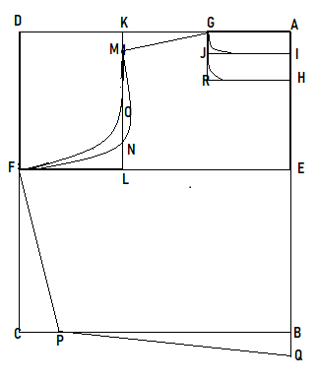MEASUREMENTS:

* + - * Bodice’s length = 9”
      * Chest = 20”
      * Waist = 20”
      * Shoulder = 10”
      * Sleeve length = 4”
      * Sleeve Round = 7”

INSTRUCTION FOR DRAFTING:

* AB= Bodice’s Length+1”
* AD & BC =1/4 Chest +1.5”
* Join ABCD with a square line
* AG & AH =1/12 of chest
* Square out from G to H for Front neck line.
* AI = 1” and join GJI for Back neck line.
* AK = 1/2 Shoulder width + 0.5”
* Square down from K to L
* KM = .5”
* Shape arm circle MNF (front) & MOF (back) with

a curve front and back armhole as shown in the diagram.

* CP= 0.5” Shape and join F to P.
* BQ=0.5” for front bodice.
* Shape and join Q to P with a straight line.

**CHILD’S BASIC SLEEVE BLOCK**

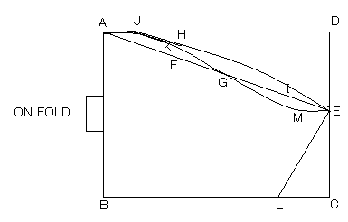MEASUREMENTS:

* + - * Sleeve length = 4”
      * Sleeve Round = 7”

INSTRUCTION FOR DRAFTING:

* + - * AB & CD =Sleeve length + 1”
      * AD & BC =1/4 Chest - 0.5”
      * Square line ABCD and keep AB on fold.
      * DE = 2” to 2.5”
      * Join AE with a straight line & divide this line into three equal parts and name them FI.
      * G is midpoint of F and I
      * H = ½” above from F.
      * K = ¼” above from F.
      * M=1/8”below J
      * AJ= 0.5”
      * Join AJKGME for front curve and AJHE for back curve.
      * BL half sleeve round +1”

**ADULT BASIC BODICE BLOCK**

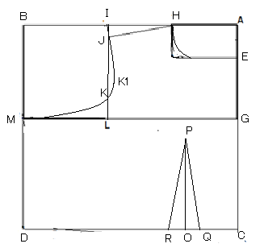MEASUREMENTS:

* + - * Bodice’s length = 34”
      * Chest = 34”
      * Waist = 32”
      * Shoulder = 14”
      * Sleeve length = 4”
      * Sleeve Round = 10”

INSTRUCTION FOR DRAFTING:

**FRONT BODICE**

* AC-BD= Bodice’s Length+1”
* AB & CD =1/4 Chest +1.5”
* Join ABCD with a square line
* AE & AH =1/12 of chest
* Square out from HE for front neck line
* AG-BM=1/4 of chest round
* Straight line K is 2” to 2.5” above L
* AI = 1/2 OF Shoulder
* Square down from IL,KK1=0.5”
* IJ=0.5”Sloop down & join with H to J
* Shape arm circle JK1M with a curve for front armhole as shown in the diagram.

**DART POINT:**

GP-CO=1/10 of chest

Draw a dart of 1.5”at point O

OR-OQ=3/4” & Join with P to O,P to R, P to Q.

**BACK BODICE’S**

* + 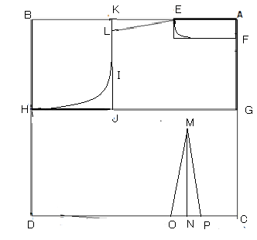AC-BD= Bodice’s Length+1”
  + AB & CD =1/4 Chest +1.5”
  + Join ABCD with a square line
  + AE=1/12 of chest
  + AF=1.5”
  + Square out from EF for back neck line
  + AG-BH=1/4 of chest round
  + Straight line I is 2” to 2.5” above J
  + AK = 1/2 OF Shoulder
  + Square down from KJ
  + KL=0.5”Sloop down & join with E to L
  + Shape arm circle “LIH” with a curve for back armhole as shown in the diagram.

**DART POINT:**

GM-CN=1/10 of chest

Draw a dart of 1.5”at point N

NO-NP=3/4” & Join with P to O, P to R, P to Q.

**ADULT BASIC SLEEVE BLOCK**

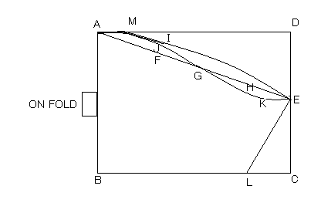MEASUREMENTS:

* + - * Sleeve length = 4”
      * Sleeve Round = 10”

INSTRUCTION FOR DRAFTING:

* + - * AB & CD =Sleeve length + 1”
      * AD & BC =1/4 Chest - 0.5”
      * Square line ABCD and keep AB on fold.
      * DE = 2.5”to 3”
      * Join AE with a straight line & divide this line into three equal parts and name them F & H.
      * G is midpoint of F and H
      * I = ½” above from F.
      * J = ¼” above from F.
      * AM= 0.5”
      * K=0.5” below H
      * Join AMJGKE for front curve and AMIE for back curve.
      * BL half sleeve round +1”