**1.1 Meristems**

Almost all tissues starts to divide from some incipient cells, called as meristems or

meristematic cells. Early phased meristematic cells are also called as promeristems or

constructive tissue. Unlike other cells of plants, meristematic cells remain totipotent. They

play an important role in the formation of new tissues and in the correct placement of those

tissues within the plant body. This process is called as pattern formation. These play a pivotal

role in normal plant growth. They are also the source of the regenerative potential of a plant

after injury.

Meristematic cells have following properties: **nt**

**1.** These are found in the vegetative part of the plants.

**2.** They are living (lack non-living substances or inclusions) and of thinner wall (having

primary cell wall only), isodiametric cells.

**3.** The cells are small and their protoplasm fills the cell completely. They have

prominent nucleus (positioned in the centre) and either they lack vacuole or vacuoles

are extremely small. The cytoplasm does not contain differentiated plastids

(chloroplasts or chromoplasts), although they are present in rudimentary form

(proplastids).

**4.** These cells are either dividing or about to divide or have potential to divide.

**5.** They lack intercellular spaces in between them.

**6.** These cells are metabolically more active and grow as long as they are alive.

**2. Classification of Meristematic Tissues**

Meristematic tissues are variously classified, on the basis of their growth, plane of division

and position and function etc.

**2.1 Classification of meristematic tissues on the basis of origin and development:**

On the basis of origin, meristematic tissues have been divided into three categories: **ny**

**(a) Promeristem or primordial meristem:** Promeristem or primordial meristemis

the embryonic stage of developing meristems and represents the primary phase of

the meristem of a growing plant. Promeristems are the young growing points of

meristems, situated on the apices of roots and shoots. They are the sites of active

mitotic division. Promeristem gives rise to primary meristems.

**(b) Primary meristem:** Primary meristems develop from promeristems. Such type of

tissues is found on the apical and intercalary regions of shoots and roots. Their

cells are also in the continuous phase of division. The cells of primary meristems

give rise to primary permanent tissues.

**(c) Secondary meristem:** Initially, these types of tissues are not present but, if

required, develop in the later stages by acquiring potential to divide in some of the

primary permanent tissues, e.g., interfascicular and cork cambium of roots.

Secondary meristems form secondary permanent tissues.

**2.2 Classification of meristematic tissues on the basis of position:**

On the basis of position, meristematic tissues have been divided into three

categories (Fig. 1):

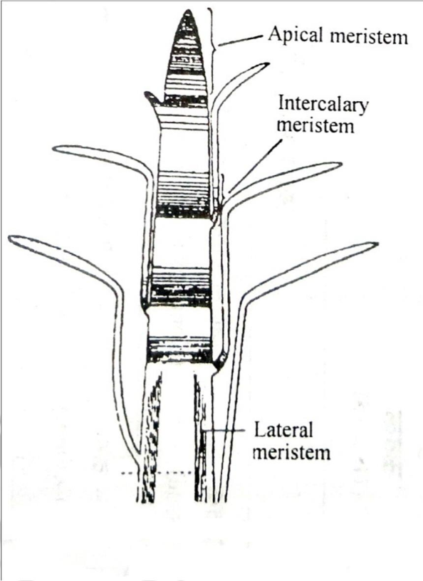

**Fig. 1.** Meristems, according to the position.

**(a) Apical Meristem**

These meristems are situated on the apices of roots and shoots. Roots and shoots

increase in their lengths by the continuous division of these tissues. These meristems

form the growing point on the apices of growing point.

**(b) Intercalary Meristem**

Actually, they are the regions separated from the apical meristems at the time of

growth of the shoot and do not change into permanent tissues and remained included

as meristematic tissues in between permanent tissues. Intercalary meristems are

capable of cell division and allow for rapid growth of many monocots. Intercalary

meristems at the nodes of bamboo promise rapid stem elongation, while those at the

base of most grass leaf blades assure damaged leaves to rapidly grow. Horsetails

(*Equisetum*) and *Mentha* also exhibit intercalary meristems.

**(c) Lateral Meristem:**

These meristems are situated in lateral parts of stems and roots. Lateral meristems are

responsible for the secondary growth in stems and roots increasing their girth. For

example, vascular cambium and cork cambium of the perennial plants, formed after

redifferentiation in permanent tissues.

**2.3 Classification of meristematic tissues on the basis of plane of division**

There are three types of meristems on the basis of plane of division:

**B**

**(a) Mass meristem:** Its cells divide in all directions resulting into irregular

organogenesis. These meristems are seen in primary developmental phase of

embryo and endosperm.

**(b) Plate meristem:** Its cells divide anticlinally (i.e. at an angle of 90º) and form plate

like structure resulting into plate like tissue formation. These meristems are

involved in the formation of epidermis and multiliner blade of flat pinna.

**(c) Rib meristem:** Its cells always divide in anticlinal manner due to which rows of

cells are formed at longitudinal axis. These meristems form pro-meristem to

cortex and pith in roots and stems.

**2.4 Classification of meristematic tissues on the basis of function:**

**(a) Protoderm:** This type of meristem is situated on outer layer and develops into the

epidermis.

**(b) Procambium:** It lies just inside the protoderm and its cells are elongated and form

primary vascular bundles. It develops into primary xylem and primary phloem. It

also produces the vascular cambium, cork cambium and secondary meristems.

The cork cambium further differentiates into the phelloderm (to the inside) and the

phellem, or cork (to the outside). All three layers (cork cambium, phellem and

phelloderm) constitute the periderm. In roots, the procambium can also give rise

to the pericycle, which produces lateral roots in eudicots.

**(c) Ground tissue:** Its cells are comparatively large, thin walled and isodiametric.

Division of these cells gives rise to epidermis, cortex, endodermis, pericycle,

medullary rays and medulla. These meristems are responsible for primary growth,

or an increase in length or height.

**(d) Secondary meristems:** These are also called as the lateralmeristemsbecause

they surround the stem of a plant and stems grow laterally due to their activity

(i.e., enlarge in girth by producing secondary xylem and secondary phloem).

Secondary meristems produce wood in trees and give them arborescent habit.

Secondary meristems do not occur in herbaceous plants. Cork cambium is also a

kind of secondary meristem, which gives rise to the periderm by replacing the

epidermis.

**3. Shoot Apical Meristem (SAM)**

**3.1 Organization of SAM**

In higher plants, the shoot apical meristem (SAM) gives rise to all the above-ground organs.

It is supposed to be the site of organogenesis in flowering plants. It contains all the necessary

information of shoot building and its pattern formation in the form of cell signalling. The

SAM supplies cells that divide and differentiate to form the elements of the shoot. It also

initiates the lateral organ formation and decides their anatomical features and cell division

patterns. Primordia of leaves, sepals, petals, stamens and ovaries are initiated at SAM. First

indication of flower development appears in the form of loss of the apical dominance.

The SAM gives rise to:

**(a) Central zone:** It is located in the center of the SAM and acts as a pool of

undifferentiated, indeterminate cells. Cells of this zone have a stem cell (initial

cell) function and are essential for meristem maintenance. Here the cell division is

less frequent.

**(b) Peripheral zone:** This zone flanks the SAM, its cells divide more frequently and

are incorporated into leaf primordia.

**(c) Rib zone:** It is the proximal region. It supplies the cells that form the body of the

stem.

Although all the tissues of shoot originate from shoot apex, despite of this, the organization

of shoot apical meristem differs from plant to plant.

Different workers tried to explain the structure of organization of apical meristems

differently. Wardlaw (1957) explained following 5 regions in shoot apical meristems

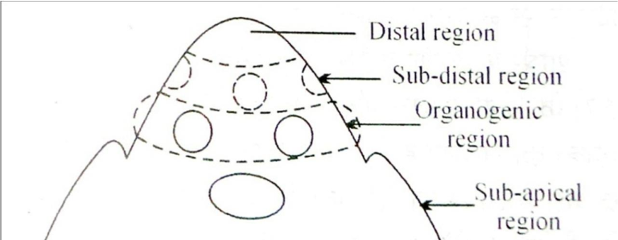

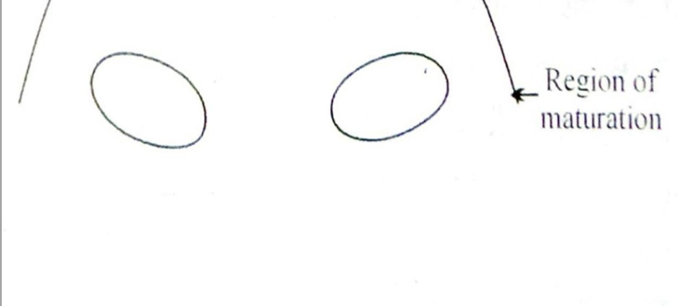

**Fig. 2.** Shoot apex with different regions, after Wardlaw (1957).

**(a) Distal region:** This is the apical most region of SAM and is made of meristematic

cells arranged in one or many rows.

**(b) Sub-Distal region:** It is situated just after the distal region. This is also made of

meristematic cells. Growing points are situated in this very region.

**(c) Organogenic Region:** The process of leaf initiation and tissue differentiation

occurs in this region.

**(d) Sub-apical region:** This region is situated below the organogenic region. Cells of

this region constantly dividing and show cell elongation and cellular

differentiation.

**(e) Region of maturation:** This region is situated below the sub-apical region. All

the cells of this region are mature and neither do they divide or differentiate.

**3.5 Theories related to shoot apex organization**

Multiple theories have been proposed to understand the structure and organization of shoot

apical meristem:

**3.5.1 Apical Cell Theory:**

This theory was proposed by Hofmeister (1957) and elaborated by Nageli (1978). According

to this theory, the apical cell of shoot is always in most active state. Various tissues of shoots

are formed by the activity of this apical cell. Apical cell of the shoot apex also exhibits

differentiation and regulatory function necessary for pattern formation. The apical cell gives

rise to new cells by cutting one or two cells on its posterior face. These cells transform into

tissues in the later stage (Fig. 5).

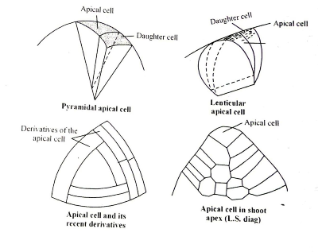

**Fig. 5.** Apical cell of shoot apex

This theory efficiently explains growth and differentiation process in some higher algae,

bryophytes and some pteridophytes, but failed to explain the structure and organization of

shoot apex in phanerogams, i.e. gymnosperms and angiosperms, since the shoot apices of

phanerogams consist of many cells.

**3.5.2 Histogen Theory:**

Hanstein (1970) proposed this theory after studying the shoots and embryos of many

angiosperms. He identified 3 clear-cut regions in shoots and roots (Fig. 6):

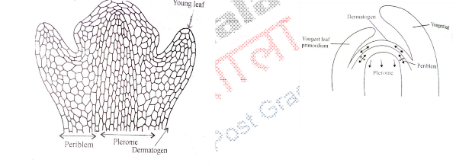

**Fig.6.** LS of shoot apex showing histogen layers (A), LS of shoot apex with histogen

layers wherein arrows indicate direction of growth (B).

**i) Dermatogen**: This is the outermost layer of cells. It forms epidermis of the

stems.

**ii) Periblem**: This region is just below the dermatogens. It is unilayered at apical regions but multilayered at lower regions. Division and differentiation of this region gives rise to hypodermis, general cortex and endodermis.

**iii) Plerome**: This is situated at inner side of periblem and middle part of the

shoot apex. This is made of thin layered isodiametric cells. This forms the stellar tissues, viz. pericycle, primary vascular tissue, medullary rays and medulla. Additionally, it also gives rise to procambium situated at sub-apical region in the shoot.

Plerome in the roots performs the similar function as the plerome in shoots.

Histogen theory is not suitable for the explanation of shoot apex because there is no

clear-cut demarcation between dermatogens and periblem. Thus, histogen theory is used

to explain the growth of the root apices only.

**3.5.3 Tunica** **Corpus** **Theory:**

This theory was proposed by Schmidt in 1924 to explain the apical growing regions of shoots only (and not used to explain the growth of root apices). According to this theory, two regions viz. tunica and corpus are found in shoot apical regions. Tunica comprises one or many outer layers of shoot apex. Cells of tunica region are cut only by anticlinal divisions. Tunica expands the surface of shoot apex, and its outer most layer gives rise to epidermal layer. Tunica covers the corpus wherein cells divide in all directions and volume of the shoot increases (Fig. 7).

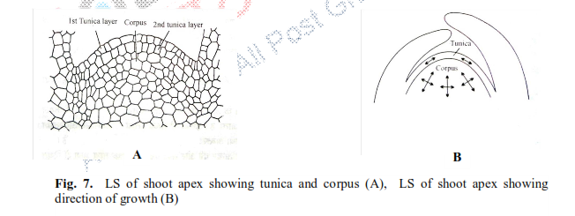

By studying the shoot apex in many angiosperms, it becomes clear that in some special

cases, tunica divides by periclinal divisions also along with anticlinal divisions. In monocots,

the tunica determines the physical characters of the leaf edge and margin. In dicots, corpus

determines the characteristics of the edge of the leaf.

**3.5.5 Histogen Layer Theory:**

Dermen (1947)defied tunica-corpus theory and proposed histogen layer theory. According to this theory, shoot apex of angiosperms is organized in 3 layered structure. They may be called as L-I, L-Iand L-III. According to this theory, epidermis of leaves and stem develop from LI; hypodermis, cortex and some of the vascular bundle regions develop from L-IIwhile vascular tissues and medulla develop from L-III. Organizational form oshoot apex in 3 layers gives this theory a modified version of histogen theory.

**4. Root Apical Meristem (RAM)**

Root apical meristems (RAM) are the sub-apical region of apical portion of the roots wherein

the meristematic cells are situated. They produce different internal tissues of roots. This region has following distinctive features (Fig. 9):

**1.** It is always sub-terminal region because it is covered by the root cap.

**2.** Neither any lateral appendage or branch or their growth zone, e.g. leaf or branch primordia are

attached to the RAM.

**3.** It is smaller than the shoot apex.

**4.** The cells of RAM consistently divide and their activity enables the roots to grow in positively

geotropic and negatively phototropic direction.

**4.1 Organization of Root Apex**

Apical cells of the primary roots are meristematic in nature and they attain the capability to

divide as soon as the embryonal radical forms. The cells of RAM have bigger and prominent

nucleus and have dense cytoplasm, either lack vacuoles or vacuoles are very small. These

cells are either ellipsoidal or polygonal and lack inter-cellular spaces. Their cell walls are thin

and uniform. They divide to form the cells of mature root system. Root apex is either partially

or completely covered with the root cap cells. Root cap cells are fully matured cells which

develop from dermatocalyptrogen in dicot plants and calyptrogen in monocot plants. RAM

gives rise the cells of the main axis of roots and the root cap initial cells. Tissue system

comprised of epidermis, cortex and vascular cylinder is situated behind the root apex (Fig.

10).

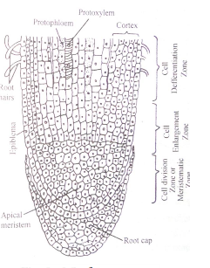

**Botany**

**MFig. 9.** LS of root apex.

**4.3 Theories related to root apex organization**

Multiple theories have been proposed to understand the structure and organization of root

apex:

**4.3.1 Apical Cell Theory:**

This theory was proposed by Hofmeister (1957) and later elaborated by Nageli (1978).

According to this theory, there is a tetrahedral cell in root apex which divides in three planes

producing different tissues of roots. Division in the basal plane of this tetrahedral cell gives

rise to root cap (Fig. 12).

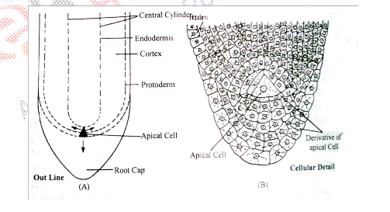

**Fig. 12.** LS of root apex of Ferns, outline (A), cellular details (b).

**4.3.2 Histogen Theory:**

Hanstein (1970) proposed this theory after studying the shoots and embryos of many

angiosperms. He asserted that the meristematic cells of root apex are made of 3 layers exactly

similar to shoot apical meristems. He identified the presence of 3 regions in shoots and roots

(Fig. 13):

**(i) Dermatogen**: This is the outermost layer of the cells of root apex and divide to form new cells. Later it produces tissues consisting smaller cells, called as calyptrogens. Calyptrogen is also a kind of meristematic cell and its activity makes root cap. Dermatogen produces epidermis.

**(ii) Periblem**: This region is just below the dermatogen layer. This region is apical most or middle portion of the root apex. This is single layered at apical portion but becomes multilayered in middle portion. Division and differentiation of this region gives rise to cortical region of the roots.

**(iii) Plerome**: Plerome is the central meristematic part of the apical meristem of the roots. This forms the stelar tissues, some parts of ground tissues like, pericycle, pith rays or medullary ray and pith. These three layers were collectively called as histogen.

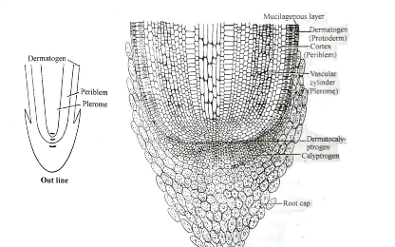

**Fig. 13.** LS of root apex depicting histogens. **Y**

**4.3.3 Korper-Kappe Theory**:

This theory was proposed by Schuepp (1917). According to this theory, the cells of root apex are

divided into two elements. The first division is of transverse type resulting into two cells, out of

which one divides anticlinally, called as T division.

In some of the portions of the root apex,especially in the middle portion ‘T’ is seen upright

while in rest of the regions, inverted T is seen (┴).When ‘T’ is upright, then this is directed towards the apical portion, but, when ‘T’ is inverted, it is directed opposite to the apical portion. Schuepp named upright ‘T’ as Korper or body while inverted ‘T’ was named as Kappy or cap. Such type of division is found in the members of poaceae. This theory is equivalent to the Tunica Corpus Theory of shoot apex (Fig.14).

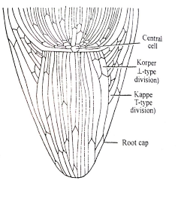

**Fig. 14.** LS of root apex depicting Korper-Kappe zones

**4.3.4 Quiscent Centre Concept**:

This concept was given by Clowes (1958). He studied root apex in *Zea* *mays* and ascertained

the presence a cellular region in between root cap and meristematic cells called as Quiscent

Centre (QC). The cells of QC remain inactive and often do not divide. Unlike the shoot apical

meristems, the root apical meristems which flank the QC produce cells in two dimensions at

its periphery and together produce most of the cells in an adult root. He recognized these cells

as constituent of pro-meristem. At its terminus, the root meristem is covered by the root cap,

which protects and guides its growth trajectory. Cells are continuously shed-off the outer

surface of the root cap. Root apical meristem and tissue patterns are established at the very

embryo stage in the case of the primary root (Fig. 15).

The cells of quiescent centre have lesser DNA, RNA and protein content. These cells

have lesser number of ER and mitochondria. Nucleus and nucleolus are smaller in size. The

QC cells are characterized by their low mitotic activity as they are maintained at the G1/S

checkpoint in the cell cycles. Rate of DNA replication is lesser than those of other cells. QC

acts as a reservoir of root cells to recover whatever is lost or damaged. The QC cells are

pluripotent and are the source of stem cell initials.

The cells of quiescent centre remain inactive till the peripheral cells are in active stage

of division, but start to divide in unfavorable condition, especially when roots are destroyed

somehow and also when secondary roots are formed. They heal the wounds on secondary

roots or damaged portion of the roots. Evidence suggests that the QC maintains the

surrounding cells by preventing their differentiation via signals. The cells of QC actively

divide when exposed to the damaging dose of X-ray while other meristematic cells do not

show such responses. Histogen Theory and Korper-Kappe Theory successfully explain the

organization of root apices except the presence of an independent calyptrogens and four-cell

layered root in monocots. The activity of meristematic tissues enables roots to grow and the

zone of elongation and root hair zone grow. Root cap protects the roots from the damage

posed by positive geotropism. The cells of root cap are impermeable to water while

meristematic cells of root apex have capability to absorb water along with their capacity to

divide. The cells of zone of elongation do not efficiently absorb water while actively absorb **ny**

the ions of mineral elements. The cells of root hair zone are most permeable for water. The cells of zone of maturation are lesser permeable due to the deposition of lignin and suberin.

