**1.1 Meristems**

Almost all tissues starts to divide from some incipient cells, called as meristems or

meristematic cells. Early phased meristematic cells are also called as promeristems or

constructive tissue. Unlike other cells of plants, meristematic cells remain totipotent. They

play an important role in the formation of new tissues and in the correct placement of those

tissues within the plant body. This process is called as pattern formation. These play a pivotal

role in normal plant growth. They are also the source of the regenerative potential of a plant

after injury.

Meristematic cells have following properties: **nt**

**1.** These are found in the vegetative part of the plants.

**2.** They are living (lack non-living substances or inclusions) and of thinner wall (having

primary cell wall only), isodiametric cells.

**3.** The cells are small and their protoplasm fills the cell completely. They have

prominent nucleus (positioned in the centre) and either they lack vacuole or vacuoles

are extremely small. The cytoplasm does not contain differentiated plastids

(chloroplasts or chromoplasts), although they are present in rudimentary form

(proplastids).

**4.** These cells are either dividing or about to divide or have potential to divide.

**5.** They lack intercellular spaces in between them.

**6.** These cells are metabolically more active and grow as long as they are alive.

**2. Classification of Meristematic Tissues**

Meristematic tissues are variously classified, on the basis of their growth, plane of division

and position and function etc.

**2.1 Classification of meristematic tissues on the basis of origin and development:**

On the basis of origin, meristematic tissues have been divided into three categories: **ny**

**(a) Promeristem or primordial meristem:** Promeristem or primordial meristemis

the embryonic stage of developing meristems and represents the primary phase of

the meristem of a growing plant. Promeristems are the young growing points of

meristems, situated on the apices of roots and shoots. They are the sites of active

mitotic division. Promeristem gives rise to primary meristems.

**(b) Primary meristem:** Primary meristems develop from promeristems. Such type of

tissues is found on the apical and intercalary regions of shoots and roots. Their

cells are also in the continuous phase of division. The cells of primary meristems

give rise to primary permanent tissues.

**(c) Secondary meristem:** Initially, these types of tissues are not present but, if

required, develop in the later stages by acquiring potential to divide in some of the

primary permanent tissues, e.g., interfascicular and cork cambium of roots.

Secondary meristems form secondary permanent tissues.

**2.2 Classification of meristematic tissues on the basis of position:**

On the basis of position, meristematic tissues have been divided into three

categories (Fig. 1):

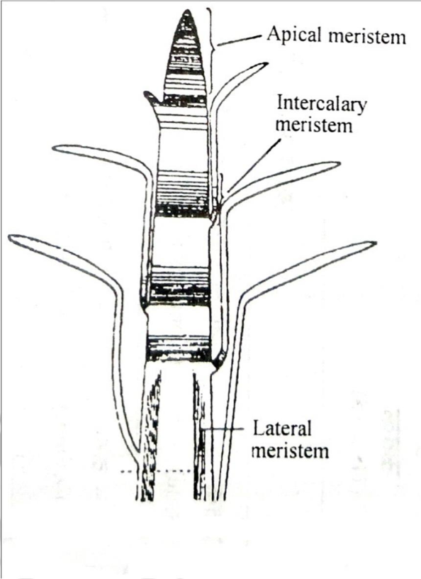

**Fig. 1.** Meristems, according to the position.

**(a) Apical Meristem**

These meristems are situated on the apices of roots and shoots. Roots and shoots

increase in their lengths by the continuous division of these tissues. These meristems

form the growing point on the apices of growing point.

**(b) Intercalary Meristem**

Actually, they are the regions separated from the apical meristems at the time of

growth of the shoot and do not change into permanent tissues and remained included

as meristematic tissues in between permanent tissues. Intercalary meristems are

capable of cell division and allow for rapid growth of many monocots. Intercalary

meristems at the nodes of bamboo promise rapid stem elongation, while those at the

base of most grass leaf blades assure damaged leaves to rapidly grow. Horsetails

(*Equisetum*) and *Mentha* also exhibit intercalary meristems.

**(c) Lateral Meristem:**

These meristems are situated in lateral parts of stems and roots. Lateral meristems are

responsible for the secondary growth in stems and roots increasing their girth. For

example, vascular cambium and cork cambium of the perennial plants, formed after

redifferentiation in permanent tissues.

**2.3 Classification of meristematic tissues on the basis of plane of division**

There are three types of meristems on the basis of plane of division:

**B**

**(a) Mass meristem:** Its cells divide in all directions resulting into irregular

organogenesis. These meristems are seen in primary developmental phase of

embryo and endosperm.

**(b) Plate meristem:** Its cells divide anticlinally (i.e. at an angle of 90º) and form plate

like structure resulting into plate like tissue formation. These meristems are

involved in the formation of epidermis and multiliner blade of flat pinna.

**(c) Rib meristem:** Its cells always divide in anticlinal manner due to which rows of

cells are formed at longitudinal axis. These meristems form pro-meristem to

cortex and pith in roots and stems.

**2.4 Classification of meristematic tissues on the basis of function:**

**(a) Protoderm:** This type of meristem is situated on outer layer and develops into the

epidermis.

**(b) Procambium:** It lies just inside the protoderm and its cells are elongated and form

primary vascular bundles. It develops into primary xylem and primary phloem. It

also produces the vascular cambium, cork cambium and secondary meristems.

The cork cambium further differentiates into the phelloderm (to the inside) and the

phellem, or cork (to the outside). All three layers (cork cambium, phellem and

phelloderm) constitute the periderm. In roots, the procambium can also give rise

to the pericycle, which produces lateral roots in eudicots.

**(c) Ground tissue:** Its cells are comparatively large, thin walled and isodiametric.

Division of these cells gives rise to epidermis, cortex, endodermis, pericycle,

medullary rays and medulla. These meristems are responsible for primary growth,

or an increase in length or height.

**(d) Secondary meristems:** These are also called as the lateralmeristemsbecause

they surround the stem of a plant and stems grow laterally due to their activity

(i.e., enlarge in girth by producing secondary xylem and secondary phloem).

Secondary meristems produce wood in trees and give them arborescent habit.

Secondary meristems do not occur in herbaceous plants. Cork cambium is also a

kind of secondary meristem, which gives rise to the periderm by replacing the

epidermis.