**3. Shoot Apical Meristem (SAM)**

**3.1 Organization of SAM**

In higher plants, the shoot apical meristem (SAM) gives rise to all the above-ground organs.

It is supposed to be the site of organogenesis in flowering plants. It contains all the necessary

information of shoot building and its pattern formation in the form of cell signalling. The

SAM supplies cells that divide and differentiate to form the elements of the shoot. It also

initiates the lateral organ formation and decides their anatomical features and cell division

patterns. Primordia of leaves, sepals, petals, stamens and ovaries are initiated at SAM. First

indication of flower development appears in the form of loss of the apical dominance.

The SAM gives rise to:

**(a) Central zone:** It is located in the center of the SAM and acts as a pool of

undifferentiated, indeterminate cells. Cells of this zone have a stem cell (initial

cell) function and are essential for meristem maintenance. Here the cell division is

less frequent.

**(b) Peripheral zone:** This zone flanks the SAM, its cells divide more frequently and

are incorporated into leaf primordia.

**(c) Rib zone:** It is the proximal region. It supplies the cells that form the body of the

stem.

Although all the tissues of shoot originate from shoot apex, despite of this, the organization

of shoot apical meristem differs from plant to plant.

Different workers tried to explain the structure of organization of apical meristems

differently. Wardlaw (1957) explained following 5 regions in shoot apical meristems

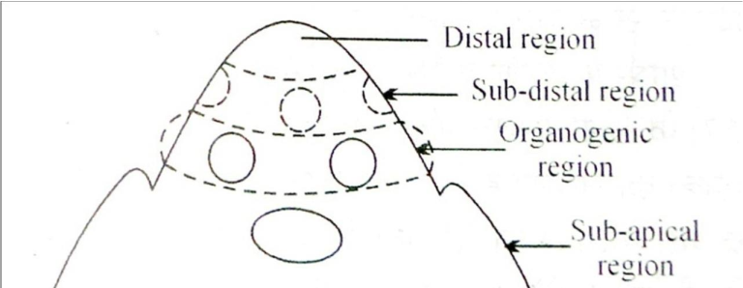

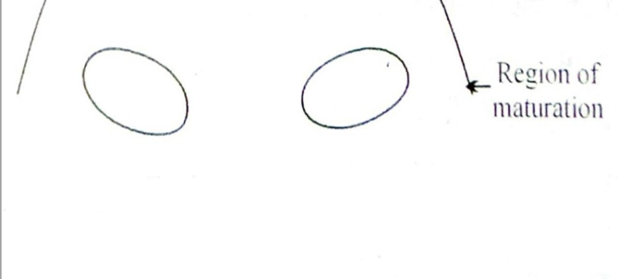

**Fig. 2.** Shoot apex with different regions, after Wardlaw (1957).

**(a) Distal region:** This is the apical most region of SAM and is made of meristematic

cells arranged in one or many rows.

**(b) Sub-Distal region:** It is situated just after the distal region. This is also made of

meristematic cells. Growing points are situated in this very region.

**(c) Organogenic Region:** The process of leaf initiation and tissue differentiation

occurs in this region.

**(d) Sub-apical region:** This region is situated below the organogenic region. Cells of

this region constantly dividing and show cell elongation and cellular

differentiation.

**(e) Region of maturation:** This region is situated below the sub-apical region. All

the cells of this region are mature and neither do they divide or differentiate.

**3.5 Theories related to shoot apex organization**

Multiple theories have been proposed to understand the structure and organization of shoot

apical meristem:

**3.5.1 Apical Cell Theory:**

This theory was proposed by Hofmeister (1957) and elaborated by Nageli (1978). According

to this theory, the apical cell of shoot is always in most active state. Various tissues of shoots

are formed by the activity of this apical cell. Apical cell of the shoot apex also exhibits

differentiation and regulatory function necessary for pattern formation. The apical cell gives

rise to new cells by cutting one or two cells on its posterior face. These cells transform into

tissues in the later stage (Fig. 5).

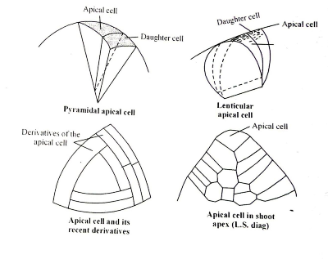

**Fig. 5.** Apical cell of shoot apex

This theory efficiently explains growth and differentiation process in some higher algae,

bryophytes and some pteridophytes, but failed to explain the structure and organization of

shoot apex in phanerogams, i.e. gymnosperms and angiosperms, since the shoot apices of

phanerogams consist of many cells.

**3.5.2 Histogen Theory:**

Hanstein (1970) proposed this theory after studying the shoots and embryos of many

angiosperms. He identified 3 clear-cut regions in shoots and roots (Fig. 6):

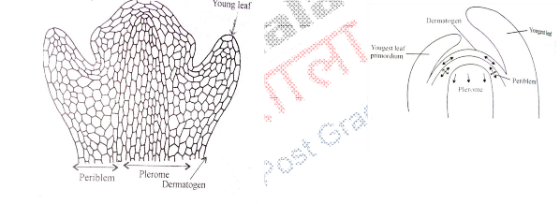

**Fig.6.** LS of shoot apex showing histogen layers (A), LS of shoot apex with histogen

layers wherein arrows indicate direction of growth (B).

**i) Dermatogen**: This is the outermost layer of cells. It forms epidermis of the

stems.

**ii) Periblem**: This region is just below the dermatogens. It is unilayered at apical regions but multilayered at lower regions. Division and differentiation of this region gives rise to hypodermis, general cortex and endodermis.

**iii) Plerome**: This is situated at inner side of periblem and middle part of the

shoot apex. This is made of thin layered isodiametric cells. This forms the stellar tissues, viz. pericycle, primary vascular tissue, medullary rays and medulla. Additionally, it also gives rise to procambium situated at sub-apical region in the shoot.

Plerome in the roots performs the similar function as the plerome in shoots.

Histogen theory is not suitable for the explanation of shoot apex because there is no

clear-cut demarcation between dermatogens and periblem. Thus, histogen theory is used

to explain the growth of the root apices only.

**3.5.3 Tunica** **Corpus** **Theory:**

This theory was proposed by Schmidt in 1924 to explain the apical growing regions of shoots only (and not used to explain the growth of root apices). According to this theory, two regions viz. tunica and corpus are found in shoot apical regions. Tunica comprises one or many outer layers of shoot apex. Cells of tunica region are cut only by anticlinal divisions. Tunica expands the surface of shoot apex, and its outer most layer gives rise to epidermal layer. Tunica covers the corpus wherein cells divide in all directions and volume of the shoot increases (Fig. 7).

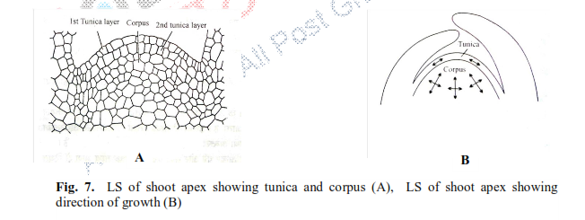

By studying the shoot apex in many angiosperms, it becomes clear that in some special

cases, tunica divides by periclinal divisions also along with anticlinal divisions. In monocots,

the tunica determines the physical characters of the leaf edge and margin. In dicots, corpus

determines the characteristics of the edge of the leaf.

**3.5.5 Histogen Layer Theory:**

Dermen (1947)defied tunica-corpus theory and proposed histogen layer theory. According to this theory, shoot apex of angiosperms is organized in 3 layered structure. They may be called as L-I, L-Iand L-III. According to this theory, epidermis of leaves and stem develop from LI; hypodermis, cortex and some of the vascular bundle regions develop from L-IIwhile vascular tissues and medulla develop from L-III. Organizational form oshoot apex in 3 layers gives this theory a modified version of histogen theory.