**4. Root Apical Meristem (RAM)**

Root apical meristems (RAM) are the sub-apical region of apical portion of the roots wherein

the meristematic cells are situated. They produce different internal tissues of roots. This region has following distinctive features (Fig. 9):

**1.** It is always sub-terminal region because it is covered by the root cap.

**2.** Neither any lateral appendage or branch or their growth zone, e.g. leaf or branch primordia are

attached to the RAM.

**3.** It is smaller than the shoot apex.

**4.** The cells of RAM consistently divide and their activity enables the roots to grow in positively

geotropic and negatively phototropic direction.

**4.1 Organization of Root Apex**

Apical cells of the primary roots are meristematic in nature and they attain the capability to

divide as soon as the embryonal radical forms. The cells of RAM have bigger and prominent

nucleus and have dense cytoplasm, either lack vacuoles or vacuoles are very small. These

cells are either ellipsoidal or polygonal and lack inter-cellular spaces. Their cell walls are thin

and uniform. They divide to form the cells of mature root system. Root apex is either partially

or completely covered with the root cap cells. Root cap cells are fully matured cells which

develop from dermatocalyptrogen in dicot plants and calyptrogen in monocot plants. RAM

gives rise the cells of the main axis of roots and the root cap initial cells. Tissue system

comprised of epidermis, cortex and vascular cylinder is situated behind the root apex (Fig.

10).

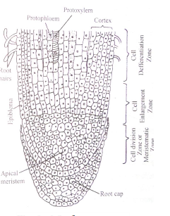

**Botany**

**MFig. 9.** LS of root apex.

**4.3 Theories related to root apex organization**

Multiple theories have been proposed to understand the structure and organization of root

apex:

**4.3.1 Apical Cell Theory:**

This theory was proposed by Hofmeister (1957) and later elaborated by Nageli (1978).

According to this theory, there is a tetrahedral cell in root apex which divides in three planes

producing different tissues of roots. Division in the basal plane of this tetrahedral cell gives

rise to root cap (Fig. 12).

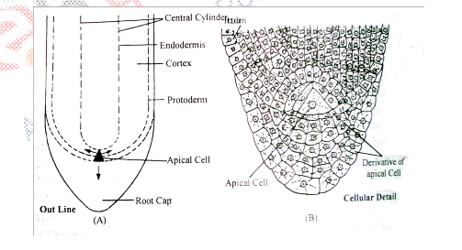

**Fig. 12.** LS of root apex of Ferns, outline (A), cellular details (b).

**4.3.2 Histogen Theory:**

Hanstein (1970) proposed this theory after studying the shoots and embryos of many

angiosperms. He asserted that the meristematic cells of root apex are made of 3 layers exactly

similar to shoot apical meristems. He identified the presence of 3 regions in shoots and roots

(Fig. 13):

**(i) Dermatogen**: This is the outermost layer of the cells of root apex and divide to form new cells. Later it produces tissues consisting smaller cells, called as calyptrogens. Calyptrogen is also a kind of meristematic cell and its activity makes root cap. Dermatogen produces epidermis.

**(ii) Periblem**: This region is just below the dermatogen layer. This region is apical most or middle portion of the root apex. This is single layered at apical portion but becomes multilayered in middle portion. Division and differentiation of this region gives rise to cortical region of the roots.

**(iii) Plerome**: Plerome is the central meristematic part of the apical meristem of the roots. This forms the stelar tissues, some parts of ground tissues like, pericycle, pith rays or medullary ray and pith. These three layers were collectively called as histogen.

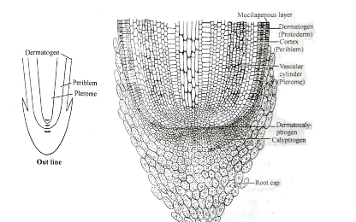

**Fig. 13.** LS of root apex depicting histogens. **Y**

**4.3.3 Korper-Kappe Theory**:

This theory was proposed by Schuepp (1917). According to this theory, the cells of root apex are

divided into two elements. The first division is of transverse type resulting into two cells, out of

which one divides anticlinally, called as T division.

In some of the portions of the root apex,especially in the middle portion ‘T’ is seen upright

while in rest of the regions, inverted T is seen (┴).When ‘T’ is upright, then this is directed towards the apical portion, but, when ‘T’ is inverted, it is directed opposite to the apical portion. Schuepp named upright ‘T’ as Korper or body while inverted ‘T’ was named as Kappy or cap. Such type of division is found in the members of poaceae. This theory is equivalent to the Tunica Corpus Theory of shoot apex (Fig.14).

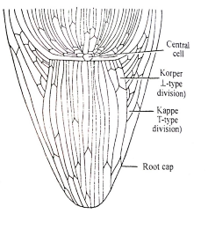

**Fig. 14.** LS of root apex depicting Korper-Kappe zones

**4.3.4 Quiscent Centre Concept**:

This concept was given by Clowes (1958). He studied root apex in *Zea* *mays* and ascertained

the presence a cellular region in between root cap and meristematic cells called as Quiscent

Centre (QC). The cells of QC remain inactive and often do not divide. Unlike the shoot apical

meristems, the root apical meristems which flank the QC produce cells in two dimensions at

its periphery and together produce most of the cells in an adult root. He recognized these cells

as constituent of pro-meristem. At its terminus, the root meristem is covered by the root cap,

which protects and guides its growth trajectory. Cells are continuously shed-off the outer

surface of the root cap. Root apical meristem and tissue patterns are established at the very

embryo stage in the case of the primary root (Fig. 15).

The cells of quiescent centre have lesser DNA, RNA and protein content. These cells

have lesser number of ER and mitochondria. Nucleus and nucleolus are smaller in size. The

QC cells are characterized by their low mitotic activity as they are maintained at the G1/S

checkpoint in the cell cycles. Rate of DNA replication is lesser than those of other cells. QC

acts as a reservoir of root cells to recover whatever is lost or damaged. The QC cells are

pluripotent and are the source of stem cell initials.

The cells of quiescent centre remain inactive till the peripheral cells are in active stage

of division, but start to divide in unfavorable condition, especially when roots are destroyed

somehow and also when secondary roots are formed. They heal the wounds on secondary

roots or damaged portion of the roots. Evidence suggests that the QC maintains the

surrounding cells by preventing their differentiation via signals. The cells of QC actively

divide when exposed to the damaging dose of X-ray while other meristematic cells do not

show such responses. Histogen Theory and Korper-Kappe Theory successfully explain the

organization of root apices except the presence of an independent calyptrogens and four-cell

layered root in monocots. The activity of meristematic tissues enables roots to grow and the

zone of elongation and root hair zone grow. Root cap protects the roots from the damage

posed by positive geotropism. The cells of root cap are impermeable to water while

meristematic cells of root apex have capability to absorb water along with their capacity to

divide. The cells of zone of elongation do not efficiently absorb water while actively absorb **ny**

the ions of mineral elements. The cells of root hair zone are most permeable for water. The cells of zone of maturation are lesser permeable due to the deposition of lignin and suberin.

