

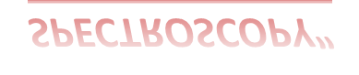

“INFRARED ABSORPTION
SPECTROSCOPY”
INTRODUCTION

Spectroscopy

Absorption spectroscopy
Emission spectroscopy

UV
spectroscopy

Fluorimetry

IR
spectroscopy
Flame photometery



NMR
spectroscopy

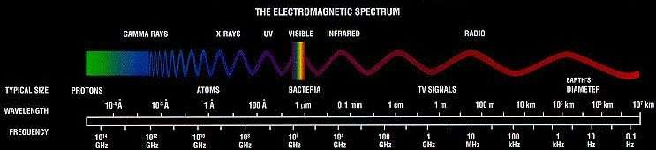

- Infrared spectroscopy (IR spectroscopy) is
the spectroscopy that deals with the infrared region of the electromagnetic spectrum, that is light with a longer wavelength and lower frequency than visible light
- Infrared Spectroscopy is the analysis of infrared light interacting with a molecule.
- It is based on absorption
spectroscopy

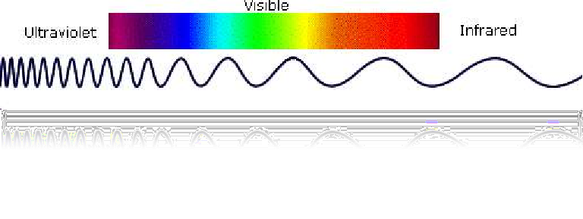

INFRARED REGIONS | RANGE
Near infrared region | 0.8-2.5 µ(12,500-4000 cm-1)
Main infrared region | 2.5-15 µ(4000-667cm-1)
Far infrared region | 15-200 m µ(667-100 cm-1)

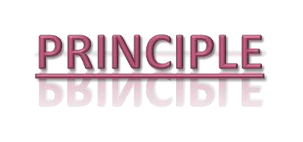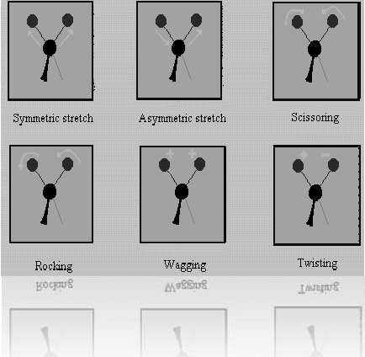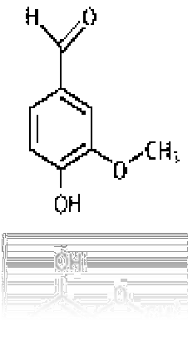

 When infrared 'light' or radiation hits a molecule, the bonds in the molecule absorb the energy of the infrared and respond by vibrating.

IR
radiation

vanllin
Molecular vibrations

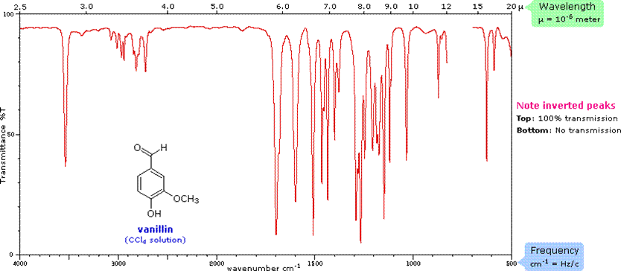

MOLMMMMMMMMM
Molecular Vibrations

MOLECULAR
VIBRATIONS

Fundament al Vibrations
Non- fundamental Vibrations

Stretchin g Vibration
Bending
Vibration

Over Tones,
Combination
Tones,
Fermi

Symmetri Asymmetri c c
In-plane Bending
Out Of Plane Bending
Resonance

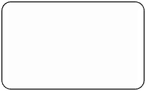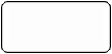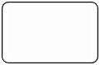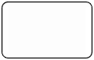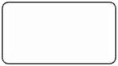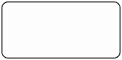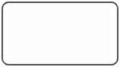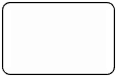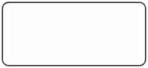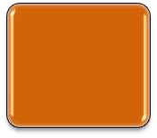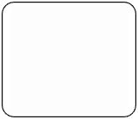Scissorin
g
Rocking
Wagging Twisting

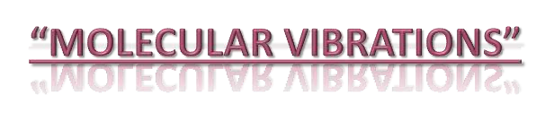

What is a vibration in a molecule?

“Any change in shape of the molecule- stretching of bonds, bending of bonds, or internal rotation around single bonds”.

Why we study the molecular vibration?
Because whenever the interaction b/w electromagnetic waves & matter occur so change appears in these vibrations.

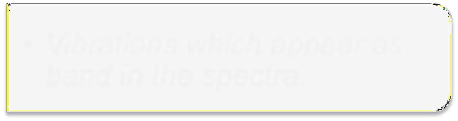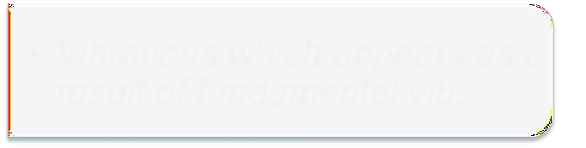Mol. vibration divided into 2 main types:

FUNDAMENTAL
VIBRATIONS

Vibrations which appear as band in the spectra.

NON- FUNDAMENTAL VIBRATIONS

Vibrations which appears as a result of fundamental vib.

Fundamental vibration is also divided into types:

STRETCHING
VIB.
- Streching vibration Involves a continuous change in the inter atomic distance along the axis of the bond b/w 2 atoms.
- It requires more energy so appear at shorter wavelength.
BENDING
VIB.

- Bending vibrations are characterized by a change in the angle b/w two bonds.
- It requires less energy so appear at longer wavelength.

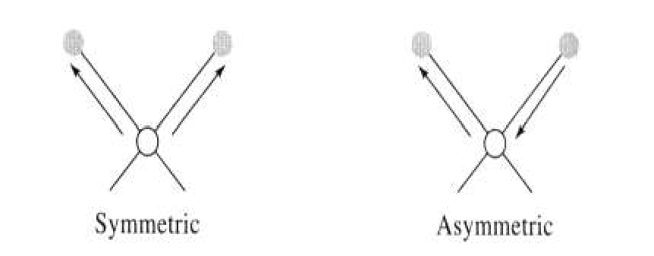
- Inter atomic distance b/w 2 atoms is alternate/opposite.
ASYMMETRIC VIB.
- Inter atomic distance b/w 2 atoms increases/decreases.
SYMMETRIC VIB.

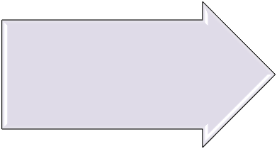
IN PLANE BENDING
- If all the atoms are on same plane.

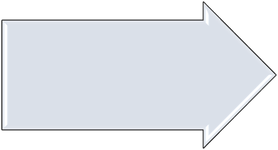OUT OF PLANE BENDING

If 2 atoms are on same plane while the 1 atom is on opposite plane.

SCISSORING: ROCKING:

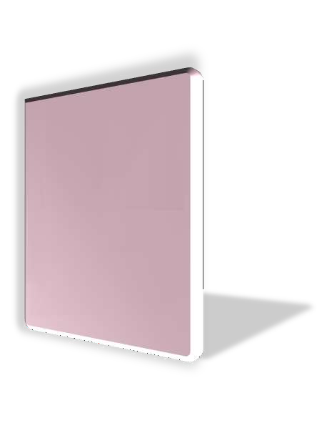When 2 atoms move away or close towards each other.
Change in angle b/w a group of atoms.

  - Change in angle b/w the plane of a group of atom

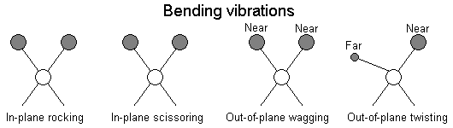WAGGING
TWISTING
- Change in angle b/w the plane of 2 groups of atoms.

OVER TONES:
These are observed at twice the frequency of strong band.
Ex: carbonyl group.
COMBINATION TONES:
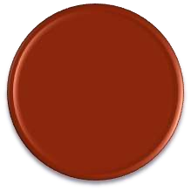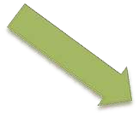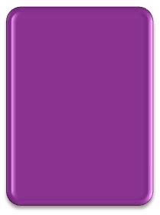Weak bands that appear occasionally at frequencies that are sum/difference of 2 or more fundamental bands.

FERMI RESONANCE:
Interaction b/w fundamental vibration & overtones or combination tones.
Ex:CO2



NON- FUNDAMENTAL

Coupled Interactions And Factors”



Interactions between vibrations can occur (Coupling) if the vibrating bonds are joined to a single, central atom.
This is because there is mechanical coupling interaction between the oscillators.
Example:
C=O (both symmetric and asymmetric stretching vibrations)

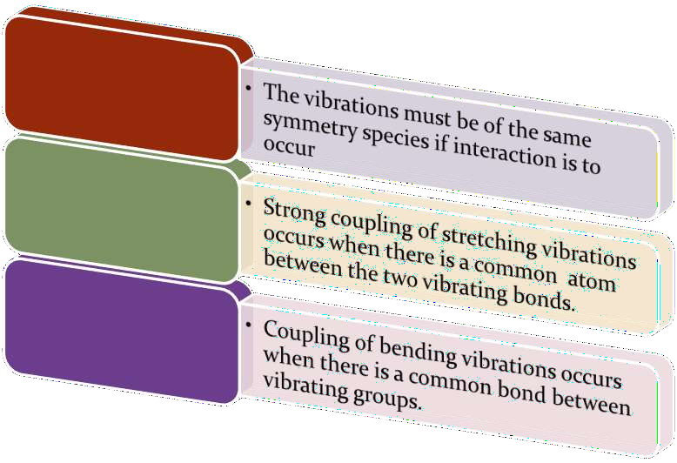

  - 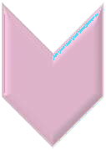Coupling is greatest when the coupled groups have approximately equal energies

  - Coupling between a stretching vibration and a bending vibration occurs if the stretching bond is one side of an angle varied by bending vibration.

  - No coupling is seen between groups separated by two or more bonds

c
C c c
Less coupling no coupling

Greater coupling

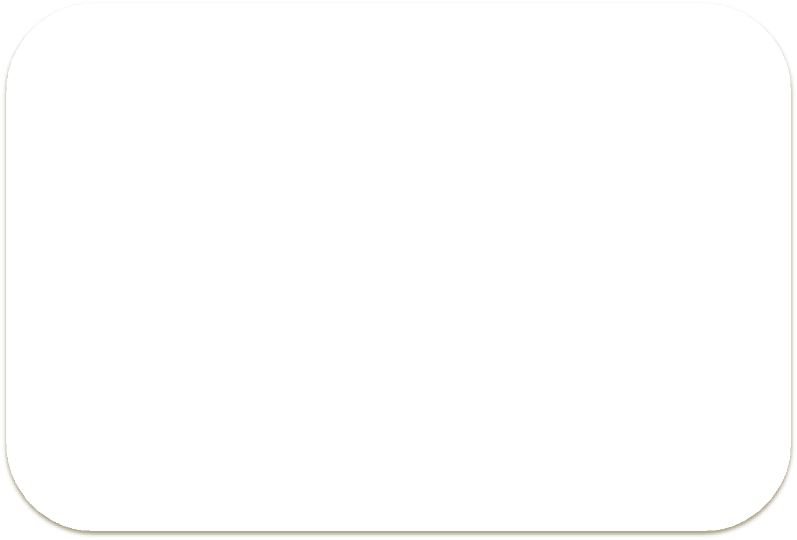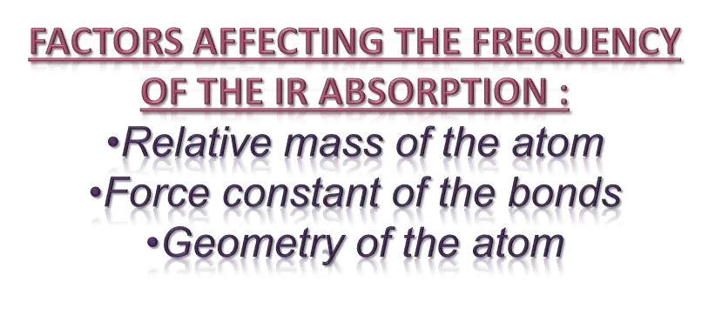


THE RELATIVE MASS OF THE
ATOMS: heavier the atoms lower is the vibration frequency of the bond between them.

THE FORCE CONSTANT OF
THE BONDS: Stronger the bond higher is the vibration frequency.

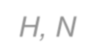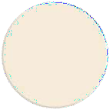
Stronger bonds O-H, N-H & C-H weaker bonds C-C & C-O bond.

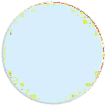
EFFECTS OF BONDS: C=C stretching is expected to absorb at a higher frequency than C-C stretching.

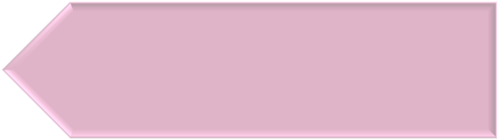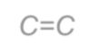

Example: C≡C 2200cm-1 C=C 1650cm-1
C-C 1200cm-1

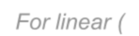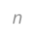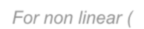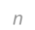
Fundamental vibration of molecule depend on degree of freedom

Each atom has 3 degree of freedom depend on x , y ,z

For a molecule containing n number of atom s has 3n degree of freedom

For non linear molecule 3 degree of freedom represent rotational &
transational motion

For non linear (3n-6)degree of freedom represent fundamental vibrations

For linear (3n-5)degree of freedom represent fundamental vibrations


All vibrational changes don’t appear as
band
Only those vibrational changes that result in change in dipole movement appear as band



It gives the relation between frequency of oscillation , atomic mass , force constant of the bond .
- 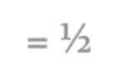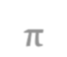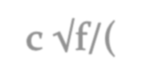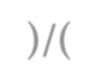Thus vibrational frequency is

- C = velocity of light
- F = force constant
- Mx= mass of atom x
- My = mass of atom y

- Since force constant measures the strength of bond, value of f is

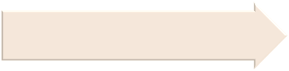FOR SINGLE BOND
FOR DOUBLE BOND
FOR TRIPLE BOND
- 5×10⁵ dynes/cm

- 10×10⁵ dynes /cm

- 15×10⁵ dynes/cm

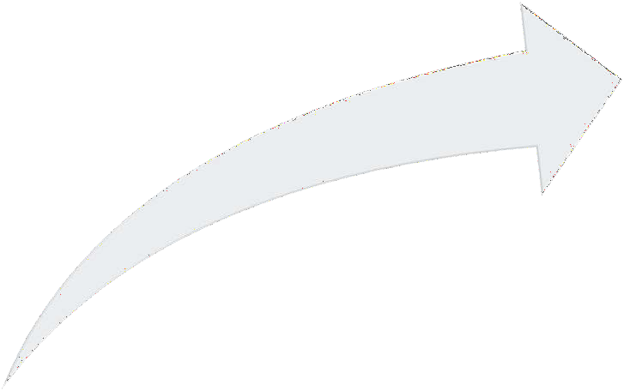Factors On Which Vibrational Frequency Depends:

BOND STRENGTH
ATOMIC MASS

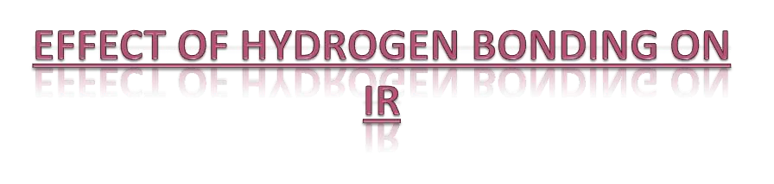

Proton Donor Group (S-Orbital )

Proton Acceptor Group (P-Orbital)

Hydrogen Bonding

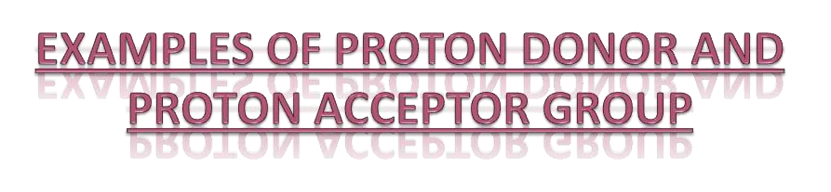

Proton Donor Group
Carboxyl, Hydroxyl, Amine Or Amide Group

Proton Acceptor Group
Oxygen, Nitrogen, Halogens And Unsaturated Group



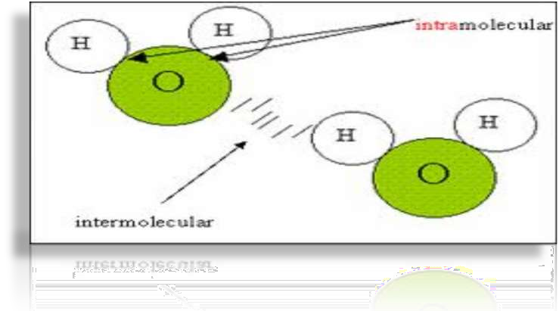
1-Intermolecular Hydrogen Bonding 2-Intramolecular Hydrogen Bonding

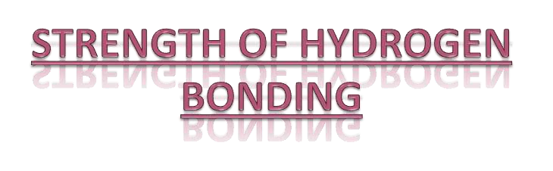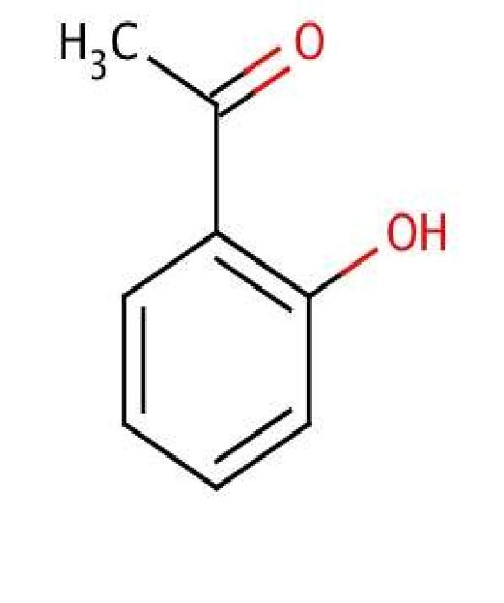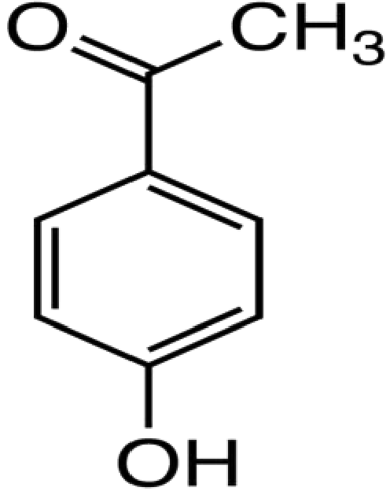

Collinear
Non-linear

P-Hydroxyacetophenone o-Hydroxyacetophenone

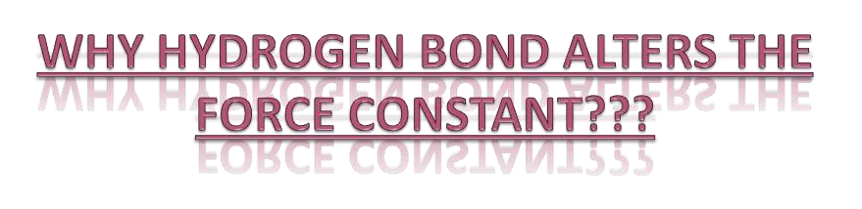

Stretching bands move towards longer wavelength or lower frequencies And Bending vibrations shift towards Shorter wavelength or Higher frequencies.

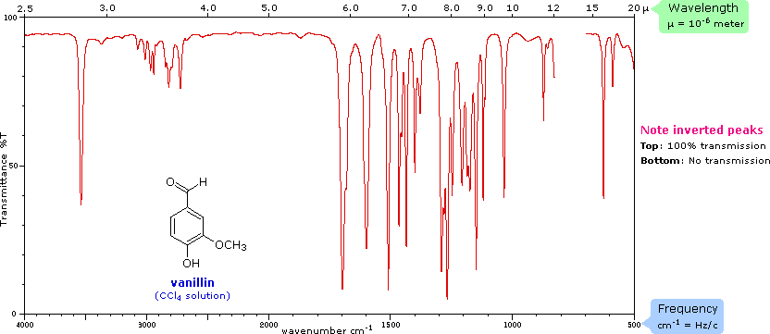Bending vibrations Stretching vibrations

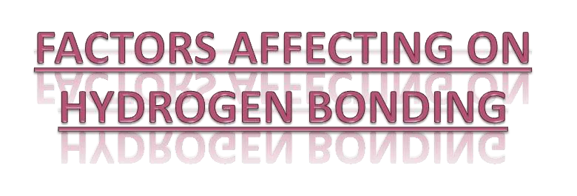

- Temperature
- Concentration
- Molecular Geometry
- Relative Acidity
- Basicity

“Instrumentation”



The main parts of IR spectrometer are as follows:

radiation source
- sample cells and sampling of substances
- monochromators
- detectors
- recorder

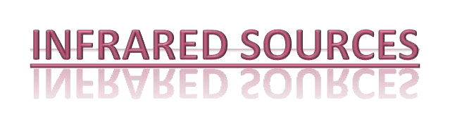
IR instruments require a source of radiant energy which emit IR radiation which must be:


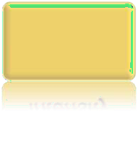
Sufficient intensity

Continuous

Stable

Sources of IR radiations are as follows:
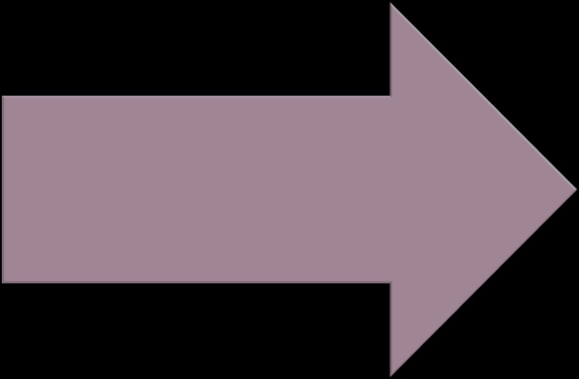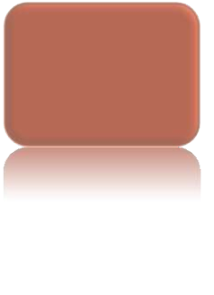GLOBAR:

Rod of silicon carbide
Heated up to 1300 degree centigrade
Produce radiant energy from 1-40 micron

 NERNST GLOWER:

Rod of zirconium and yittrium
Heated up to 1500 degree centigrade
Emits radiation between 0.4-
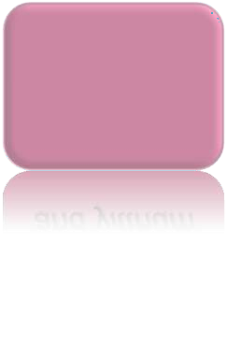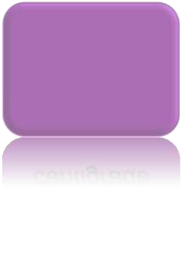20 micron.

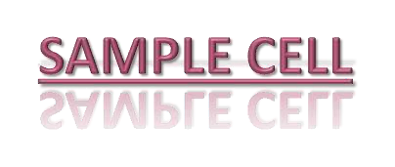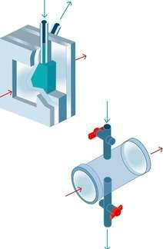

  - For gas samples:
The spectrum of a gas can be obtained by permitting the sample to expand into an evacuated cell, also called a cuvette.
  - For solution sample:
Infrared solution cells consists of two windows
of pressed salt sealed. Samples that are liquid at
room temperature are usually analyzed in pure
form or in solution. The most common solvents are
Carbon Tetrachloride (CCl4) and Carbon Disulfide
(CS2).

 For solid sample:

Solids reduced to small particles (less than 2 micron) can be examined as a thin paste or mull. The mull is formed by grinding a 2-5 milligrams of the sample in the presence of one or two drops of a hydrocarbon oil (nujol oil). The resulting mull is then examined as a film between flat salt plates.

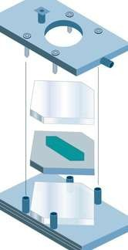Another technique is to ground a milligram or less of the sample with about 100 milligram potassium bromide. The mixture is then pressed in an evaluable die to produce a transparent disk.



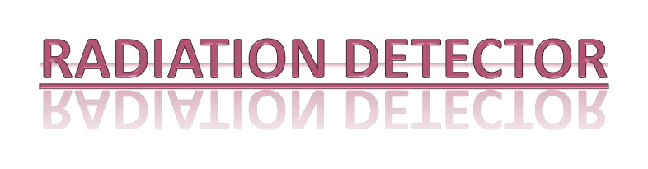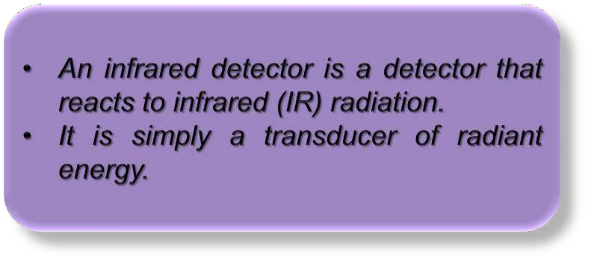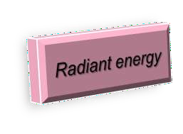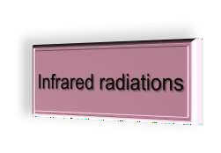



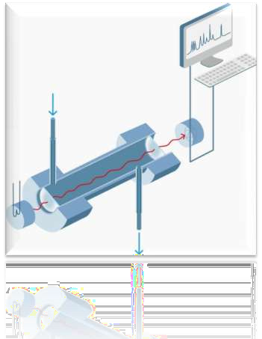
Detector

Thermal Non-thermal

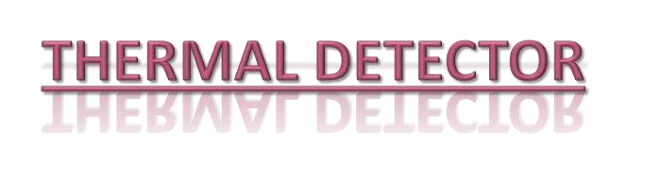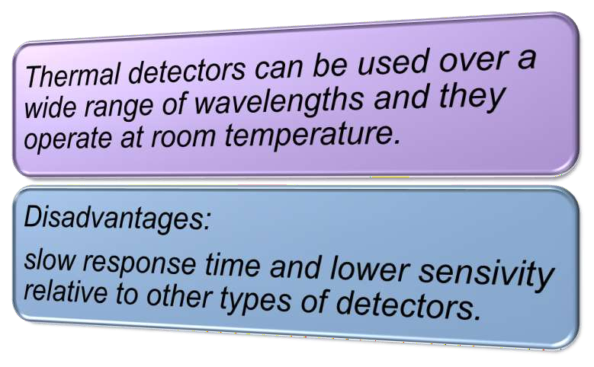



There are four types of thermal detector.
    - Bolometers
    - Thermocouple and thermopile
    - Pyro electric detector
    - Golay cell

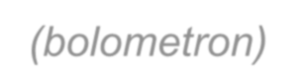

Bolometer is derived from a Greek word
(bolometron)
Bolo = for something thrown Metron = measure

Construction
- A bolometer consists of an absorptive element, such as a thin layer of metal.
- Most bolometers use semiconductor or superconductor absorptive elements rather than metals.

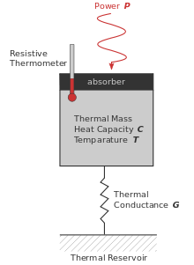Working

Thin layer of metal connected to a reservoir

Any radiation on the absorptive element raises its temperature above that of the reservoir.

The temperature change can be measured directly with an attached thermometer.

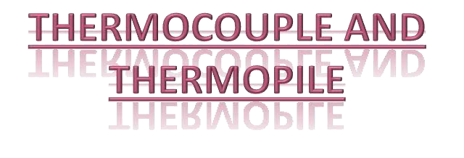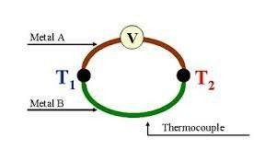

Thermocouples consist of a pair of junctions of different metals; for example, two pieces of bismuth fused to either end of a piece of antimony.

Temperature changes Potential difference changes

Thermopile detectors are voltage-generating devices, which can be thought of as miniature arrays of thermocouple junctions.

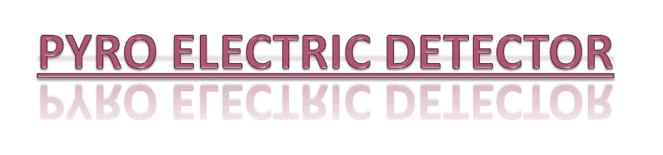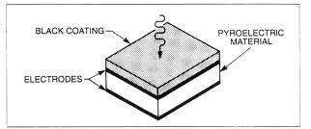

Construction:
  - Single crystalline wafer of a pyro electric material, such as triglycerine sulphate.
  - Pyro electric Infrared Detectors (PIR) convert the changes in incoming infrared light to electric signals.

Below curie temperature


Pyro electric materials exhibit electrical polarization.


Temperature is altered, the polarization changes.

Observed as an electrical signal
(if electrodes are placed on opposite faces of a thin slice of the material to form a capacitor)



Construction:
- Small metal cylinder
- Flexible silvered diaphragm
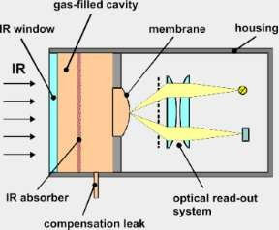
- Whole chamber is filled with xenon gas.


Metal cylinder and flexible diaphragm

Temperature increases


Gas is expended and diaphragm deforms

detect as a signal

Thin film overlaps over non- conducting surface

Absorption of IR radiation
Non conducting valence e- to higher energy conducting state

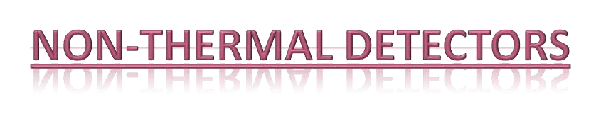



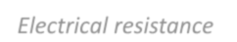

Voltage drops

Electrical resistance
decreases

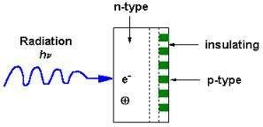

Infrared radiations


Photovoltaic detector

Generates a small voltage


Detected as a signal

“Single/Double Beam
IR Absorption Spectrophotometers”

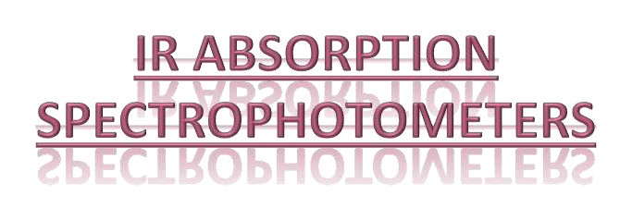SINGLE BEAM SPCETROPHOTOMETER
 A single beam of light , which can pass through one solution at a time (sample or reference).
DOUBLE BEAM SPECTROPHOTOMETER
- A single beam of light splits into two separate beams.
One passes through the sample, another passes through the reference.

Radiation Source
Sample Cell

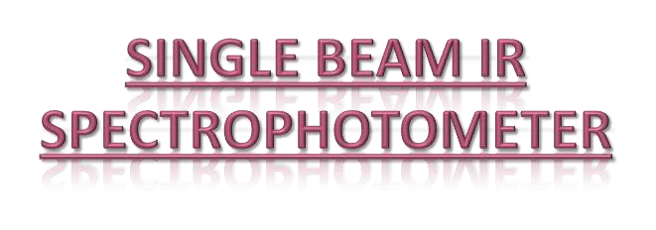Mono- chromator
Detector

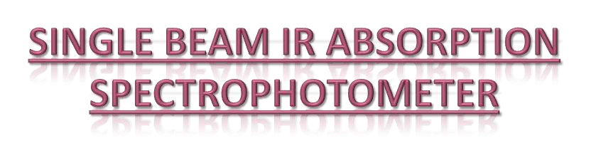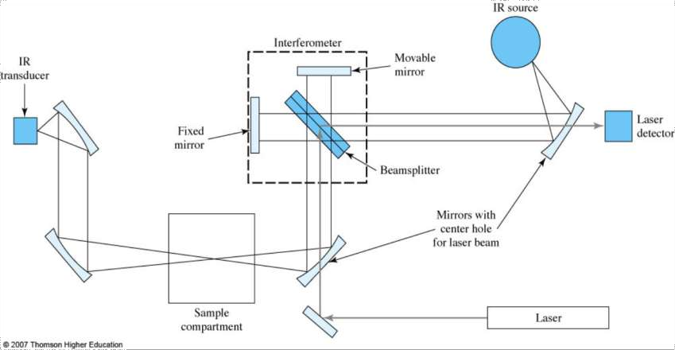

Radiation
Source
Attenuator Synchronous

Sample & Reference Compartment

Monochromator
rectifier
Synchronous motor

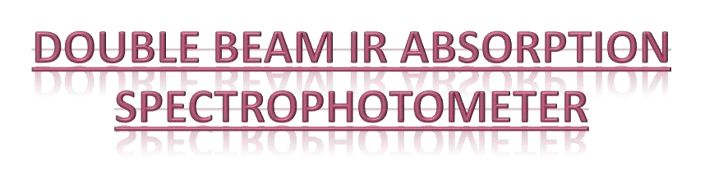Chopper Detector
Attenuator &
recorder

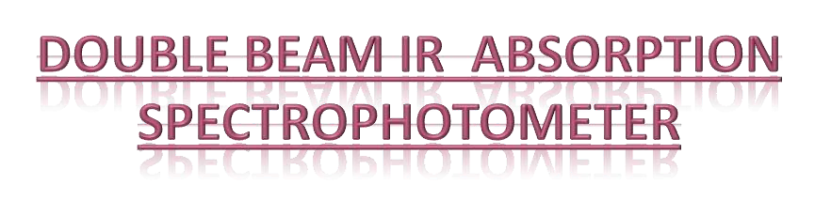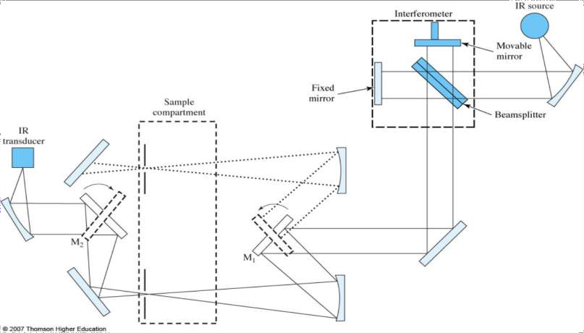

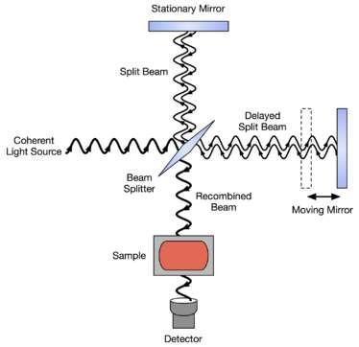


- All frequencies are examined simultaneously in Fourier transform infrared (FTIR) spectroscopy.

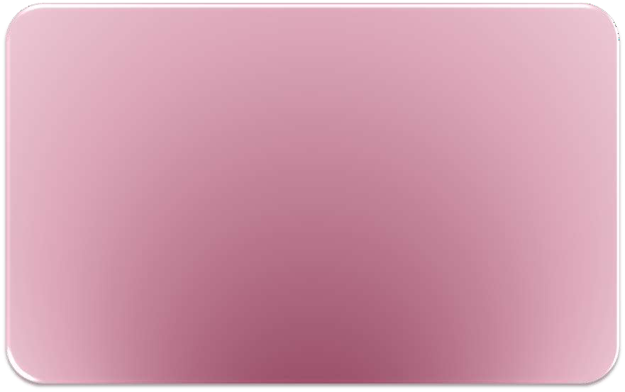Since different molecules with different combination of atoms produce their unique spectra, infrared spectroscopy can be used to qualitatively identify substances.



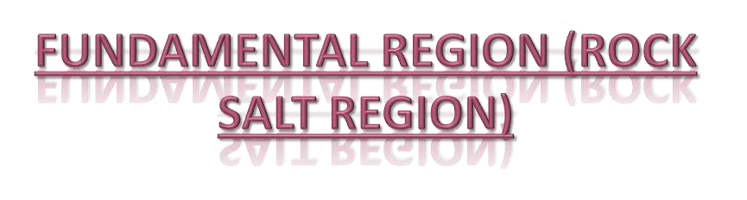Group Frequency Region
 consisting of the absorption bands of the functional
groups.
 frequency = 4000-1300cm-¹
- wavelength = 2.5-8

Fingerprint Region

- IR spectra is called “fingerprints” because no other chemical species will have similar IR spectrum.
- Single bonds give their absorption bands in this region.
- Frequency=1300-650cm-1
- Wavelength=8-15.4

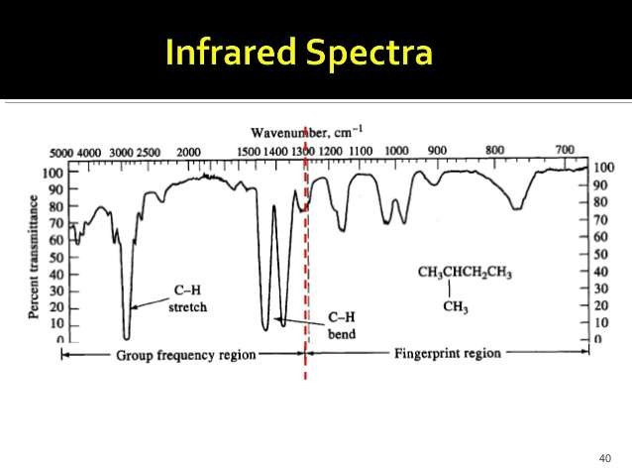



Organic groups differ from one another both in the strength of the bond and the masses of the atom involved.

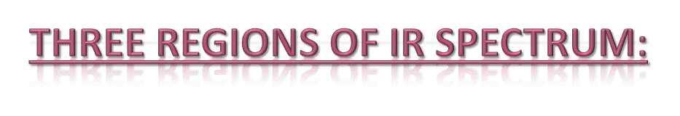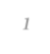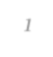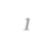

    - 4000 and 1300 cm-¹
    - Alcohols and amines

    - 1300 and 909 cm-¹
    - Complex interactions

    - 909 and 65o cm-¹
    - Benzene rings

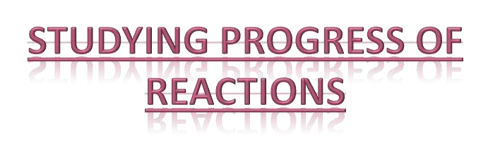

  - Observing rate of disappearance of characteristic absorption band in reactants; or
  - Rate of increasing absorption bands in products of a particular product.
 E.g.: O—H = 3600-3650 cm-¹ C=O = 1680-1760 cm-¹

