**PHASE EQUILIBRIUM**

For a system at equilibrium the phase rule relates:

P = number of phases that can coexist, to C = number of components making up the phases, and F = degrees of freedom. Where these three variables are related in the equation P + F = C + 2 The degrees of freedom represent the environmental conditions which can be independantly varied without changing the number of phases in the system. Conditions include: Temperature, Pressure, Chemical Composition, Oxygen Fugacity ,etc .

**SYSTEM:** An assemblage of materials that is isolated in some manner from rest of the universe.

* isolated system:one that does not exchange matter or energy with its surroundings.
* closed system: one that exchanges only energy with its surroundings.
* open system: one that exchanges both matter and energy with its surroundings.
* adiabatic system: a system with changes in energy caused only by a change in volume as pressure changes.

**EQUILIBRIUM:** The lowest energy state of a system in which there is no tendency for a spontaneous change.

Metastable Equilibrium: state of a system which is not in its lowest energy state at the imposed conditions, but cannot spontaneously change due to high activation energy for change. All chemical reactions are broadly classified into 2 types:

1) Irreversible Reactions : Zn + H2SO4 −−−−−> ZnSO4 + H2↑

2) Reversible reactions: The reversible reactions are represented by double arrows in the opposite directions. The homogeneous reversible reactions can be studied by the law of mass action and the heterogeneous reversible reactions using the phase rule, given by Willard Gibbs (1874) which is defined as

(a) Homogeneous reversible reactions Eg: N2(g ) + 3H2(g) 2NH3(g)

(b) Heterogeneous reversible reactions Eg: CaCO3(s) CaO(s) + CO2(g)

**PHASE RULE:** If the equilibrium between any numbers of phases is not influenced by gravitational/electrical/ magnetic forces but is influenced by pressure, temperature and concentration, then the number of degrees of freedom (F) is related to the number of components (C) and the number of phases (P) as: F = C − P + 2

Explanation of terms with examples

PHASE (P): PHASE is defined as, ―any homogeneous physically distinct and mechanically separable portions of a system which is separated from other parts of the system by definite boundaries.

a) Gaseous phase (g): All gases are completely miscible and have no boundaries between them. Hence all gases constitute a single phase. Eg: Air, a mixture of O2, H2, N2, CO2 and water vapor, etc., constitutes a single phase.

b) Liquid Phase (l): The number of liquid phases depends on the number of liquids present and their miscibilities.

(i) If two liquids are immiscible, they will form two separate liquid phases. (e.g.) Benzene – Water system.

(ii) If two liquids are completely miscible, they will form only one liquid phase. (e.g.) Alcohol - Water system.

c) Solid Phase (s): Every solid constitutes a separate single phase. (e.g.) Decomposition of CaCO3

CaCO3(s) CaO(s) + CO2(g)

It involves 3 phases namely solid CaCO3, solid CaO and gaseous CO2

Other examples:

1) A water system has 3 phases namely one solid, one liquid and one gaseous phase. Ice(s) Water(l) Vapour(g)

2) A solution of a substance in a solvent constitutes only one phase. (e.g.) Sugar solution in water.

3) An emulsion of oil in water forms two phases

4) MgCO3 (s) → MgO (s) + CO2 (g) It involves 3 phases, solid MgCO3, solid MgO and gaseous CO2.

5) Rhombic sulphur (s) −−−−> Monoclinic sulphur (s). It forms 2 phases.

6) Consider the following heterogeneous system. CuSO4(s) + 5H2O(l) → CuSO4.5H2O(s) It involves 3 phases namely, 2 solids and 1 liquid phase.

COMPONENT (C): Component is defined as, ―the minimum number of independent variable constituents, by means of which the composition of each phase can be expressed in the form of a chemical equation. Examples:

(a) Consider a water system consisting of three phases. Ice(s) Water(l) Vapour(g) The chemical composition of all the three phases is H2O. Hence the number of component is one.

(b) Sulphur exists in 4 phases namely rhombic, monoclinic, liquid and vapour, but the chemical composition is only sulphur. Hence it is a one component system.

(c) Thermal decomposition of CaCO3 : CaCO3(s) → CaO (s) + CO2(g) The system has 3 phases namely, solid CaCO3, solid CaO and gaseous CO2 and 2 components, as the composition of each of the above phases can be expressed as equations considering any two of the three components present. When CaCO3 and CaO are considered as components, the chemical equations are:

|  |  |
| --- | --- |
| **Phase** | **Components** |
| CaCO3 | CaCO3 + 0CaO |
| CaO | 0CaCO3 + CaO |
| CO2 | CaCO3 − CaO |

(d) PCl5(s) → PCl3(l) + Cl2(g) This system has 3 phases and 2 components namely, PCl3 and Cl2.

(e) An aqueous solution of NaCl is a two component system. The constituents are NaCl and H2O.

(f) CuSO4. 5H2O(s) → CuSO4. 3H2O(s) + 2H2O(g) It is also a two component system as components are CuSO4.3H2O and H2O.

(g) In the dissociation of NH4Cl , the following equilibrium occurs.

NH4Cl (s) → NH3 (g) + HCl (g) The system consists of 2 phases namely solid NH4Cl and the gaseous mixture containing NH3 + HCl. When NH3and HCl are present in equivalent quantities the composition of both the phases can be represented by NH4Cl and hence the system will be a one component system.

DEGREE OF FREEDOM (F): Degree of freedom is defined as, the minimum number of independent variable factors like temperature, pressure and concentration, which must be fixed in order to define the system completely‖. A system having 1, 2, 3 or 0 degrees of freedom are called as univariant, bivariant, trivariant and non-variant systems respectively. Examples:

(a) Consider the following equilibrium Ice(s) Water(l) Vapour(g) These 3 phases will be in equilibrium only at a particular temperature and pressure. Hence, this system does not have any degree of freedom, so it is non-variant (or) zero-variant (or) in-variant system.

(b) Consider the following equilibrium Liquid Water(l) Water- vapour(g) Here liquid water is in equilibrium with water vapour. Hence any one of the degrees of freedom such as temperature (or) pressure has to be fixed to define the system. Therefore the degree of freedom is one.

(c) For a gaseous mixture of N2 and H2, both the pressure and temperature must be fixed to define the system. Hence, the system is bivariant.

**PHASE DIAGRAM:** Phase diagram is a graph obtained by plotting one degree of freedom against theother. Types of Phase Diagrams

1. P-T Diagram If the phase diagram is plotted between temperature and pressure, the diagram is called P -T diagram. P -T diagram is used for one component system.
2. T-C Diagram If the phase diagram is plotted between temperature and composition, the diagram is called T-C diagram. T- C diagram is used for two component system Uses of Phase Diagram: It helps in
   * 1. Predicting whether an eutectic alloy (or) a solid solution is formed on cooling a homogeneous liquid containing mixture of two metals.
     2. Understanding the properties of materials in the heterogeneous equilibrium system.
     3. Studying of low melting eutectic alloys, used in soldering.

**ONE COMPONENT SYSTEM**

**APPLICATIONS OF PHASE RULE - TO ONE COMPONENT SYSTEM**

1. **THE WATER SYSTEM**: Water exists in 3 possible phases, namely solid ice, liquid water and water-vapour. Hence, there can be three forms of equilibria, each involving two phases such as. Solid Ice Liquid Water Liquid Water Water- vapour Solid Ice Water- vapour The phase diagram for the water system is as follows and it contains curves, areas, and triple point.

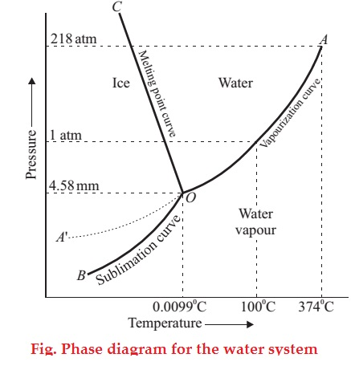

Curve OA: The curve OA is called vapourisation curve, it represents the equilibrium between water and vapour. At any point on the curve the following equilibrium will exist. Liquid Water Water- vapour This equilibrium (i.e. line OA) will extend upto the critical temperature (374°C). Beyond the critical temperature the equilibrium will disappear and only water vapour will exist

Curve OB: The curve OB is called sublimation curve of ice, it represents the equilibrium between solid ice and water-vapour. At any point on the curve the following equilibrium will exist. Solid Ice Water- vapour This equilibrium (i.e.line OB) will extend up to the absolute zero (− 273°C) Beyond absolute zero only solid ice will exist and no water-vapour.

Curve OC: The curve OC is called melting point curve of ice, it represents the equilibrium between ice and water. At any point on the curve the following equilibrium will exist. Solid Ice Liquid Water The curve OC is slightly inclined towards pressure axis. This shows that melting point of ice decreases with increase of pressure.

Curve OB′ (Metastable Equilibrium): The curve OB′ is called vapour pressure curve of the super-cooled water (or) metastable equilibrium where the following equilibrium will exist. Super- cooled water Water- vapour Sometimes water can be cooled below it’s freezing point (0°C) without the formation of ice, this water is called super-cooled water. Super cooled water is unstable and it can be converted into solid ice by ―seeding‖ (or) by slight disturbance.

Along the curves OA,OB,OC and OB′ The no. of phases(P) is 2 ,component(C) is 1 and the degree of freedom of the system is one i.e., univariant. This is predicted by the phase rule: F = C − P + 2; F = 1 − 2 + 2; F = 1 Therefore, either temperature (or) pressure must be fixed to define the system.

Point ‘O’ (Triple point): The three curves OA, OB and OC meet at a point „O‟, where three phases namely solid ice, liquid water and water-vapour are simultaneously at equilibrium. This point is called triple point, at this point the following equilibrium will exist Ice(s) Water(l) Vapour(g) At this point the no. of phases(P) is 3, component(C) is 1 and the degree of freedom of the system is zero i.e., nonvariant. This is predicted by the phase rule: F = C − P + 2; F = 1 − 3 + 2; F = 0 This takes place only at a constant temperature (0.0075°C) and pressure (4.58 mm of Hg). Areas Areas AOC, BOC, AOB represents liquid water, solid ice and water-vapour respectively where the no. of phases(P) and component(C) are one. Hence the degree of freedom of the system is two i.e., bivariant. This is predicted by the phase rule: F = C − P + 2; F = 1 − 1 + 2; F = 2 Therefore, both temperature and pressure must be fixed to define the system at any point in the areas.

1. **THE SULPHUR SYSTEM:** It is a one-component, four-phase system. The four phases are :
2. Two solid polymorphic forms : (i) Rhombic Sulphur (SR) (ii) Monoclinic Sulphur (SM)
3. Sulphur Liquid (SL)
4. Sulphur Vapour (SV)

All the four phase can be represented by the only chemical individual sulphur itself and hence one component of the system. The two crystalline forms of sulphur SR and SM exhibit enantiotropy with a transition point at 95.6ºC. Below this temperature SR is stable, while above it SM is the stable variety. At 95.6ºC each form can be gradually transformed to the other and the two are in equilibrium. At 120ºC, SM melts. Thus, The phase diagram for the sulphur system is shown in Fig. The salient features of the phase diagram are described below.

1. The six curves AB, BC, CD, BE, CE, EG
2. The three Triple points B, C, E
3. The four areas :
   1. ABG marked solid Rhombic
   2. BEC marked solid Monoclinic
   3. GECD marked liquid Sulphur
   4. ABCD marked Sulphur vapour

Let us now proceed to discuss the significance of these features :

The curves AB, BC, CD, BE, CE, EG These six curves divide the diagram into four areas.

Curve AB, the Vapour Pressure curve of SR. It shows the vapour pressure of solid rhombicsulphur (SR) at different temperatures. Along this curve the two phases S R and sulphur vapour (SV) are in equilibrium. The system SR/SV has one degree of freedom, F = C – P + 2 = 1 – 2 + 2 = 1 i.e., it is monovariant.

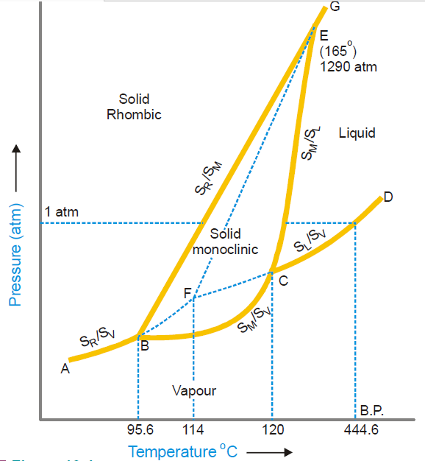

Curve BC, the Vapour Pressure curve of SM.It shows variation of the vapour pressure ofmonoclinic sulphur (SM) with temperature. SM and SV coexist in equilibrium along this curve. The system SM/SV is monovariant.

Curve CD, the Vapour Pressure curve of SL. It depicts the variation of the vapour pressure ofliquid sulphur (SL) with temperature. SL and SV are in equilibrium along CD. The two phase system SL/SV is monovariant. One atmosphere line meets this curve at a temperature (444.6ºC) which is the boiling point of sulphur.

Curve BE, the Transition curve. It shows the effect of pressure on the transition temperature for SR and SM. As two solid phases are in equilibrium along the curve, the system SR/SM is monovariant. The transformation of SR and S M is accompanied by increase of volume (density of SR = 2.04; SM = 1.9) and absorption of heat i.e., Thus the increase of pressure will shift the equilibrium to the left (Le Chatelier’s Principle) and the transition temperature will, therefore, be raised. This is why the line BE slopes away from the pressure axis showing thereby that the transition temperature is raised with increase of pressure.

Curve CE, the Fusion curve of SM. It represents the effect of pressure on the melting point of SM.The two phases in equilibrium along this curve are SM and SL. The system SM/SL is monovariant. As the melting or fusion of SM is accompanied by a slight increase of volume, the melting point will rise by increase of pressure (Le Chatelier’s principle). Thus the curve CE slopes slightly away from the pressure axis. The curve ends at E because SM ceases to exist beyond this point.

Curve EG, the Fusion curve for SR. Here the two phases in equilibrium are SR and SL. Thenumber of phases being two, the system SR/SL is monovariant. 2 The Triple points B, C, E Triple point B. This is the meeting point of the three curvesAB,BCandBE. Three phases, solid SR, solid SM and SV are in equilibrium at the point B. There being three phases and one component, the system SR/SM/S L is nonvariant. F = C – P + 2 = 1 – 3 + 2 = 0 At B, SR is changed to SM and the process is reversible. Thus the temperature corresponding to B is the transition temperature (95.6ºC).

Triple point C. The curves BC, CD, CE meet at this point. The three phases in equilibrium are SM,SL and SV. There being three phases and one component, the system SM/S L/SV is nonvariant. The temperature corresponding to C as indicated on the phase diagram is 120ºC. This is the melting point of SM. Triple point E. The two linesCEandBE, having different inclinations away from the pressureaxis, meet at E where a third line EG also joins. The three phases SR, SM and SL are in equilibrium and the system at the point E is nonvariant. This point gives the conditions of existence of the system SR/SM/SL at 155ºC and 1290 atmospheres pressure.

The Areas: The phase diagram of the sulphur system has four areas or regions. These are labelled as rhombic sulphur, monoclinic sulphur, liquid sulphur and vapour. These represent single phase systems which have two degrees of freedom, F = C – P + 2 = 1 – 1 + 2 = 2 That is, each of the systems SR, SM, SL, and SV are bivariant.

Metastable Equilibria: The change of SR to SM takes place very slowly. If enough time for the change is not allowed and SR is heated rapidly, it is possible to pass well above the transition point without getting SM. In that case, there being three phases (SR, S L, SV) only and one component, the phase diagram, like that of water system, will consist of three curves, one triple point and three areas. The dashed curve BF, the Vapour Pressure curve of metastable SR. This is a continuation ofthe vapour pressure curve AB of stable SR. The metastable phases SR and SV are in equilibrium along this curve. It is a monovariant system. The dashed curve CF, the Vapour Pressure curve of supercooled SL. On supercooling liquidsulphur, the dashed curve CF is obtained. It is, in fact, the back prolongation of DC. The curve CF represents the metastable equilibrium between supercooled SL and SV. Thus it may be designated as the vapour pressure curve of supercooled SL. It meets the dashed curve BF at F. The dashed curve FE, the Fusion curve of metastable SR. The two metastable phases SRand SLare in equilibrium along this curve and the system is monovariant. This shows that the melting point of metastable SR is increased with pressure. Beyond E, this curve depicts the conditions for the stable equilibrium SR/SL as the metastable SR disappears. The metastable Triple point F. At this point, three metastable phases SR, SLand SVare inequilibrium. The system is a metastable triple point with no degree of freedom. The corresponding temperature is the melting point of metastable SR (114ºC).

**TWO COMPONENT ALLOY SYSTEM (or) MULTI COMPONENTEQUILIBRIA** Reduced Phase Rule (or) Condensed System The maximum number of degree of freedom for a two component system will be three, when the system exists as a single phase. F = C − P + 2; F = 2 − 1 + 2; F = 3 In order to represent the conditions of equilibrium graphically, it requires three coordinates, namely P, T and C. This requires three dimensional graph, which cannot be conveniently represented on paper. Therefore, any two of the three variables must be chosen for graphical representation. A Solid-liquid equilibrium of an alloy has practically no gaseous phase and the effect of pressure is negligible. Therefore, experiments are conducted under atmospheric pressure. Thus, the system in which only the solid and liquid phases are considered and the gas phase is ignored is called a condensed system. Since the pressure is kept constant, the phase rule becomes F′ = C − P + 1 This equation is called reduced phase rule (or) condensed phase rule. 3.6.1 Classification of Two Component System Based on the solubility and reactive ability, the two component systems are classified into three types.

1. Simple eutectic formation: A binary system having two substances, which are completely miscible in the liquid state, but completely immiscible in the solid state, is known as eutectic (easy melt) system. They do not react chemically. Of the different mixtures of two substances, a mixture having the lowest melting point is known as the eutectic mixture

(ii) (a) Formation of compound with congruent melting point: The binary alloy systems with two substances form one or more compounds with definite proportions. Of the compounds, a compound is said to have congruent melting point, if it melts exactly at a constant temperature into liquid, having the same composition as that of the solid.

(b) Formation of compound with incongruent melting point: Formation of compound with incongruent melting point Of the above compounds, a compound is said to have incongruent melting point, if it decomposes completely at a temperature below its melting point forming a new solid phase with a different composition from that of the original.

(iii) Formation of solid solution

A binary system in which two substances, especially metals, are completely miscible in both solid and liquid states form solid solutions and their mixing takes place in the atomic levels. This happens only when the atomic radius of the two metals not differ by more than 15%.

**BINARY ALLOY SYSTEM (OR) THE SIMPLE EUTECTIC SYSTEM**

1. **THE LEAD-SILVER SYSTEM:** The Lead-Silver system is studied at constant pressure and the vapour phase is ignored. Hence the condensed phase rule is used: F′ = C − P + 1 The phase diagram of lead-silver system is shown as follows. It contains curves, areas and eutectic point.
2. Curve AO: The curve AO is known as freezing point curve of silver. Point A is the melting point of pure Ag (961°C). The curve AO shows the melting point depression of Ag by the successive addition of Pb. Along this curve AO, solid Ag and the melt are in equilibrium. Solid Ag Liquid Melt
3. Curve BO The curve BO is known as freezing point curve of lead. Point B is the melting point of pure lead (327°C). The curve BO shows the melting point depression of Pb by the successive addition of Ag. Along this curve BO, solid Pb and the melt are in equilibrium. Solid Pb Liquid Melt Along the curves AO and BO The degree of freedom according to reduced phase rule is as follows: F′ = C − P + 1; F′ = 2 − 2 + 1; F′ = 1 The system is univariant which means either temperature (or) composition must be fixed to define the system.

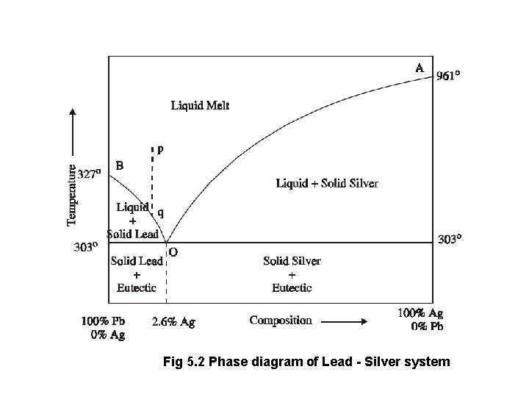

1. Point ‘O’ (Eutectic point) The curves AO and BO meet at point „O‟ at a temperature of 303°C, where three phases (solid Ag, solid Pb and their liquid melt) are in equilibrium. Solid Ag + Solid Pb Liquid Melt According to reduced phase rule equation. F′ = C − P + 1; F′ = 2 − 3 + 1; F′ = 0 The system is non-variant. The point O is called eutectic point or eutectic temperature and its corresponding composition, 97.4%Pb + 2.6% Ag, is called eutectic composition. Below this point the eutectic compound and the metal solidify.
2. Area The area above the line AOB has a single phase (molten Pb+Ag) or liquid melt. According to reduced phase rule the degree of freedom. F′ = C − P + 1; F′ = 2 − 1 + 1; F′ = 2 The system is bivariant which means both the temperature and composition have to be fixed to define the system completely. The area below the line AO (solid Ag + liquid melt), below the line BO (solid Pb + liquid melt) and below the point „O‟ (Eutectic compound + solid Ag or solid Pb) have two phases and hence the system is univariant F′ = C − P + 1; F′ = 2 − 2 + 1; F′ = 1. Application of Pattinson’s process for the desilverisation of Argentiferous lead The argentiferous lead, having a very small amount of silver (say 0.1%), is heated to a temperature above its melting point, so that the system has only the liquid phase represented by the point ―p in the phase diagram . It is then allowed to cool where the temperature decreases along the line ―pq. As soon as the point ―q is reached, Pb is crystallised out and the solution will contain relatively increasing amounts of ―Ag‟. On further cooling, more and more of ―Pb is separated along the line ―BO. The melt continues to be richer and richer in Ag until the point O is reached, where the percentage of Ag rises to 2.6%. Thus, the process of raising the relative proportions of Ag in the alloy is known as Pattinson’s process.
3. **POTASSIUM IODIDE–WATER SYSTEM:** It has four phases :
4. Solid KI
5. Solution of KI in water
6. Ice
7. Vapour.

Only two chemical constituents KI and H2O being necessary to depict the composition of all the four phases, it is a two-component system. Since the conditions for the existence of the various phases are studied at atmospheric pressure the vapour phase is ignored and the system KI-H2O is regarded as a condensed system. Pressure being constant, the two variables, temperature and concentration will be considered. The TC diagram of the system is shown in Fig. It consists of : (a) The Curves AO and OB

(b) The Eutectic Point O

(c) The area above AOB and the areas below the curves OA and BO

The Curve AO; the Freezing point curve of Water. The pointArepresents the freezing point ofwater or the melting point of ice (0ºC) under normal conditions. The curve AO shows that the melting point of ice falls by the addition of solid KI. As more and more of KI is added, the concentration of solution and the melting temperature changes along the curve AO. The phases in equilibrium along the curve AO are ice and solution. Applying the reduced phase rule equation to the condensed system ice/solution, we have F' = 2 – 2 + 1 = 1 Thus the system is monovariant.

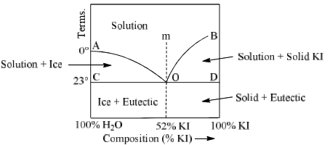

The Eutectic point. The lowest point attainable by the addition of KI along the curve OA is O. Here the solution becomes saturated with KI and the solid KI appears as the third phase. This point is termed the Eutectic Point or Cryohydric Point as one of the components in the system is water. Applying the reduced phase rule equation to the system ice/solid KI/solution at point O. F' = 2 – 3 + 1 = 0 Hence the system is nonvariant. That is, both the temperature (– 22ºC) and composition (52% KI + 48% ice) are fixed.

The Curve BO; the Solubility curve of KI. At O, the solution is saturated with KI. Thus the curve BO depicts the effect of temperature on the concentration of saturated solution or the solubility of KI. The phases in equilibrium along the curve are solid KI and solution. Applying the reduced phase rule equation, we have F = C – P + 1 = 2 – 2 + 1 = 1 That is, the condensed system solid KI/solution is monovariant.

The Area above AOB. It represents the single phase system “solution”. Applying the phase ruleequation, F = C – P + 1 = 2 – 1 + 1 = 2 Therefore the system is bivariant. As labelled in the diagram, the area below AO shows the existence of ice and solution, while the area below BO depicts the presence of solid KI and solution. Below the eutectic temperature line, there can exist ice and solid KI only. Cooling Produced by Freezing Mixtures KI-H2O is a typical eutectic system with a salt and water as components. Many other salts as sodium chloride, sodium nitrate, ammonium chloride and ammonium nitrate constitute eutectic systems with water and form similar phase diagrams as shown in Fig. The facts contained in this diagram explain the theory of freezing mixtures which are obtained by mixing salt and ice. When we add a salt, common salt (NaCl) to melting ice, we follow along the curve AO. Thus the addition of salt to the system ice/water produces a continued lowering of temperature until the eutectic point O is reached. Thus the lowest temperature attained in this way will be the eutectic temperature (– 22.0ºC). Alternatively, we may start with a concentrated solution of the salt represented by point X on the phase diagram. As we withdraw heat by adding ice, we travel along the dashed line XY. At Y which lies on the solubility curve BO, the solution becomes saturated with the salt. On further withdrawing heat, we go along with the curve BO until the eutectic point is reached. Thus the same minimum temperature can be attained with a freezing mixture, whether we add salt to ice or ice to salt solution. The eutectic temperatures of some salt/ice systems are listed below.

|  |  |
| --- | --- |
| System | Eutectic Temperature |
| NH4Cl + ICE | – 16.0ºC |
| NaCl.2H2O + ICE | – 22.0ºC |
| KNO2 + ICE | – 2.6ºC |
| NaNO2 + ICE | – 18.1ºC |
| KCl + ICE | – 11.4ºC |

Uses of Eutectic system

1. Suitable alloy composition can be predicted.
2. Making solders, used for joining two metal pieces together.

Differences between Melting point, Eutectic point and Triple point

1. Melting Point: It is the temperature at which the solid and liquid phases, having thesame composition, are in equilibrium. Solid A Liquid A

2. Eutectic Point: It is the temperature at which two solids and a liquid phase are inequilibrium Solid A + Solid B Liquid

3. Triple Point It is the temperature at which three phases are in equilibrium. Solid Liquid Vapour All the eutectic points are melting points All the melting points need not be eutectic points. Similarly all the eutectic points are triple points, but all the triple points need not be eutectic points.

**SYSTEM FORMING COMPOUNDS WITH CONGRUENT MELTING POINT:** When the components of a binary system at a particular stage form a compound which melts at a sharp temp to give a liquid of the same composition as that of solid and the temp at which the compound melt is called congruent melting point.

**THE MAGNESIUM–ZINC SYSTEM**: It is a typical 2-component system which involves the formation of an intermetallic compound MgZn2. It has four phases: solid magnesium (Mg), solid zinc (Zn), solid MgZn2 and the liquid solution of Mg and Zn. The complete phase diagram of the system magnesium-zinc is shown in Fig. It appears to be made of two simple eutectic diagrams. The one toward the left represents the eutectic system Mg-MgZn2, while the one to the right the system Zn-MgZn2. The curves AC, CDE and BE. AC is the freezing point curve of magnesium; BE is the freezing point curve of zinc; and CDE is that of the compound MgZn2.

The curve AC shows that the melting point of magnesium (651ºC) is lowered on the addition of zinc. This continues until the point C is reached. Here a new phase, solid MgZn2 appears. The curve CD shows the increase of concentration of zinc in the melt with the rise of temperature. At the maximum point D, the composition of the melt and the solid compound becomes the same i.e., MgZn2. The point D, therefore, represents the melting point of MgZn2 (575ºC).

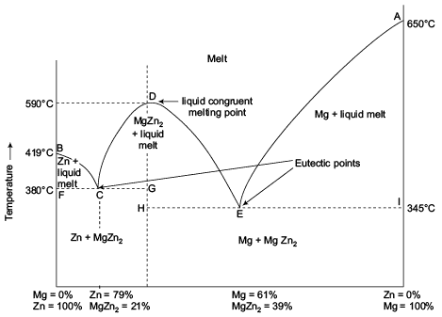

The curve DE now shows the lowering of the melting point with the addition of zinc until the lowest point is attained. Here solid zinc appears.

The curve BE exhibits that the melting point of zinc (420ºC) falls with the addition of magnesium until the point E is reached. Along the freezing point curves AC, CDE and BE, there are two phases in equilibrium viz., one solid phase (Mg, Zn, or MgZn2) and the other liquid phase. Applying the reduced phase rule equation, we have F = C – P + 1 = 2 – 2 + 1 = 1 This shows that the system Mg/liquid, Zn/liquid and MgZn2/liquid are all monovariant.

Eutectic points C and E. There are two eutectic points in the phase diagram. The systems at the points C and E have two components and three phases in equilibrium. Phases Present C Solid Mg, solid MgZn2, Liquid E Solid Zn, solid MgZn2, Liquid These systems are, therefore, nonvariant. F = C – P + 1 = 2 – 3 + 1 = 0 Congruent Melting Point. As already stated, the composition of the compound MgZn2 and the melt at D is identical. The corresponding temperature is the congruent melting point of the compound. Here the system has two phases viz., the solid compound and the melt. Both these can be represented by one component (MgZn2). Therefore the system at D is nonvariant, F = C – P + 1 = 1 – 2 + 1 = 0

The Areas: The area above the curves AC, CDE and BE represents the solution of magnesium and zinc (the melt). The single phase system at any point in this area is bivariant. The phases present in the other regions of the phase diagram are as labelled.

**USES (OR) MERITS OF PHASE RULE**

1. Applicable to both physical and chemical equilibria.

2. A convenient method to classify the equilibrium systems in terms of phases, components and degree of freedom.

3. Indicates that different systems having the same degrees of freedom behave similarly.

4. Decides whether the given number of substances remains in equilibrium or not.

5. Applicable to macroscopic systems without considering their molecular structures.

6. Does not consider the nature (or) amount of substances in the system.

**DEMERITS OF PHASE RULE:**

1. Phase rule can be applied only for the heterogeneous systems in equilibrium.

2. Only three variables like P, T & C are considered, but not electrical, magnetic and gravitational forces. 3. All the phases of the system must be present under the same conditions of pressure and temperature.

4. Solid and liquid phases must not be in finely divided state, otherwise deviations occur.