**NUCLEAR CHEMISTRY**

Some basic terminologies are:

1. Atom : It is the smallest particle of an element which can take part in a chemical reaction.
2. Atomic number(Z) : It represents the total number of protons present in the nucleus which also indicates the total number of electrons present in a neutral atom.
3. Atomic mass number:The total number of neutrons and protons present in the nucleus of an atom contributing to its total mass is called as mass number.
4. Neutron number: It represents the number of neutrons present in the nucleus of an atom.It is equal to the difference between mass number and atomic number, ie. N=A-Z.
5. Isotopes: Atoms of the same element having same atomic number but different atomic mass number are called isotopes .
6. Isobars :Atoms of different elements having same atomic mass number but different atomic number are called isobars.
7. Radioactivity : The spontaneous emission of radiations from heavy, unstable nuclei of radioactive elements is called radioactivity.
8. Isotones: Atoms having same number of neutrons but different mass numbers and hence having different atomic numbers are called isotones.

Some basic particles are:

1. Electrons : These are negatively charged particles which revolve around the nucleus in close orbits. Mass of an electron is 5.5 x 10-4 a. m. u. or 9.11 x 10-31 kg. Electron carry a charge of 4.8 x 10-20 e.s. u. or 1.6 x 10-19 coulomb.It exhibits dual character i.e . a particle as well as a wave . An electron is represented by the symbol -1e0
2. Neutrons : These are electrically neutral particles present in the nucleus of all atoms except hydrogen. The mass of a neutron is 1.0086 a.m.u which is 1840 times heavier than that of an electron . It is represented as 0n1.
3. Protons : These are positively charged particles present in the nucleus of an atom . They have a mass of 1.0078 a.m.u . They are present in the nuclei of all atoms . A proton carries a positive charge equal and opposite to the charge of an electron . Thus, on a electron scale its charge is +1.It is represented as 1H1 or 1P1

**Factors affecting stability of nucleus:**

1. **Mass defect:** It is the difference between the total mass of the nucleons of an atom and the experimentally measured mass. i.e. isotopic mass.

Explanation: In case of Helium, the experimentally measured mass is 4.0128 a.m.u. while mass of two protons and two neutrons are 4.0331 a.m.u. Therefore, mass defect Dm is given by

Dm = 4.0331 - 4.0128 = 0.0203 a.m.u.

For a nucleus having atomic number 'Z' and neutron number ( A-Z ), if mp, mn and M represent the masses of a proton, a neutron and isotopic mass respectively, then the mass defect is given by

Dm = [ Z.mp + ( A-Z ).mn ] -M

The mass defect represents the amount of energy given out when the protons and neutrons combine to form a new nucleus. This according to the Einstein's equation is

E = Dm .c2

Higher the mass defect, greater the stability of the nucleus.

1. **Binding energy:** It is the energy required to break the nucleus into its constituent nucleons.i.e. neutrons and protons.

Explanation: During the formation of the nucleus, it is observed that some amount of mass is lost. This loss in mass is responsible for binding the nucleons together in the nucleus. Formation of nucleus is accompanied by the release of energy. The relationship between mass and energy is given by Einstein's equation : E = Dm.c2

Where Dm = mass defect E = energy in ergs c = velocity of light

Relation between mass defect and binding energy:

Binding energy = Dm X 931 MeV

For nucleus with A no. of nucleons, Binding energy per nucleon = Dm X 931 MeV.

A Calculate the binding energy for a mass defect of 1 a.m.u.

1 a.m.u. = 1.66 x 10-24 gm = 1.66 x 10-27 kg.

For Dm = 1 a.m.u. = 1.66 x 10-24kg (3x108 )2 = 14.94 x 10-11 Joules

Now 1 MeV = 1.603 X 10-6 ergs = 1.603 x 10-13 Joules.

Binding energy = 14.94 X 10-11 / 1.603 x 10-13 x 931 MeV.

Binding Energy Curve: It is a plot of average binding energy per nucleon against the mass number 'A’. It gives the information leading to condition of the stability of the nucleus.

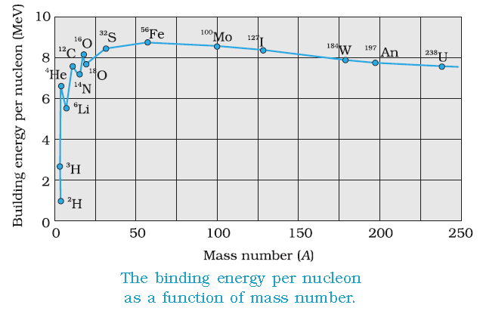

Following conclusions can be drawn from the curve:

1. Binding energy per nucleon for elements with atomic mass number below 20 is very low ( < 8 MeV ). These elements have a tendency for nuclear fusion. But as the mass number increases from 20 to 60, the binding energy per nucleon increases from 8 to 8.5 MeV. It becomes maximum of 8.7 MeV for nucleus with atomic mass number 64. Thus, elements with mass number varying from 20 to 64 have stable nuclei and the binding energy slowly decreases with increases in mass number.
2. Elements with mass numbers ranging from 60 to 140 have constant binding energy value of 8.5 MeV indicating the most stable nuclei of these elements.
3. However, binding energy per nucleon for element with mass number arranging from 140 to 240 decreases slowly to about 7.5MeV thereby decreasing the stability.
4. Lastly, atoms with mass number>240 are unstable and radioactive.Therefore, they readily undergo nuclear fission.

**C) Neutron-Proton ratio:** A study of the nuclei of various elements revealed that the elements with neutron-proton(N/P) ratio in the range 1 to 1.536 are more stable than the other nuclei having ratio less than this range. For light nuclei upto 20Ca40 , the N/P ratio is 1 while that for 82Pb208it is 1.536.As Z increases the number of neutrons also increases but not in a linear relationship as observed in the following belt of stability

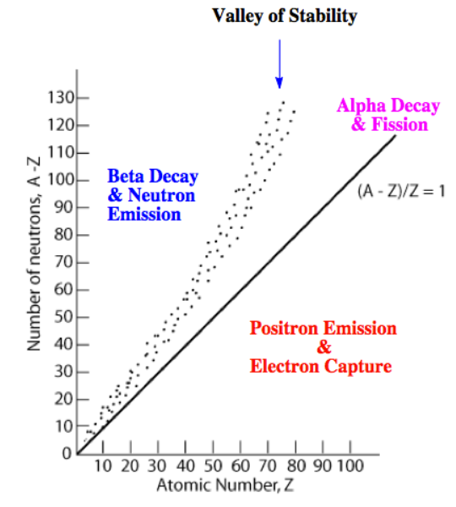

From the stability belt, it is observed that

a) Nuclei upto Z=20 have N/P=1.The lower portion of the dotted curve almost lie on the ideal curve.

b) Region above the belt represent excess neutrons.

c) Region below the belt represents excess protons.

d) All nuclei with Z greater than 83 are unstable as observed from the deviation of the dotted curve from the deal one.

Conclusions:

1. Those nuclei with high N/P ratio i.e lying above the belt of stability, these nuclei lower their ratio by the emission of beta ray by the following nuclear reaction

0n1 → 1H1 + -1e0

Thus the number of protons in the nucleus increases and these nuclei move towards the belt of stability.

1. Those nuclei with N/P ratio less than 1 i.e lying below the belt of stability, the ratio is increased to one by the protons in the nucleus getting converted into neutrons with the emission of positron as seen from the following nuclear reaction

1p1→  0n1 + +1e0

The neutron number is also increased by electron capture process but positron emission is common.

3) Those nuclei with Z greater than 83(which lie beyond the upper right edge end of the band of stability) they decay by alpha emission and achieve stability.

**D) Magic numbers:** The numbers 2, 8,20, 50, 82 ,126 which accounts for unusual stability to the nucleus of the elements are called magic numbers.The nuclei with number of proton or number of neutron equal to the magic numbers are found to be more stable.The magic number nuclei are found to be at the end of the radioactive series.

Evidence for magic numbers

1) The nuclear shell model describes that the neutrons and protons are arranged in a complete shell within the atomic nucleus to achieve stability(to become non-radioactive) just as elements during formation of bond achieve stability by completion of octet.

2) All naturally occurring radioactive series end with magic numbers of either N or Z E) Odd-Even number rule: The stability of their nucleus is also predicted by finding out whether the nucleus contains odd/even number of neutrons and protons.A detailed study of various nuclei reveal the following facts:

|  |  |  |  |  |
| --- | --- | --- | --- | --- |
| **Neutron** | **Proton** | **Number of stable nuclei** | **Stability order** | **Examples** |
| Even | Even | 168 | Very high | 2He4, 6C12 |
| Odd | Even | 57 |  | 6C13 |
| Even | Odd | 50 |  | 7N15 |
| Odd | Odd | 04 | Least | 1H2, 3Li6 |

**Packing Fraction:**

It is defined as mass defect per unit nucleon. The value of packing fraction depends upon the manner of packing of the nucleons within the nucleus. It’s value can be negative, positive or even zero. A positive packing fraction describes a tendency towards instability. A negative packing fraction means isotopic mass is less than actual mass number indicates stability of the nucleus. From the figure it is clear that the packing fraction beyond mass number 200 becomes positive and increases with increase in mass number. In general, lower the packing fraction, greater is the binding energy per nucleon and hence greater is the stability. Mathematically it is defined as

pf = IsotopicM ass − M assNumber /M assNumber × 104

**Artificial and Natural Radioactivity**:

The harsh reality is that radioactivity has not been invented by man; it has been there, existing in the universe since time immemorial. The of nuclei which takes place in nature, is called natural radioactivity. However there are elements beyond uranium which have been artificially made. They are called the transuranium elements which can be made to disintegrate into other nuclei by colliding with slow moving neutrons. This is called artificial radioactivity. Thus it is customery to check the difference between these two types.

Difference between Artificial and Natural Radioactivity:

|  |  |
| --- | --- |
| **Natural Radioactivity** | **Artificial Radioactivity** |
| Radioactivity that takes place on its own in nature | 1It is induced by man in laboratories |
| Occurs in elements with atomic number greater than 82 | Can be induced in elements with low atomic numbers. |
| It usually have long half life. | This usually have short half life |
| Decay partcles are α, β & γ | Decay partcles are α, β, −β & γ |

**Properties of α, β & γ-decay:**

In radioactive processes, particles or electromagnetic radiation are emitted from the nucleus. The most common forms of radiation emitted have been traditionally classified as α, β, and γ radiation. Let’s now inspect the characteristics of them.

• Characteristics of α-decay

1 These particles are helium nuclei 2He4 .(Alpha rays consist of stream of positively charged particles carrying charge of +2 units and a mass almost equal to 4 amu)

2 They affect photographic plate

3 They are deflected only slightly towards the negative plate in electric field. They are also deflected by magnetic field. (see they are charged and hence Lorentz force is in action)

4 These particles can ionize gases. Alpha rays have maximum ionizing power. (Again because these particles will interact with the medium as they are charged)

5 They have a velocity of the order of 1 × 107ms−1 .

6 They have very little penetrating power.

• Characteristics of β-decay

1 Beta rays are electrons −1e 0 .( these rays are made up of streams of negatively charged particles with a negligible mass.

2 They affect photographic plate.

3 They get deflected to the maximum extent towards the positive plate in electric field. They are also deflected by magnetic field.

4 Their ionising power is less than that of α- rays. ( It is about one hundredth of α- particles).

5 Their velocity varies with the source sometimes reaches 2.7 × 108ms−1 .

6 Their penetration power is about 100 times more than that of α- particles. (Since mass is too small).

• Characteristics of γ-decay

1 They are electromagnetic radiations (photons) like X-rays having very short wavelength, in the range of 10−10 m to 10−13 m.

2 They affect photographic plate.

3 They are unaffected by electric and magnetic fields.(No charge no Lorentz force)

4 Their ionizing power is low, and is about one hundredth of β- particles.(No charge no ionisation)

5 Their velocity is same as that of light.

6 Their penetrating power is very high, about 100 times more than that of β - particles.(since they donot interact they keep on moving moving... and moving)

• Positron emission

Although positron emission doesnt occur with naturally occurring radioactive isotopes, it does occur naturally in a few man-made ones. A positron is essentially an electron that has a positive charge instead of a negative charge. A positron is formed when a proton in the nucleus decays into a neutron and a positively charged electron. The positron is then emitted from the nucleus.

• Electron capture or K-capture

Electron capture is a rare type of nuclear decay in which an electron from the innermost energy level is captured by the nucleus. This electron combines with a proton to form a neutron. The atomic number decreases by one, but the mass number stays the same. The capture of the 1s electron leaves a vacancy in the 1s orbitals. Electrons drop down to fill the vacancy, releasing energy in the X-ray portion of the electromagnetic spectrum.

**Half-life of a radioactive nucleus:**

As I have told you earlier that it is not possible to predict when an individual atom might decay. But it is possible to measure how long it takes for half the nuclei of a piece of radioactive material to decay. The half-life of a radioactive nucleus is one of its main features with the nature of radiations it emits. It determines how quickly it will decay and for how long we need to worry about its radiations. Half-lives can range from a fraction of a second to billions of years. For example, the half-life of carbon-14 is 5,715 years, but the half-life of francium-223 is just 20 minutes. There are two definitions of half-life, but they mean essentially the same thing. Half-life is the time taken for:

1. The number of nuclei of the radioactive isotope in a sample to halve.

2. The count rate from a sample containing the radioactive isotope to fall to half its starting level. Either way you are correct if write in your exam. Since half-life is kind of stability in the time frame that indicates we must have some connection between the decay constant and half-life. Let’s now investigate this on a mthematical ground. Now with a bit reorientation of the last mathematical expression we obtain

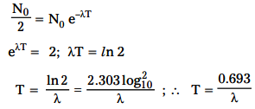

The longer the half-life of a nucleus, the lower the radioactive activity. A nucleus with a half-life that is a million times greater than another will be a million times less radioactive. Thus half-life is a convenient way to assess the rapidity of a decay, but it should not be confused with the average life span of a radioactive nucleus.

**Average life of a radioactive nucleus:**

Radioactive atoms disintegrate spontaneously and it is not possible to predict which atom is going to disintegrate next which I have told you n number of times. The practical way is you take a sample of the radioactive atoms and wait for all of them to decay away, and keep track of how long each atom lasts. The atom which disintegrates at first is said to have zero (0) life and the atom which disintegrate last is said to have infinite life. That means what is the mean life of all that nuclei becomes a legitimate question. Thus the sum of all the lifetimes of the atoms, divided by the original number of nuclei, is the mean lifetime. In other words, the mean lifetime is simply the arithmetic average of the lifetimes of the individual nuclei. Thus we can put it in a mathematical way Tavg will be

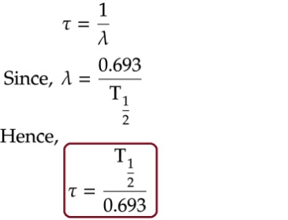

Thus the number times the life-time will give the numerator and ofcourse integrated over 0 to ∞ will cover all possible values of time. Which then is getting divided by the number of nuclei present at that time.

**models of the nucleus:** There are two models of nucleus.

1. **Liquid Drop model of the nucleus**:

The liquid drop model in nuclear physics treats the nucleus as a drop of incompressible nuclear fluid of very high density. It was first proposed by George Gamow along with Weizsacher in 1935 who have recognized some experimental evidences and found resemblance of nucleus with a liquid drop and then developed by Niels Bohr and John Wheeler later on. What they have justified in favour of this model are the following

• Like the molecules in a drop of liquid, the nucleons are imagined to interact strongly with each other.

• Just like liquid molecules can collide with each other due to thermal agitation but then well inside the drop, a given nucleon collides frequently with other nucleons in the nuclear interior, its mean free path as it moves about being substantially less than the nuclear radius.

• The liquid drop is assumed as imcompressible meaning its density can’t be changed similar is the case for nucleus also where the density of the nucleus is constant for all the nuclei.

• The liquid drop is spherical because of surface tension similarly the nucleus is spherical because of the strong nuclear force.

• In case of the liquid drop the cohesive force always saturates just like the nuclear force which also saturates.

• The heat of vaporization which represents the amount of energy required to convert molecules from liquid phase to gas phase or rather more specifically the latent heat of vaporisation is proportional to the number of molecules in the liquid just like the bindind energy of nucleus is also proporsonal to number of nucleon. However there are some differences too which are as follows

• The nucleus has a limited number of particles (< 270) compared to chemical systems (≈ 1023). The net result is that there is a much larger fraction of nucleons on the surface relative to those in the bulk for nuclei compared to chemical systems.

• The nucleus is a two-component system composed of neutrons and protons whereas in a liquid drop number of components may be more or less. This is a crude model that does not explain all the properties of the nucleus, but does predict the nuclear binding energy. As the model justifies the similarities between a liquid drop and a nucleus one can then construct a semiempirical model (half theory/half data) also known as Bethe-Weizacker Semi-empirical Mass Formula to account for the total nuclear binding energy, the most basic of nuclear properties.

1. **Shell model of the nucleus:**

The basic assumption of the liquid drop model is that each nucleon interacts only with its nearest neighbour. Though it explains nuclear fission, sphericity of the nucleus and binding energy of the nuclei to a large extent but few significant things it fails to explain. Which are

• There are some peaks or kinks the in binding energy/nucleon curve

• It underestimate the actual binding energies of some magic nuclei for which either the number of neutrons N = (A - Z) or the number of protons, Z is equal to one of the magic numbers (a fancy term used by the nuclear physicist) which are 2, 8, 20, 28, 50, 82 etc. These numbers are exceptional in the sense that any nucleus which posseses any of these values in terms of neutrons or protons or sum of these two are highly stable nuclei. For example for 28N i56 the Liquid Drop Model predicts a binding energy of 477.7 MeV, whereas the measured value is 484.0 MeV. Likewise for 50Sn132 the Liquid Drop model predicts a binding energy of 1084 MeV, whereas the measured value is 1110 MeV. You know that an α-particle is exceptionally stable because its proton number and neutron number are both equal to 2, a magic number. An α-particle is therefore said to be doubly magic because they contain filled shells of both protons and neutrons.

• Changes in separation energies (the energy required to remove the last neutron (or proton)) for certain numbers of neutron and protons.

• If N is magic number then the cross-section for neutron absorption is much lower than for other nuclides.

The shell model is an attempt to solve these ambiguities which a model of the nucleus that uses the Pauli exclusion principle to describe the structure of the nucleus in terms of energy levels. The shell model is partly analogous to the atomic shell model which describes the arrangement of electrons in an atom, in that a filled shell results in greater stability. In the Shell Model it is assumed that each nucleon in the nucleus moves in a net attractive potential that represents the avg. effect of its interaction. The potential has a constant depth inside the nucleus and outside the nucleus it goes to zero within a distance equal to the range of the nuclear force. It almost like a 3D potential with round edges. And in the ground state of the nucleus the nucleons are filled without violating the Pauli’s exclusion principle. And that immediately excludes the possibility of nucleon-nucleon collision. But two nucleons can exchange their quantum states which will be indistinguishable. Hence all the nucleons that constitute the nucleus can move freely inside the ground state nucleus. So, this model is also called as independent particle model. And the behaviour of each nucleon can be understood by solving the Schrodinger equation for that potential.

**Nuclear Fission**:

Nuclear fission, subdivision of a heavy atomic nucleus, such as that of uranium or plutonium, into two fragments of roughly equal mass. The process is accompanied by the release of a large amount of energy. The process may take place spontaneously in some cases or may be induced by the excitation of the nucleus with a variety of particles (e.g., neutrons, protons, deuterons, or α particles) or with electromagnetic radiation in the form of gamma rays. In the fission process, a large quantity of energy is released, radioactive products are formed, and several neutrons are emitted. These neutrons can induce fission in a nearby nucleus of fissionable material and release more neutrons that can repeat the sequence, causing a chain reaction in which a large number of nuclei undergo fission and an enormous amount of energy is released. If controlled in a nuclear reactor, such a chain reaction can provide power for societys benefit. If uncontrolled, as in the case of the so-called atomic bomb, it can lead to an explosion of awesome destructive force.

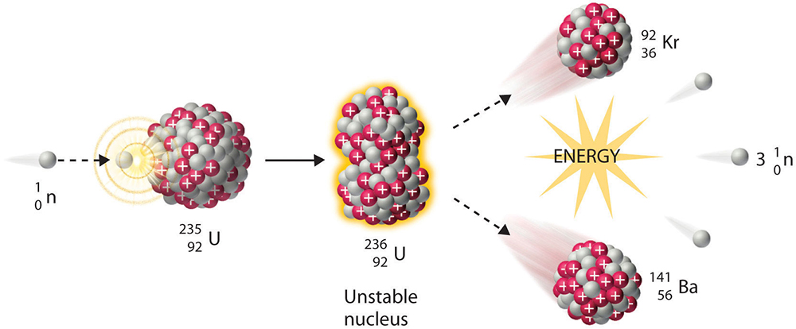

Controlled Thermonuclear Fission: As you might have guessed that the emission of several neutrons in the fission process leads to the possibility of a chain reaction if at least one of the fission neutrons induces fission in another fissile nucleus, which in turn fissions and emits neutrons to continue the chain. If more than one neutron is effective in inducing fission in other nuclei, the chain multiplies more rapidly. To maintain a sustained controlled nuclear reaction, for every 2 or 3 neutrons released, only one must be allowed to strike another nucleus. To realise all these nuclear engineer have devised a parameter to explain it mathematically. It’s called as the effective neutron multiplication factor. Definition: The effective neutron multiplication factor is the ratio of number of neutrons produced by fission in one generation to the number of neutrons produced by fission in the preceding generation. In other words it is the average number of neutrons from one fission that cause another fission.

Controlled nuclear fission lab: The Nuclear Reactor A nuclear reactor is a system that contains and controls sustained nuclear chain reactions. Reactors are used for generating electricity, moving aircraft carriers and submarines, producing medical isotopes for imaging and cancer treatment, and for conducting research. Well quite a large applicability! They are, however, differentiated either by their purpose or by their design features. The two main types of classifiaction are

• Research reactors • Power reactors

• Research reactors These reactor are operated at universities and research centres in many countries. These reactors generate neutrons for multiple purposes, including producing radiopharmaceuticals for therapy, testing materials and conducting basic research.

• Power reactors They are usually found in nuclear power plants. Dedicated to produce thermal energy that can be used for its own sake or converted into mechanical energy and ultimately, in the vast majority of cases, into electrical energy. These reactors are just exotic heat sources. However these two reactors have entirely different designs. But we will only discuss the Power reactor as per the instruction of the course.

**Nuclear Fusion:**

nuclear fusion is a nuclear reaction in which two or more nuclei collide at a very high energy and fuse together into a new nucleus, e.g. helium. If light nuclei are forced together, they will fuse with a yield of energy because the mass of the combination will be less than the sum of the masses of the individual nuclei. Fusion reactions have an energy density many times greater than nuclear fission and fusion reactions are themselves millions of times more energetic than chemical reactions. The Sun is a hot star. Really hot star. However in astrophysical language it’s an ordinary star. But all of the heat and light coming from the Sun comes from the fusion reactions happening inside the core of the Sun. Inside the Sun, the pressure is million of times more than the surface of the Earth, and the temperature reaches more than 15 million Kelvin. Massive gravitational forces create the these conditions for nuclear fusion. The primary source of solar energy, and similar size stars, is the fusion of hydrogen to form helium (the proton-proton chain reaction), which occurs at a solar-core temperature of around 15 million kelvin. The net result is the fusion of four protons into one α particle, with the release of two positrons and two neutrinos, and energy.

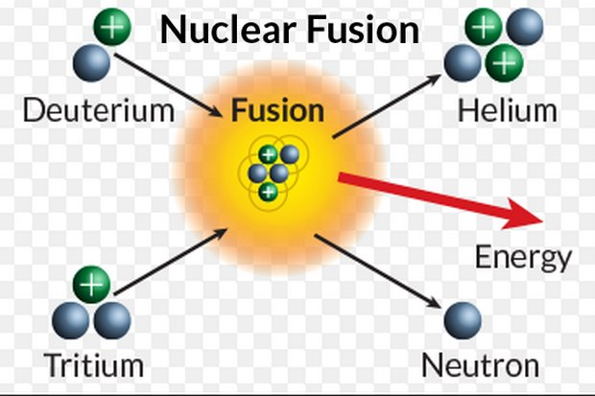

**Detection of radioactivity:** There are two methods for detection of radioactivity.

1. **Geiger-Muller Counter, (GM counter):**

Introduction: It is an instrument used for detecting and measuring ionizing radiation, α, β and γ radiation. The principle of working remains the same as that of proporsonal counter, charged particles ionize the gas through which they pass ,the electrons so produced during ionization get accelerated under high potential and further produce ionization. The main advantages are that they are relatively inexpensive, durable and easily portable. But they have very low efficiency in determining the the exact energy of the detected radiation.

Construction: The construction of the GM counter is exactly similar to that of the proporsonal counter. A Geiger tube which is nothing but a charged capacitor with a region between them occupied by a gas. The apparatus consists of two parts, the tube and the (counter + power supply). The Geiger-Mueller tube is usually cylindrical, with a wire down the center. The (counter + power supply) have voltage controls and timer options. A high voltage is established across the cylinder and the wire.

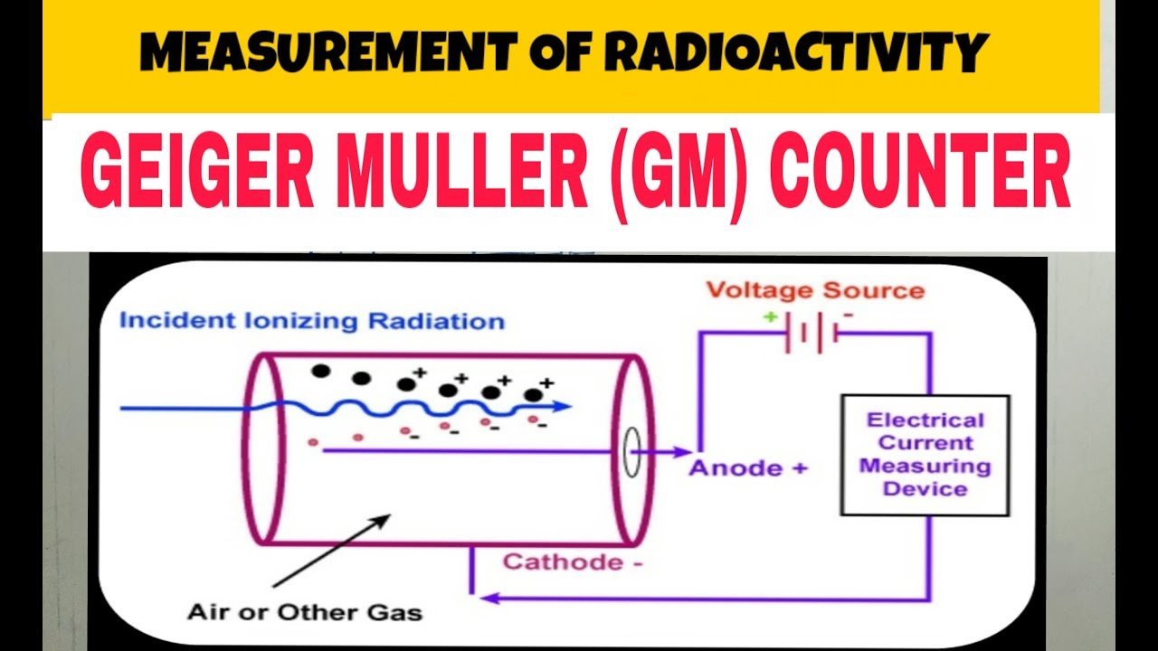

• The anodes are usually thin metal wires, which are held at a positive potential with respect to the rest of the detector.

• The cathode is cylinder arranged in a co-axial manner. The metal wire is at the center surrounding that the cathode cylinder.

• A voltage source (This will create an electric field between the electrodes)

• An electrometer circuit (This is capable of measuring the very small output current which is in the region of femtoamperes to picoamperes)

Working Principle: When ionizing radiation such as an α, β or γ particle enters the tube, it can ionize some of the gas molecules in the tube. From these ionized atoms, an electron is knocked out of the atom, and the remaining atom is positively charged. The high voltage in the tube produces an electric field inside the tube. The electrons that were knocked out of the atom are attracted to the positive electrode, and the positively charged ions are attracted to the negative electrode. This produces a pulse of current in the wires connecting the electrodes, and this pulse is counted. After the pulse is counted, the charged ions become neutralized, and the Geiger counter is ready to record another pulse. In order for the Geiger counter tube to restore itself quickly to its original state after radiation has entered, a gas is added to the tube. This gas is called as a quench gas to ensure each pulse discharge terminates; a common mixture is 90% argon, 10% methane. For low voltages, no counts are recorded. This is because the electric field is too weak for even one pulse to be recorded. As the voltage is increased, eventually one obtains a counting rate. The voltage at which the G-M tube just begins to count is called the starting potential. The counting rate quickly rises as the voltage is increased. The rise is so fast, that the graph looks like a step potential. After the quick rise, the counting rate levels off. This range of voltages is termed the plateau region. Eventually, the voltage becomes too high and we have continuous discharge. The threshold voltage is the voltage where the plateau region begins. Proper operation is when the voltage is in the plateau region of the curve.

Dead Time: After a count has been recorded, it takes the G-M tube a certain amount of time to reset itself to be ready to record the next count. The resolving time or dead time, T, of a detector is the time it takes for the detector to reset itself. Since the detector is not operating while it is being reset, the measured activity is not the true activity of the sample. If the counting rate is high, then the effect of dead time is very important.

1. **Cloud Chamber:**

Introduction: A cloud chamber makes the invisible visible, allowing us to see delicate, wispy proof that there are tiny particles whose story starts in outer space shooting through all of us, every minute of every day. It’s a unique device for detection and measurement of elementary particles and other ionizing radiation. Also known as a Wilson Cloud Chamber after the name of inventor C.T.R. Wilson in 1911. In particular, the discoveries of the positron in 1932 and the muon in 1936, both by Carl Anderson (awarded a Nobel Prize in Physics in 1936), used cloud chambers. Discovery of the kaon by George Rochester and Clifford Charles Butler in 1947, also was made using a cloud chamber as the detector.

Construction: The construction of the cloud chamber is very simple and naive one. You can make it in your home also. (But I doubt if you could detect a particle in that) Here is what you need to construct it • A closed chamber.(Say a fish tank ie an aquarium of any shape)

• Some alchohol (Go to the chemistry department. I never said to go to a wine shop.)

• Some dry ice. (Go to the daily bazaar and ask in the fish seller.)

• A perforated substance. ( Again chemistry department. One iron net like that net which you use while heating something in Bunsen burner.)

• One piece of cloth to put alchohol.

• A hot source. (A hot water bag will also work)

• One black piece of cloth to cover up the entire set up.

• One light source (A simple torch. Don’t use mobile phone light. You will need some brightness.) All you have to maintain inside the chamber a temperature gradient and a supersaturated environment. Temperature gradient from top to bottom. So bottom of the chamber is to be kept cool and top of the chamber is to be kept hot. This is why the dry ice is kept at the bottom of the chamber the hot source is placed is placed at the top. But just below the hot source the perforated substance is kept upon which there lies the piece of cloth and over that piece of cloth plenty of alchohol is poured. This hot source will evaporate the alchohol inside the chamber since alchohol is a volatile substance. As the vapour falls, it cools rapidly due to the dry ice and the air becomes supersaturated and after a while the entire chamber will become supersaturated with alchohol vapour.

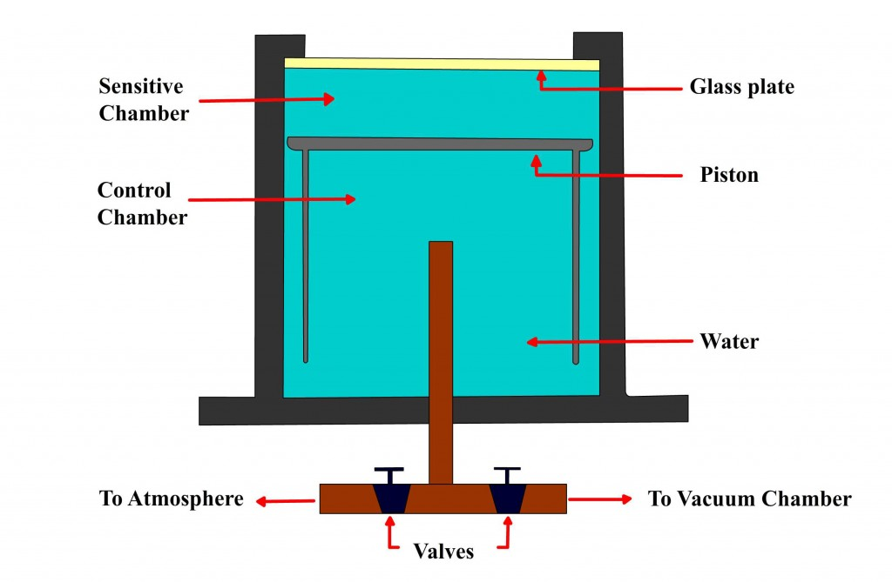

Working Principle: Now let us consider a charged particle (such as α radiation from a chunk of radioactive ore) zips through the chamber at high speed. It bumps into alcohol molecules and ionizes them - it creates a trail of ionized molecules marking its path. Now, the vapours are such that they really want to produce mist; The trail of ionized molecules is enough to do that - the ions attract a bunch of molecules, the resulting clumps attract even more, and before you know it a droplet of alchohol is formed, then another, and another. Well, a trail of mist follows the particle. However, these droplets are visible as a ”cloud” track that persist for several seconds while the droplets fall through the vapor which can be better seen by a tangential application of a light source. Then how identify which particle’s tract they are? Well, the tracks have characteristic shapes. For example, an α particle track is thick and straight, while an electron track is wispy and shows more evidence of deflections by collisions.