**SOLID STATE**

Matter can exist in three states namely, solid, liquid and gas. Under a given set of conditions of temperature and pressure, which of these would be the most stable state of a given substance depends upon the net effect of two opposing factors. Intermolecular forces tend to keep the molecules (or atoms or ions) closer, whereas thermal energy tends to keep them apart by making them move faster. At sufficiently low temperature, the thermal energy is low and intermolecular forces bring them so close that they cling to one another and occupy fixed positions. These can still oscillate about their mean positions and the substance exists in solid state. The following are the characteristic properties of the solid state:

1. They have definite mass, volume and shape.
2. Intermolecular distances are short.
3. Intermolecular forces are strong.
4. Their constituent particles (atoms, molecules or ions) have fixed positions and can only oscillate about their mean positions.
5. They are incompressible and rigid.

Solids can be classified as crystalline or amorphous on the basis of the nature of order present in the arrangement of their constituent particles.

**Crystalline solid**: A crystalline solid usually consists of a large number of small crystals, each of them having a definite characteristic geometrical shape. In a crystal, the arrangement of constituent particles (atoms, molecules or ions) is ordered. It has long range order which means that there is a regular pattern of arrangement of particles which repeats itself periodically over the entire crystal. Sodium chloride and quartz are typical examples of crystalline solids.

**Amorphous solid**: An amorphous solid (Greek amorphos = no form) consists of particles of irregular shape. The arrangement of constituent particles (atoms, molecules or ions) in such a solid has only short range order. In such an arrangement, a regular and periodically repeating pattern is observed over short distances only. Such portions are scattered and in between the arrangement is disordered.

The structures of quartz (crystalline) and quartz glass (amorphous) are shown in Fig. While the two structures are almost identical, yet in the case of amorphous quartz glass there is no long range order. The structure of amorphous solids is similar to that of liquids. Glass, rubber and plastics are typical examples of amorphous solids. Due to the differences in the arrangement of the constituent particles, the two types of solids differ in their properties.

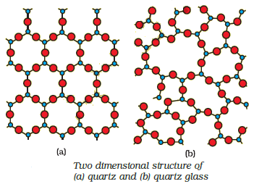

Crystalline solids have a sharp melting point. On the other hand, amorphous solids soften over a range of temperature and can be moulded and blown into various shapes. On heating they become crystalline at some temperature. Some glass objects from ancient civilisations are found to become milky in appearance because of some crystallisation. Like liquids, amorphous solids have a tendency to flow, though very slowly. Therefore, sometimes these are called pseudo solids or super cooled liquids. Glass panes fixed to windows or doors of old buildings are invariably found to be slightly thicker at the bottom than at the top. This is because the glass flows down very slowly and makes the bottom portion slightly thicker. Crystalline solids are anisotropic in nature, that is, some of their physical properties like electrical resistance or refractive index show different values when measured along different directions in the same crystals. This arises from different arrangement of particles in different directions. This is illustrated in Fig. Since the arrangement of particles is different along different directions, the value of same physical property is found to be different along each direction. Amorphous solids on the other hand are isotropic in nature. It is because there is no long range order in them and arrangement is irregular along all the directions. Therefore, value of any physical property would be same along any direction. These differences are summarised in Table.

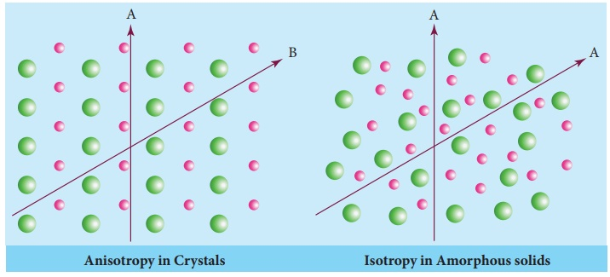

Difference between crystalline solid and amorphous solid:

|  |  |  |
| --- | --- | --- |
| **Property** | **Crystalline solid** | **Amorphous solid** |
| Shape | Definite characteristic geometrical shape | Irregular shape |
| Melting point | Melt at a sharp and characteristic temperature | Gradually soften over a range of temperature |
| Cleavage property | When cut with a sharp edged tool, they split into two pieces and the newly generated surfaces are plain and smooth | When cut with a sharp edged tool, they cut into two pieces with irregular surfaces |
| Heat of fusion | They have a definite and characteristic heat of fusion | They do not have definite heat of fusion |
| Anisotropy | Anisotropic in nature | Isotropic in nature |
| Nature | True solids | Pseudo solids or super cooled liquids |
| Order in arrangement of constituent particles | Long range order | Only short range order. |

**Classification of crystalline solids:** Crystalline solids can be classified on the basis of nature of intermolecular forces operating in them into four categories viz., molecular, ionic, metallic and covalent solids. Let us now learn about these categories.

|  |  |  |  |  |  |  |
| --- | --- | --- | --- | --- | --- | --- |
| **Type of Solid** | **Constituent Particles** | **Bonding/ Attractive Forces** | **Examples** | **Physical Nature** | **Electrical Conductivity** | **Melting Point** |
| 1. Molecular solids 2. Non polar 3. Polar 4. Hydrogen bonded | Molecules | Dispersion or London forces  Dipole-dipole interactions  Hydrogen bonding | Ar, CCl4, H2, I2, CO2  HCl, SO2  H2O(ice) | Soft  Soft  Hard | Insulator  Insulator  Insulator | Very low  Low  Low |
| 1. Ionic solids | Ions | Coulombic or electro-static | NaCl, MgO, ZnS, CaF2 | Hard but brittle | Insulators in solid state but conductors in molten state and in aqueous solutions | High |
| 1. Metallic solids | Positive ions in a sea of delocalised electrons | Metallic bonding | Fe, Cu, Ag, Mg | Hard but malleable and ductile | Conductors in solid state as well as in molten state | Fairly high |
| 1. Covalent or network solids | Atoms | Covalent bonding | SiO2 (quartz), SiC, AlN, C (diamond),  C(graphite) | Hard  Soft | Insulators  Conductor (exception) | Very high |

**Crystal lattice and unit cell**: The main characteristic of crystalline solids is a regular and repeating pattern of constituent particles. If the three dimensional arrangement of constituent particles in a crystal is represented diagrammatically, in which each particle is depicted as a point, the arrangement is called crystal lattice. Thus, a regular three dimensional arrangement of points in space is called a crystal lattice. A portion of a crystal lattice is shown in Fig. There are only 14 possible three dimensional lattices. These are called Bravais Lattices (after the French mathematician who first described them). The following are the characteristics of a crystal lattice:

(a) Each point in a lattice is called lattice point or lattice site.

(b) Each point in a crystal lattice represents one constituent particle which may be an atom, a molecule (group of atoms) or an ion.

(c) Lattice points are joined by straight lines to bring out the geometry of the lattice.

Unit cell is the smallest portion of a crystal lattice which, when repeated in different directions, generates the entire lattice. A unit cell is characterised by:

1. Its dimensions along the three edges, a, b and c. These edges may or may not be mutually perpendicular.
2. Angles between the edges, α (between b and c) β (between a and c) and γ (between a and b). Thus, a unit cell is characterised by six parameters, a, b, c, α, β and γ.

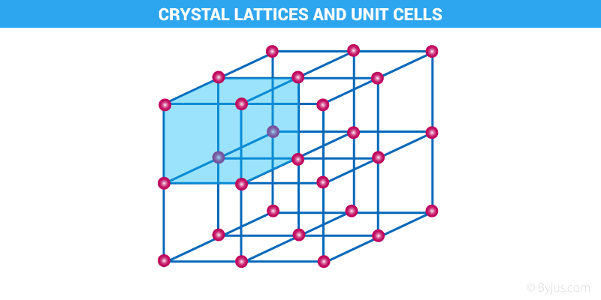

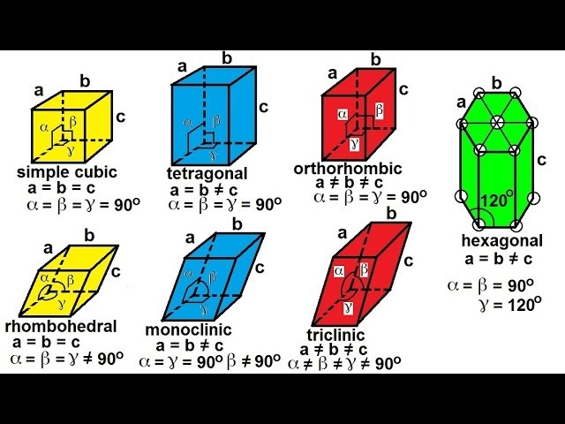

**Classification of unit cell:** Unit cells can be broadly divided into two categories, primitive and centred unit cells.

(a) Primitive Unit Cells: When constituent particles are present only on the corner positions of a unit cell, it is called as primitive unit cell.

(b) Centred Unit Cells: When a unit cell contains one or more constituent particles present at positions other than corners in addition to those at corners, it is called a centred unit cell. Centred unit cells are of three types:

(i) Body-Centred Unit Cells: Such a unit cell contains one constituent particle (atom, molecule or ion) at its body-centre besides the ones that are at its corners.

(ii) Face-Centred Unit Cells: Such a unit cell contains one constituent particle present at the centre of each face, besides the ones that are at its corners.

(iii) End-Centred Unit Cells: In such a unit cell, one constituent particle is present at the centre of any two opposite faces besides the ones present at its corners. In all, there are seven types of primitive unit cells.

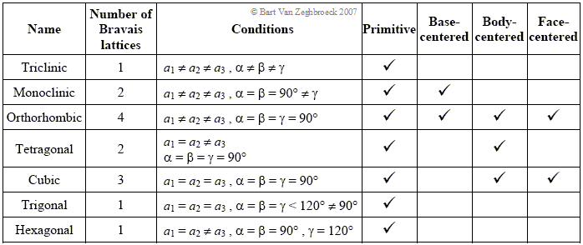

**Number of atoms in a unit cell:** We know that any crystal lattice is made up of a very large number of unit cells and every lattice point is occupied by one constituent particle (atom, molecule or ion). Let us now work out what portion of each particle belongs to a particular unit cell. We shall consider three types of cubic unit cells and for simplicity assume that the constituent particle is an atom.

* Primitive cubic unit cell has atoms only at its corner. Each atom at a corner is shared between eight adjacent unit cells as shown in Fig. 1.8, four unit cells in the same layer and four unit cells of the upper (or lower) layer. Therefore, only 1 8 th of an atom (or molecule or ion) actually belongs to a particular unit cell. A primitive cubic unit cell has been depicted in three different ways. In all, since each cubic unit cell has 8 atoms on its corners, the total number of atoms in one unit cell is

8x1/8=1 atom.

* A body-centred cubic (bcc) unit cell has an atom at each of its corners and also one atom at its body centre. It can be seen that the atom at the body centre wholly belongs to the unit cell in which it is present. Thus in a body-centered cubic (bcc) unit cell:

1. 8 corners × 1/8 per corner atom= 8 x1/8 = 1 atom
2. 1 body centre atom = 1 × 1 = 1 atom

∴ Total number of atoms per unit cell = 2 atoms

* A face-centred cubic (fcc) unit cell contains atoms at all the corners and at the centre of all the faces of the cube. Thus, in a face-centred cubic (fcc) unit cell:

1. 8 corners atoms × 1/8 atom per unit cell= 8x1/8 = 1 atom
2. 6 face-centred atoms × 1/2 atom per unit cell = 6 × 1/2 = 3 atoms

∴ Total number of atoms per unit cell = 4 atoms

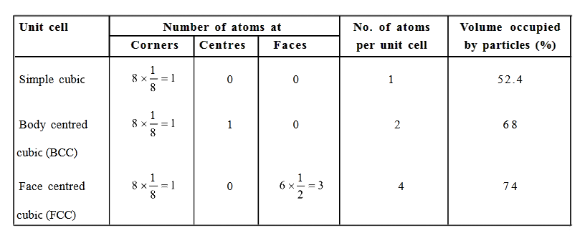

**Close packing in solids:** In solids, the constituent particles are close-packed, leaving the minimum vacant space. Let us consider the constituent particles as identical hard spheres and build up the three dimensional structure in three steps.

1. Close Packing in One Dimension: There is only one way of arranging spheres in a one dimensional close packed structure, that is to arrange them in a row and touching each other. In this arrangement, each sphere is in contact with two of its neighbours. The number of nearest neighbours of a particle is called its coordination number. Thus, in one dimensional close packed arrangement, the coordination number is 2.

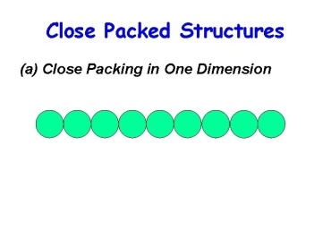

1. Close Packing in Two Dimensions: Two dimensional close packed structure can be generated by stacking (placing) the rows of close packed spheres. This can be done in two different ways.

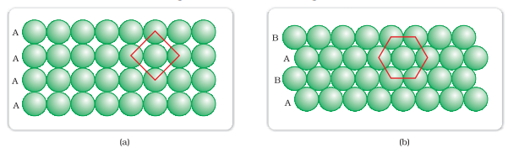

(i) The second row may be placed in contact with the first one such that the spheres of the second row are exactly above those of the first row. The spheres of the two rows are aligned horizontally as well as vertically. If we call the first row as ‘A’ type row, the second row being exactly the same as the first one, is also of ‘A’ type. Similarly, we may place more rows to obtain AAA type of arrangement as shown in Fig. In this arrangement, each sphere is in contact with four of its neighbours. Thus, the two dimensional coordination number is 4. Also, if the centres of these 4 immediate neighbouring spheres are joined, a square is formed. Hence this packing is called square close packing in two dimensions.

(ii) The second row may be placed above the first one in a staggered manner such that its spheres fit in the depressions of the first row. If the arrangement of spheres in the first row is called ‘A’ type, the one in the second row is different and may be called ‘B’ type. When the third row is placed adjacent to the second in staggered manner, its spheres are aligned with those of the first layer. Hence this layer is also of ‘A’ type. The spheres of similarly placed fourth row will be aligned with those of the second row (‘B’ type). Hence this arrangement is of ABAB type. In this arrangement there is less free space and this packing is more efficient than the square close packing. Each sphere is in contact with six of its neighbours and the two dimensional coordination number is 6. The centres of these six spheres are at the corners of a regular hexagon hence this packing is called two dimensional hexagonal closepacking. It can be seen that in this layer there are some voids (empty spaces). These are triangular in shape. The triangular voids are of two different types. In one row, the apex of the triangles are pointing upwards and in the next layer downwards.

1. Close Packing in Three Dimensions: All real structures are three dimensional structures. They can be obtained by stacking two dimensional layers one above the other. In the last Section, we discussed close packing in two dimensions which can be of two types; square close-packed and hexagonal close-packed. Let us see what types of three dimensional close packing can be obtained from these.

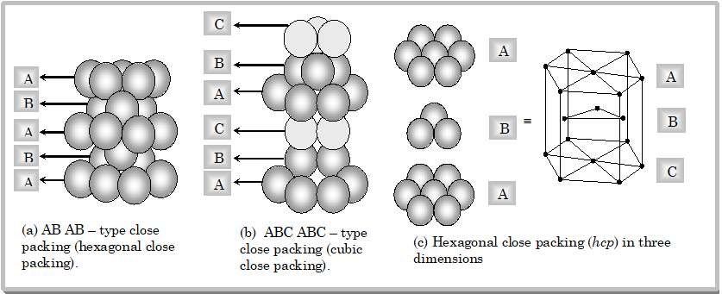

(i) Three dimensional close packing from two dimensional square close-packed layers: While placing the second square close-packed layer above the first we follow the same rule that was followed when one row was placed adjacent to the other. The second layer is placed over the first layer such that the spheres of the upper layer are exactly above those of the first layer. In this arrangement spheres of both the layers are perfectly aligned horizontally as well as vertically. Similarly, we may place more layers one above the other. If the arrangement of spheres in the first layer is called ‘A’ type, all the layers have the same arrangement. Thus this lattice has AAA.... type pattern. The lattice thus generated is the simple cubic lattice, and its unit cell is the primitive cubic unit cell.

(ii) Three dimensional close packing from two dimensional hexagonal close packed layers: Three dimensional close packed structure can be generated by placing layers one over the other.

**Packing efficiency:** In whatever way the constituent particles (atoms, molecules or ions) are packed, there is always some free space in the form of voids. Packing efficiency is the percentage of total space filled by the particles. Let us calculate the packing efficiency in different types of structures. Packing efficiency for simple cubic is:

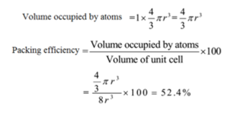

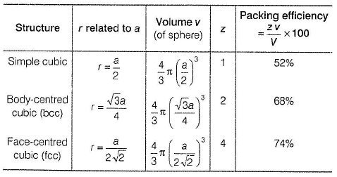

**Imperfection in solids:** Although crystalline solids have short range as well as long range order in the arrangement of their constituent particles, yet crystals are not perfect. Usually a solid consists of an aggregate of large number of small crystals. These small crystals have defects in them. This happens when crystallisation process occurs at fast or moderate rate. Single crystals are formed when the process of crystallisation occurs at extremely slow rate. Even these crystals are not free of defects. The defects are basically irregularities in the arrangement of constituent particles. Broadly speaking, the defects are of two types, namely, point defects and line defects. Point defects are the irregularities or deviations from ideal arrangement around a point or an atom in a crystalline substance, whereas the line defects are the irregularities or deviations from ideal arrangement in entire rows of lattice points. These irregularities are called crystal defects. We shall confine our discussion to point defects only. Point defects can be classified into three types:

(i) stoichiometric defects (ii) impurity defects and (iii) non-stoichiometric defects.

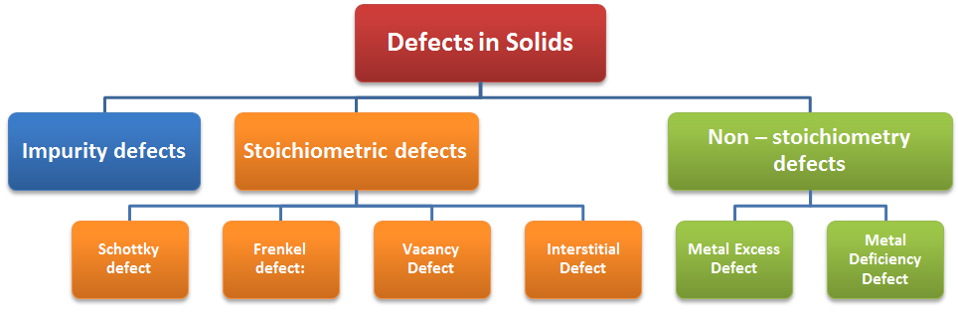

(a) Stoichiometric Defects: These are the point defects that do not disturb the stoichiometry of the solid. They are also called intrinsic or thermodynamic defects. Basically these are of two types, vacancy defects and interstitial defects.

(i) Vacancy Defect: When some of the lattice sites are vacant, the crystal is said to have vacancy defect. This results in decrease in density of the substance. This defect can also develop when a substance is heated.

(ii) Interstitial Defect: When some constituent particles (atoms or molecules) occupy an interstitial site, the crystal is said to have interstitial defect. This defect increases the density of the substance. Vacancy and interstitial defects as explained above can be shown by non-ionic solids. Ionic solids must always maintain electrical neutrality. Rather than simple vacancy or interstitial defects, they show these defects as Frenkel and Schottky defects.

Frenkel Defect: This defect is shown by ionic solids. The smaller ion (usually cation) is dislocated from its normal site to an interstitial site. It creates a vacancy defect at its original site and an interstitial defect at its new location. Frenkel defect is also called dislocation defect. It does not change the density of the solid. Frenkel defect is shown by ionic substance in which there is a large difference in the size of ions, for example, ZnS, AgCl, AgBr and AgI due to small size of Zn2+ and Ag+ ions.

Schottky Defect: It is basically a vacancy defect in ionic solids. In order to maintain electrical neutrality, the number of missing cations and anions are equal. Like simple vacancy defect, Schottky defect also decreases the density of the substance. Number of such defects in ionic solids is quite significant. For example, in NaCl there are approximately 106 Schottky pairs per cm3 at room temperature. In 1 cm3 there are about 1022 ions. Thus, there is one Schottky defect per 1016 ions. Schottky defect is shown by ionic substances in which the cation and anion are of almost similar sizes. For example, NaCl, KCl, CsCl and AgBr. It may be noted that AgBr shows both, Frenkel as well as Schottky defects.

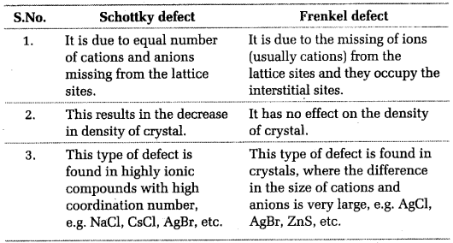

(b) Impurity Defects If molten NaCl containing a little amount of SrCl2 is crystallised, some of the sites of Na+ ions are occupied by Sr2+. Each Sr2+ replaces two Na+ ions. It occupies the site of one ion and the other site remains vacant. The cationic vacancies thus produced are equal in number to that of Sr2+ ions. Another similar example is the solid solution of CdCl2 and AgCl.

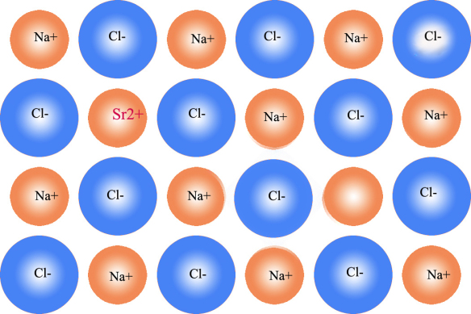

(c) Non-Stoichiometric Defects The defects discussed so far do not disturb the stoichiometry of the crystalline substance. However, a large number of nonstoichiometric inorganic solids are known which contain the constituent elements in non-stoichiometric ratio due to defects in their crystal structures. These defects are of two types:

(i) metal excess defect and (ii) metal deficiency defect.

(i) Metal Excess Defect: Metal excess defect due to anionic vacancies: Alkali halides like NaCl and KCl show this type of defect. When crystals of NaCl are heated in an atmosphere of sodium vapour, the sodium atoms are deposited on the surface of the crystal. The Cl– ions diffuse to the surface of the crystal and combine with Na atoms to give NaCl. This happens by loss of electron by sodium atoms to form Na+ ions. The released electrons diffuse into the crystal and occupy anionic sites. As a result the crystal now has an excess of sodium. The anionic sites occupied by unpaired electrons are called F-centres (from the German word Farbenzenter for colour centre). They impart yellow colour to the crystals of NaCl. The colour results by excitation of these electrons when they absorb energy from the visible light falling on the crystals. Similarly, excess of lithium makes LiCl crystals pink and excess of potassium makes KCl crystals violet (or lilac). Metal excess defect due to the presence of extra cations at interstitial sites: Zinc oxide is white in colour at room temperature. On heating it loses oxygen and turns yellow.

ZnO → Zn+2 + ½ O2 +2e−

Now there is excess of zinc in the crystal and its formula becomes Zn1+xO. The excess Zn2+ ions move to interstitial sites and the electrons to neighbouring interstitial sites.

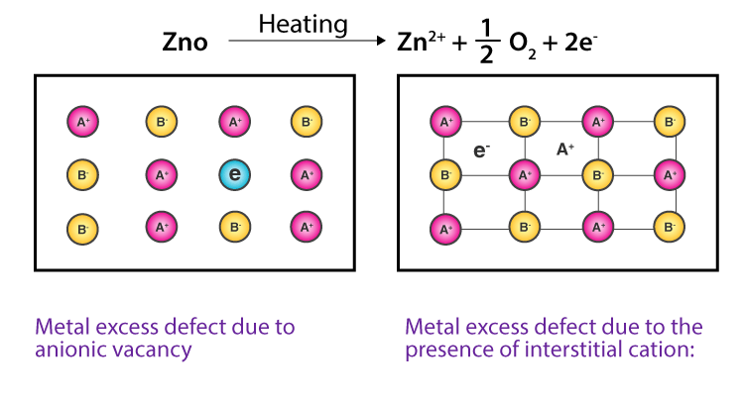

1. Metal Deficiency Defects: There are many solids which are difficult to prepare in the stoichiometric composition and contain less amount of the metal as compared to the stoichiometric proportion. A typical example of this type is FeO which is mostly found with a composition of Fe0.95O. It may actually range from Fe0.93O to Fe0.96O. In crystals of FeO some Fe2+ cations are missing and the loss of positive charge is made up by the presence of required number of Fe3+ ions.

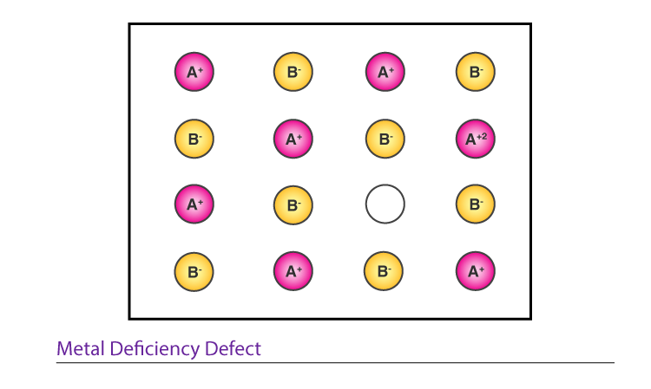

**Electrical conductivity in solids:** Solids exhibit an amazing range of electrical conductivities, extending over 27 orders of magnitude ranging from 10–20 to 107 ohm–1 m–1. Solids can be classified into three types on the basis of their conductivities.

1. Conductors: The solids with conductivities ranging between 104 to 107 ohm–1m–1 are called conductors. Metals have conductivities in the order of 107 ohm–1m–1 are good conductors. Properties.
2. Insulators: These are the solids with very low conductivities ranging between 10–20 to 10–10 ohm–1m–1.
3. Semiconductors: These are the solids with conductivities in the intermediate range from 10–6 to 104 ohm–1m–1.

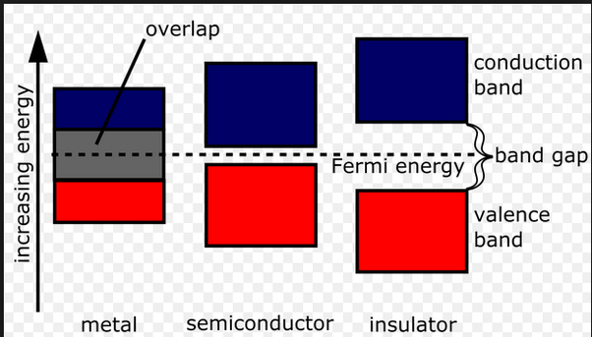

In case of semiconductors, the gap between the valence band and conduction band is small. Therefore, some electrons may jump to conduction band and show some conductivity. Electrical conductivity of semiconductors increases with rise in temperature, since more electrons can jump to the conduction band. Substances like silicon and germanium show this type of behaviour and are called intrinsic semiconductors. The conductivity of these intrinsic semiconductors is too low to be of practical use. Their conductivity is increased by adding an appropriate amount of suitable impurity. This process is called doping. Doping can be done with an impurity which is electron rich or electron deficient as compared to the intrinsic semiconductor silicon or germanium. Such impurities introduce electronic defects in them.

(a) Electron – rich impurities Silicon and germanium belong to group 14 of the periodic table and have four valence electrons each. In their crystals each atom forms four covalent bonds with its neighbours. When doped with a group 15 element like P or As, which contains five valence electrons, they occupy some of the lattice sites in silicon or germanium crystal. Four out of five electrons are used in the formation of four covalent bonds with the four neighbouring silicon atoms. The fifth electron is extra and becomes delocalised. These delocalised electrons increase the conductivity of doped silicon (or germanium). Here the increase in conductivity is due to the negatively charged electron, hence silicon doped with electron-rich impurity is called n-type semiconductor.

(b) Electron – deficit impurities Silicon or germanium can also be doped with a group 13 element like B, Al or Ga which contains only three valence electrons. The place where the fourth valence electron is missing is called electron hole or electron vacancy. An electron from a neighbouring atom can come and fill the electron hole, but in doing so it would leave an electron hole at its original position. If it happens, it would appear as if the electron hole has moved in the direction opposite to that of the electron that filled it. Under the influence of electric field, electrons would move towards the positively charged plate through electronic holes, but it would appear as if electron holes are positively charged and are moving towards negatively charged plate. This type of semi conductors are called p-type semiconductors.

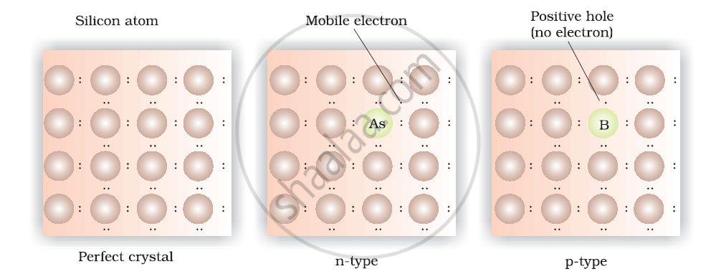

**Applications of n-type and p-type semiconductors:** Various combinations of n-type and p-type semiconductors are used for making electronic components. Diode is a combination of n-type and p-type semiconductors and is used as a rectifier. Transistors are made by sandwiching a layer of one type of semiconductor between two layers of the other type of semiconductor. npn and pnp type of transistors are used to detect or amplify radio or audio signals. The solar cell is an efficient photo-diode used for conversion of light energy into electrical energy. Germanium and silicon are group 14 elements and therefore, have a characteristic valence of four and form four bonds as in diamond. A large variety of solid state materials have been prepared by combination of groups 13 and 15 or 12 and 16 to simulate average valence of four as in Ge or Si. Typical compounds of groups 13 – 15 are InSb, AlP and GaAs. Gallium arsenide (GaAs) semiconductors have very fast response and have revolutionised the design of semiconductor devices. ZnS, CdS, CdSe and HgTe are examples of groups 12 – 16 compounds. In these compounds, the bonds are not perfectly covalent and the ionic character depends on the electronegativities of the two elements. It is interesting to learn that transition metal oxides show marked differences in electrical properties. TiO, CrO2 and ReO3 behave like metals. Rhenium oxide, ReO3 is like metallic copper in its conductivity and appearance. Certain other oxides like VO, VO2, VO3 and TiO3 show metallic or insulating properties depending on temperature.

**Magnetic properties of solids:** Every substance has some magnetic properties associated with it. The origin of these properties lies in the electrons. Each electron in an atom behaves like a tiny magnet. Its magnetic moment originates from two types of motions:

1. Its orbital motion around the nucleus and
2. Its spin around its own axis.

Electron being a charged particle and undergoing these motions can be considered as a small loop of current which possesses a magnetic moment.

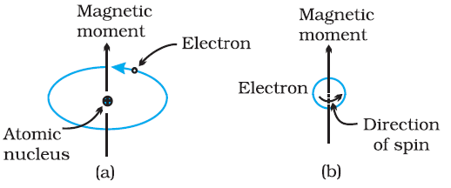

Thus, each electron has a permanent spin and an orbital magnetic moment associated with it. Magnitude of this magnetic moment is very small and is measured in the unit called Bohr magneton, μB. It is equal to 9.27 × 10–24A m2. On the basis of their magnetic properties, substances can be classified into five categories:

(i) paramagnetic (ii) diamagnetic (iii) ferromagnetic (iv) antiferromagnetic and (v) ferrimagnetic.

(i) Paramagnetism: Paramagnetic substances are weakly attracted by a magnetic field. They are magnetised in a magnetic field in the same direction. They lose their magnetism in the absence of magnetic field. Paramagnetism is due to presence of one or more unpaired electrons which are attracted by the magnetic field. O2, Cu2+, Fe3+, Cr3+ are some examples of such substances.

(ii) Diamagnetism: Diamagnetic substances are weakly repelled by a magnetic field. H2O, NaCl and C6H6 are some examples of such substances. They are weakly magnetised in a magnetic field in opposite direction. Diamagnetism is shown by those substances in which all the electrons are paired and there are no unpaired electrons. Pairing of electrons cancels their magnetic moments and they lose their magnetic character.

1. Ferromagnetism: A few substances like iron, cobalt, nickel, gadolinium and CrO2 are attracted very strongly by a magnetic field. Such substances are called ferromagnetic substances. Besides strong attractions, these substances can be permanently magnetised. In solid state, the metal ions of ferromagnetic substances are grouped together into small regions called domains. Thus, each domain acts as a tiny magnet. In an unmagnetised piece of a ferromagnetic substance the domains are randomly oriented and their magnetic moments get cancelled. When the substance is placed in a magnetic field all the domains get oriented in the direction of the magnetic field and a strong magnetic effect is produced. This ordering of domains persist even when the magnetic field is removed and the ferromagnetic substance becomes a permanent magnet.

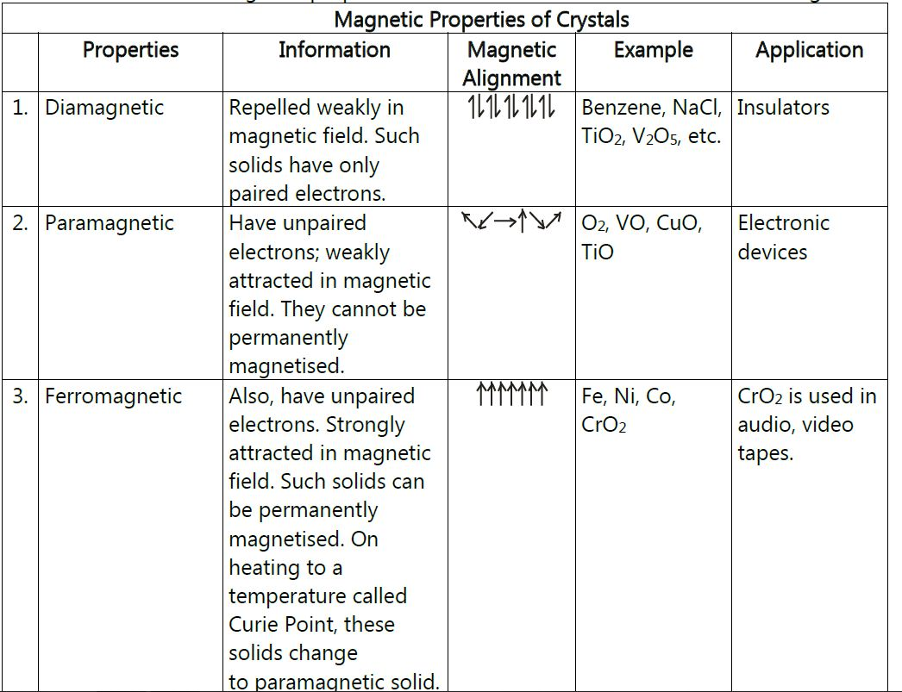

(iv) Antiferromagnetism: Substances like MnO showing antiferromagnetism have domain structure similar to ferromagnetic substance, but their domains are oppositely oriented and cancel out each other's magnetic moment.

(V) Ferrimagnetism: Ferrimagnetism is observed when the magnetic moments of the domains in the substance are aligned in parallel and anti-parallel directions in unequal numbers. They are weakly attracted by magnetic field as compared to ferromagnetic substances. Fe3O4 (magnetite) and ferrites like MgFe2O4 and ZnFe2O4 are examples of such substances. These substances also lose ferrimagnetism on heating and become paramagnetic.

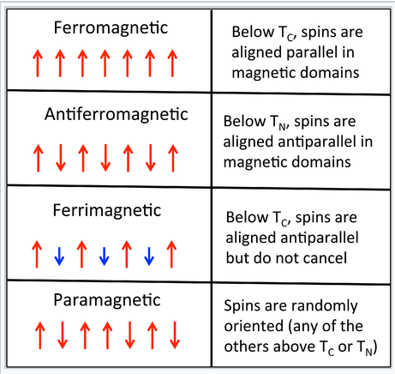

**Bragg’s Law:** The visible light rays when pass through a sharp edge of an object can form some bright regions inside the geometrical shadow of the object. This is due to the bending nature of light, called diffraction. Diffraction of visible light rays can also be produced using plane-ruled grating. This grating consists of about 6000 lines/cm; so that the spacing between any two consecutive lines in the grating is of the order of the wavelength of visible light used to produce diffraction. The wavelength of X-rays is of the order of an angstrom, so X-rays are unable to produce diffraction with plane optical grating. To produce diffraction with X-rays, the spacing between the consecutive lines of grating should be of the order of few angstroms. Practically, it is not possible to construct such a grating. In the year 1912, a German physicist Laue suggested that the three-dimensional arrangement of atoms in a crystal can serve as a three-dimensional grating for X-rays. Inside the crystal, the spacing between the crystal planes can work as the transparent regions as between lines in a ruled grating. Laue’s associates Friedrich and Knipping succeeded in diffracting X-rays by passing through a thin crystal. In 1913, W.L. Bragg and his son W.H. Bragg gave a simple interpretation of the diffraction pattern. According to Bragg, the diffraction spots produced are due to the reflection of some of the incident X-rays by various sets of parallel crystal planes. These planes are called Bragg’s planes. The Bragg’s interpretation is explained in the following topic. Therefore, Bragg’s law states that X-rays diffracted from different parallel planes of a crystal interfere constructively when the path difference is integral multiples of wavelength of X-rays.

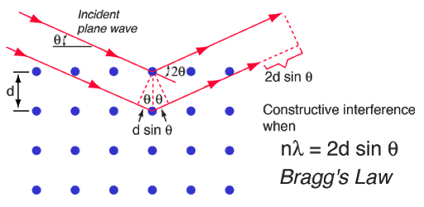

Bragg’s equation is:

n λ = 2 dhkl sin θhkl (n =1)

(Mo radiation λ = 0.71073 Å , Cu radiation λ = 1.542 Å)

dhkl = intraplanar d spacing

cubic crystal orthorhombic

d100 =d 010= d001= a d100 =a , d010 = b ,d001 = c

d200 = a/2

d2hkl = a2/(h2+k2+ l2) 1/d2hkl = (h/a)2 + (k/b)2 + (l/c)2

Bragg angle θ = sin-1 (λ/2d)

This sets the limitation on the wavelength, i.e. in order to get the diffraction pattern by a crystal, the wavelength of X-rays should not exceed twice the inter-planar spacing. Importance of Bragg’s law:

1. Bragg’s law is the essential condition to be satisfied by crystal planes in order to get diffraction pattern from a crystal.

2. It is used to calculate inter-planar spacing. Knowing the values of inter-planar spacing, lattice parameters can be determined.

**Laws of crystallography:** There are three laws of crystallography.

1. **Law of constancy of interfacial angles:** This law states that angle between adjacent corresponding faces is inter facial angles of the crystal of a particular substance is always constant inspite of different shapes and sizes and mode of growth of crystal. The size and shape of crystal depend upon the conditions of crystallisation. This law is also known as Steno's Law.
2. **Law of rational indices:** This law states that the ratio of intercepts of different faces of a crystal with the three axes are constant and can be expressed by rational numbers that the intercepts of any face of a crystal along the crystallographic axes are either equal to unit intercepts (i.e., intercepts made by unit cell) a, b, c or some simple whole number multiples of them e.g., na, n' b, n''c, where n, n' and n'' are simple whole numbers. The whole numbers n, n' and n'' are called Weiss indices. This law was given by Hauy.

The reciprocals of the parameters are known as indices. According to the crystallographic notation by Miller a law- has been established, which states that "the intercepts that any face makes on the crystallographic axes are either infinite or small rational multiples of the intercepts made by the unit form". Hence, the ratio between the intercepts on the axes of different faces on a crystal can always be expressed by rational numbers as 1: 2, 1: 3, 1: 4.

**Miller indices** form a notation system in [crystallography](https://en.wikipedia.org/wiki/Crystallography) for planes in [crystal (Bravais) lattices](https://en.wikipedia.org/wiki/Bravais_lattice). In particular, a family of [lattice planes](https://en.wikipedia.org/wiki/Lattice_plane) is determined by three [integers](https://en.wikipedia.org/wiki/Integer) *h*, *k*, and *ℓ*, the Miller indices. They are written (hkℓ), and denote the family of planes orthogonal to{\displaystyle h\mathbf {b_{1}} +k\mathbf {b_{2}} +\ell \mathbf {b_{3}} }, where {\displaystyle \mathbf {b_{i}} }are the [basis](https://en.wikipedia.org/wiki/Basis_(linear_algebra)) of the [reciprocal lattice](https://en.wikipedia.org/wiki/Reciprocal_lattice) vectors (note that the plane is not always orthogonal to the linear combination of direct lattice vectors {\displaystyle h\mathbf {a_{1}} +k\mathbf {a_{2}} +\ell \mathbf {a_{3}} }because the lattice vectors need not be mutually orthogonal).

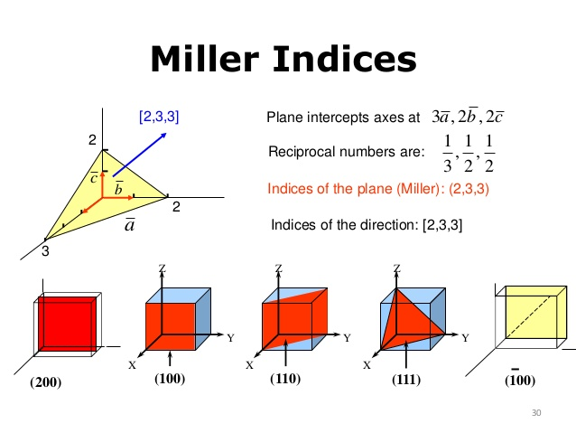

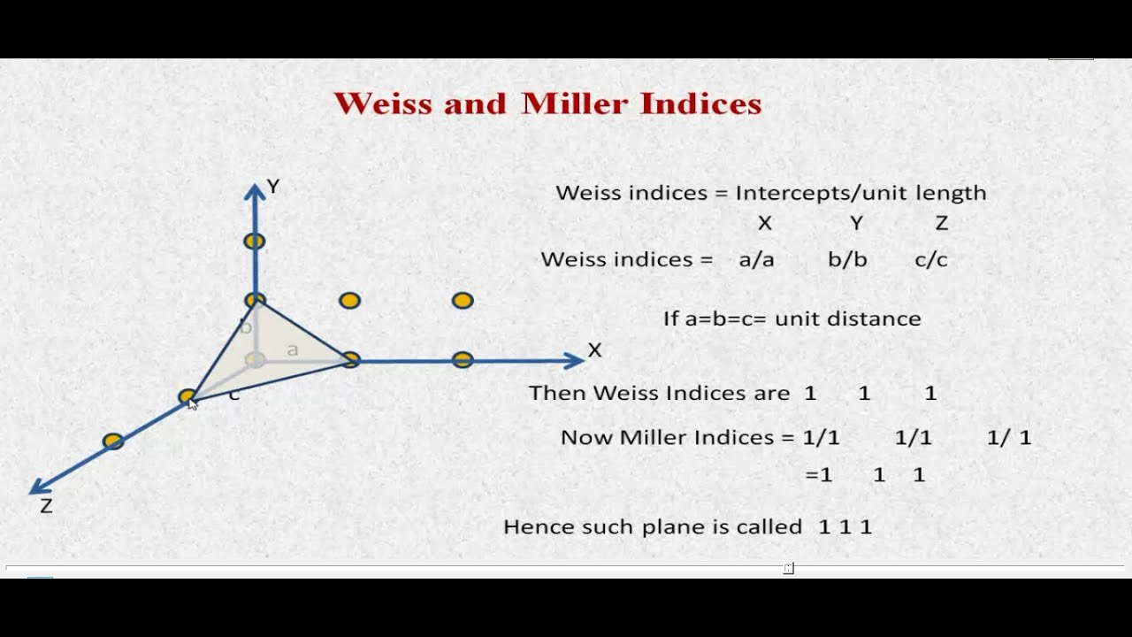

1. **Law of constancy of symmetry:** According to this law, all crystals of a substance have the same elements of symmetry is plane of symmetry, axis of symmetry and centre of symmetry.

Elements of symmetry identified in the unit cell will be present in the crystal.

1. Elements without translation - Mirror (reflection)

2. Center of symmetry (inversion)

3. Rotation

4. Glide

These are all referred to as symmetry operation.

**Diffraction methods:** There are three methods.

1. The Laue method :- applicable for single crystals
2. The Rotating crystal method :- applicable for single crystals
3. The Powder method :- used for finely divided crystalline or polycrystalline powers
4. Laue method: The Laue method was the first diffraction method ever used. This method is used to study the orientation of crystal and to verify crystal symmetry. A beam of white radiation, the continuous spectrum from an x-ray tube, is allowed to fall on a fixed single crystal. The Bragg angle θ is therefore fixed for every set of planes in the crystal, and each set picks out and diffracts that particular wavelength which satisfies the Bragg law for the particular values of d and involved. Each diffracted beam thus has a different wavelength. There are two variations of the Laue method, depending on the relative positions of source, crystal, and film. In each, the film is flat and placed perpendicular to the incident beam. The film in the transmission Laue method (the original Laue method) is placed behind the crystal so as to record the beams diffracted in the forward direction. This method is so called because the diffracted beams are partially transmitted through the crystal. In the back-reflection Laue method the film is placed between the crystal and the x-ray source, the incident beam passing through a hole in the film, and the beams diffracted in a backward direction are recorded. In either method, the diffracted beams form an array of spots on the film as shown in Fig. for a cubic crystal.

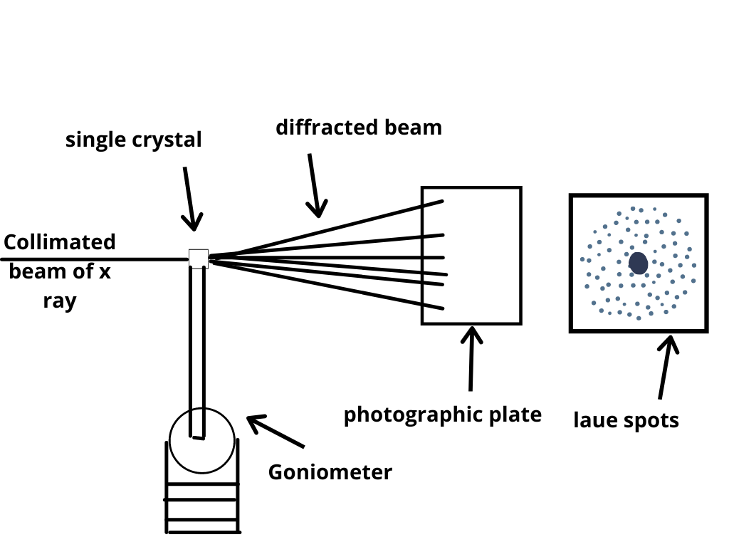

This array of spots is commonly called a pattern, more specifically, Laue pattern, but the term is not used in any strict sense and does not imply any periodic arrangement of the spots. On the contrary, the spots are seen to lie on certain curves, as shown in Fig. for transmitted pattern. These curves are generally ellipses or hyperbolas for transmission patterns and hyperbolas for back-reflection patterns. The spots lying on any one curve are reflections from planes belonging to one zone. This is due to the fact that the Laue reflections from planes of a zone all lie on the surface of an imaginary cone whose axis is the zone axis. The positions of the spots on the film, for both the transmission and the back-reflection method, depend on the orientation of the crystal relative to the incident beam, and the spots themselves become distorted and smeared out if the crystal has been bent or twisted in any way. The facts account for the two main uses of the Laue methods include: the determination of crystal orientation and the assessment of crystal perfection. Therefore, the way of arrangement of spots on a film is a characteristic property of the crystal. Laue method is useful to decide the crystal symmetry and orientation of the internal arrangement of atoms/molecules in the crystal. The atomic arrangement in a crystal can be analyzed by studying the positions and intensities of spots in Laue pattern. As several wavelengths of X-rays can reflect in different orders from the same set of planes with the different order reflections superimposed on the same spot in the film, the intensity of the spots and hence the cell parameters of a crystal cannot be determined using Laue method. For transmission Laue method, the crystal should be thin. Laue method can be used to study imperfections or strains in the crystal. The presence of above defects forms streaks instead of spots in the Laue photograph.

1. Powder diffraction Method: X-ray powder method is usually carried for polycrystalline materials. The powder photograph is obtained in the following way. The given polycrystalline material is ground to fine powder and this powder can be taken either in a capillary tube made up of non-diffracting material or is just struck on a hair with small quantity of binding material and fixed at the centre of cylindrical DebyeScherrer camera as shown in Fig. A stripe of X-ray photographic film is arranged along the inner periphery of the camera. A beam of monochromatic X-rays is passed through the collimator to obtain a narrow fine beam of X-rays. This beam falls on the polycrystalline specimen and gets diffracted. The specimen contains very large number of small crystallites oriented in random directions. So, all possible diffraction planes will be available for Bragg reflection to take place. Such reflections will take place from many sets of parallel planes lying at different angles to the incident X-ray beam. Also, each set of planes gives not only first-order reflections but also of higher orders as well. Since all orientations are equally likely, the reflected rays will form a cone whose axis lies along the direction of the incident beam and whose semi-vertical angle is equal to twice the glancing angle (θ), for that particular set of planes. For each set of planes and for each order, there will be such a cone of reflected X-rays.

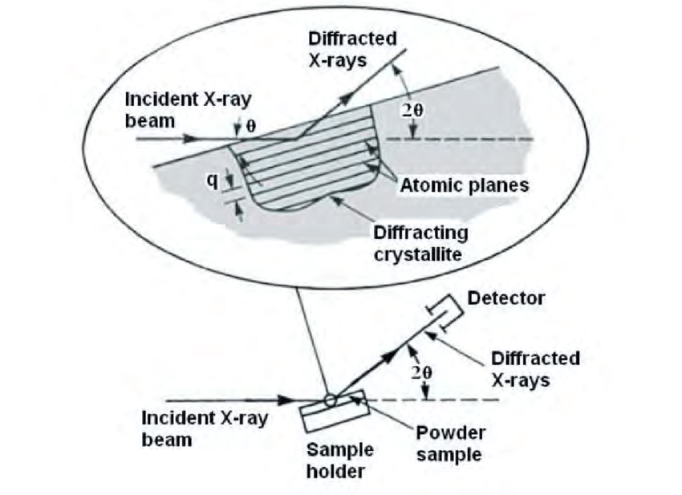

There intersections with a photographic film sets with its plane normal to the incident beam, form a series of concentric circular rings. In this case, a part of the reflected cone is recorded on the film and it is a pair of arcs, the resulting pattern is shown in Fig. Diameter of these rings or corresponding arcs is recorded on the film, and using this the glancing angle and interplanar spacing of the crystalline substance can be determined. Figure shows the film mounted in the camera and the X-ray powder pattern obtained. The film on spread-out is shown in Fig. The distance between any two corresponding arcs on the film is indicated by the symbol S.