Stable Isotopes

What is (stable) isotope?
The isotope of an atom is determined by the number of neutrons in the nucleus. Different isotopes of the same element have very similar chemical properties because chemical reactions depend almost entirely on the number of electrons that an atom has.
The number of protons and neutrons together determine the nuclide (type of nucleus). Protons and neutrons have nearly equal masses, and their combined number, the mass number, is approximately equal to the atomic mass of an atom. The combined mass of the electrons is very small in comparison to the mass of the nucleus, since protons and neutrons weigh roughly 2000 times more than electrons.
Stable isotopes are chemical isotopes that are not radioactive. Stable isotopes of the same element have the same chemical characteristics and therefore behave almost identically. The mass differences, due to a difference in the number of neutrons, result in partial separation of the light from heavy isotopes during chemical reactions (isotope fractionation).
Radioactive decay is the set of various processes by which unstable atomic nuclei emit subatomic particles (radiation). Decay is said to occur in the parent nucleus and produces a daughter nucleus. This is a random process, i.e. it is impossible to predict the decay of individual atoms. A lack of necessary neutrons makes a nucleus unstable. Protons in the nucleus are positively charged, meaning they repel each other. The presence of neutrons is necessary to separate these protons slightly, making the configuration stable. When the configuration is unstable, nuclear decay can result, turning the atoms into showers of radioactive particles.
The rate at which the isotope decays is given by its half-life, the interval after which half of the material breaks down. Half-life varies between a fraction of a second and many times longer than the age of the universe. Some isotopes, like Helium-3, are not radioactive.

Introduction

Most naturally occurring elements consist of more than one stable isotope. In elements with an atomic mass of less than 40 (i.e. lighter than Ca) it is possible for the isotopes to be fractionated through physical processes as a consequence of the mass difference between the isotopes. The degree of mass fractionation is proportional to the mass difference. At atomic masses higher than 40 the relative mass differences are too small to allow isotopes to become physically separated.

In geochemistry the study of stable isotopes is a powerful means of studying the light elements H, C, N, O and S – a group of elements not easily studied in other ways. These elements are often the main constituents of geologically important fluids, thus affording a means of directly studying both the fluids and the effects of fluid-rock interaction. In addition, stable isotopes are used as tracers to determine the source of an element, as palaeothermometers and as a means of studying diffusion and reaction mechanisms in geological processes. It is also used to illustrate its role in elucidation geochemical processes in igneous, metamorphic and sedimentary rocks. More detailed treatments are given by Hoefs (1987).

Conventionally stable isotopic are converted in to a gas (usually H₂, CO₂ or SO₂) analysis and the mass differences are measured in a mass spectrometer. With such commonly occurring elements as O, H, C and S contamination during sample preparation and analysis is a particular problem and great care must be taken to ensure clean sample handling. Increasingly, however, the ion probe and laser microprobe are being used in stable isotope analysis and a number of recent studies have illustrated how a much finer spatial resolution of isotopic composition is possible using these techniques.

Notation

Stable isotope ratios are measured relative to a standard and are expressed in parts per thousand, i. e. parts per mil (⁰/₀₀). The isotope ratio is expressed as a δ value, or ‘del value’ as it is sometimes called. Using oxygen isotopes as an example, the δ value is calculated as follows:

δ¹⁸0^{0 / 00} = $\left[\frac{{}^{\text{18}}{\text{O/}}^{\text{16}}\text{O }(\text{sample})−^{\text{18}}{\text{O/}}^{\text{16}}\text{O }(\text{standard})}{{}^{\text{18}}{\text{O/}}^{\text{16}}\text{O }(\text{standard})}\right]$ X 1000

Thus a δ¹⁸O value of +10.0 means that the sample is enriched in ¹⁸O relative to the standard by 10 parts in thousand and a value of -10.0 means that the sample is depleted in ¹⁸O relative to the standard by 10 parts in a thousand.

Isotope fractionation

The chief purpose of studying stable isotopes is as a means of investigating the processes which in nature separate isotopes on the basis of their mass rather than on the basis of their chemistry. This is known as isotopic fractionation and takes place in nature in three different ways:
(1) Isotopic exchange reactions: Isotope fractionation may take place in a conventional exchange reaction in which, for example, oxygen is exchanged between quartz and magnetite

2Si ¹⁶O₂ + Fe₃ ¹⁸O₄ = 2Si ¹⁸O₂ + Fe₃ ¹⁶O₄

The isotopic fractionation is controlled by bond-strength and follows the general rule that the lighter isotope forms a weaker bond than the heavier isotope.

(2) Kinetic processes: Kinetically controlled stable isotope fractionation reflects the readiness of a particular isotope to react. Kinetic effects are only observed when a reaction does not go to completion.

(3) Physico-chemical processes such as evaporation and condensation, melting and crystallization and diffusion.

The fractionation of an isotope between two substances A and B can be defined by the fractionation factor α:

α_{A-B} =$\frac{\text{ratio in A}}{\text{ratio in B}}$

For example, in the reaction in which ¹⁸O and ¹⁶O are exchanged between magnetite and quartz, the fractionation of ¹⁸O/¹⁶O between quartz and magnetite is expressed as

α_{quartz – magnetite} =$\frac{(^{\text{18}}{\text{O/}}^{\text{16}}\text{O in quartz}}{(^{\text{18}}{\text{O/}}^{\text{16}}O)\text{ in manetite}}$

Where ‘¹⁸O/¹⁶O in quartz’ and ‘¹⁸O and ¹⁶O in magnetite’ are the measured isotopic ratios in coexisting quartz and magnetite.

Many physical and chemical factors such as temperature, pressure, kinetic effect, diffusion, distillation, chemical composition of rocks, and crystal structures control the stable isotope fractionation.

Oxygen Isotopes

There are three stable isotopes of oxygen which have the following abundances:

¹⁶O = 99.763 %
¹⁷O = 0.0375 %
¹⁸O = 0.1995 %

The isotope ratio ¹⁸O/¹⁶O is the ratio which is normally determined in oxygen isotope studies and δ values are calculated from Equation given above. There are currently two isotopic standards in use for oxygen isotope measurements. Low-temperature geothermometry measurements are made relative to PDB, a belemnite from the cretaceous Peedee formation of South Carolina, a standard otherwise used for carbon isotope measurements whilst all other measurements are calculated relative to concentrations in Standard Mean Ocean Water (SMOW). SMOW was originally a hypothetical water sample with oxygen and hydrogen isotope ratios similar to those of standard ocean water. Currently a water standard distributed by the Atomic Energy Agency in Vienna, known as Vienna- SMOW or V-SMOW is used. This has an ¹⁸O/¹⁶O ratio identical to SMOW (Gonfiantini, 1978).V-SMOW and PDB δ¹⁸O values are related by the expressions

δ ¹⁸O_{V-SMOW} = 1.03091 δ¹⁸O_{PDB} + 30.01
and
δ ¹⁸O_{PBD} = 0.97002 δ¹⁸O_{V-SMOW} – 29.98

Oxygen isotope thermometry

One of the first applications of the study of oxygen isotopes to geological problems was to geothermometry. Ure (1947) suggested that the enrichment of ¹⁸O in calcium carbonate relative to seawater was temperature-dependent and could be used to determine the temperature of ancient ocean waters. The idea was quickly adopted and palaeotemperatures calculated for the Upper Cretaceous seas of the northern hemisphere. Subsequently, a methodology was developed for application to higher-temperature systems based upon the distribution of ¹⁸O between mineral-pairs. An excellent review of the methods and applications of oxygen isotope thermometry is given by Clayton (1981).

There are both low-temperature and high-temperature application of oxygen isotope thermometry.

Low-temperature thermometry: The earliest application of oxygen isotopes to geological thermometry was in the determination of ocean palaeotemperatures. The method assumes isotopic equilibrium between the carbonate shells of marine organisms and ocean water and uses the equation of Epstein et at. (1953) which is still applicable despite some proposed revision (Friedman and O’Neil, 1977)

T ⁰C = 16.5 – 4.3(δc – δw) + 0.14(δc – δw)²

Where δc and δw are respectively the δ¹⁸O of CO₂ obtained from CaCO₃ by reaction with H₃PO₄ at 25ºC and the δ¹⁸O of CO₂ in equilibrium with the seawater at 25ºC.

High-temperature thermometry: Stable isotope systems are frequently out of equilibrium in rocks which formed at high temperatures as a result of equilibrium with a fluid phase following crystallization. This fact can be used to make inferences about the nature of rock-water interaction but it is not useful for peak-metamorphic temperatures in igneous and metamorphic rocks.

Use of oxygen isotope, together with radiogenic isotope, in correlation diagrams

Correlation between radiogenic and oxygen isotopes are particular importance because variations in the two types of isotope come about through totally different mechanisms.

Recognizing crust and mantle reservoirs

Oxygen isotopes provide a very effective way of distinguishing between rock which formed in equilibrium with the mantle and those which formed from the continental crust. In general the continental crust is enriched in δ¹⁸O relative to the Earth’s mantle (see Figure below). This has come about largely as a consequences of the long interaction between the continental crust and the hydrosphere and the partitioning of ¹⁸O into crustal minerals during low-temperature geological processes. Oxygen isotope, therefore, are a valuable indicator of surface processes and useful tracer of rocks which at some time have had contact with the Earth’s surface.

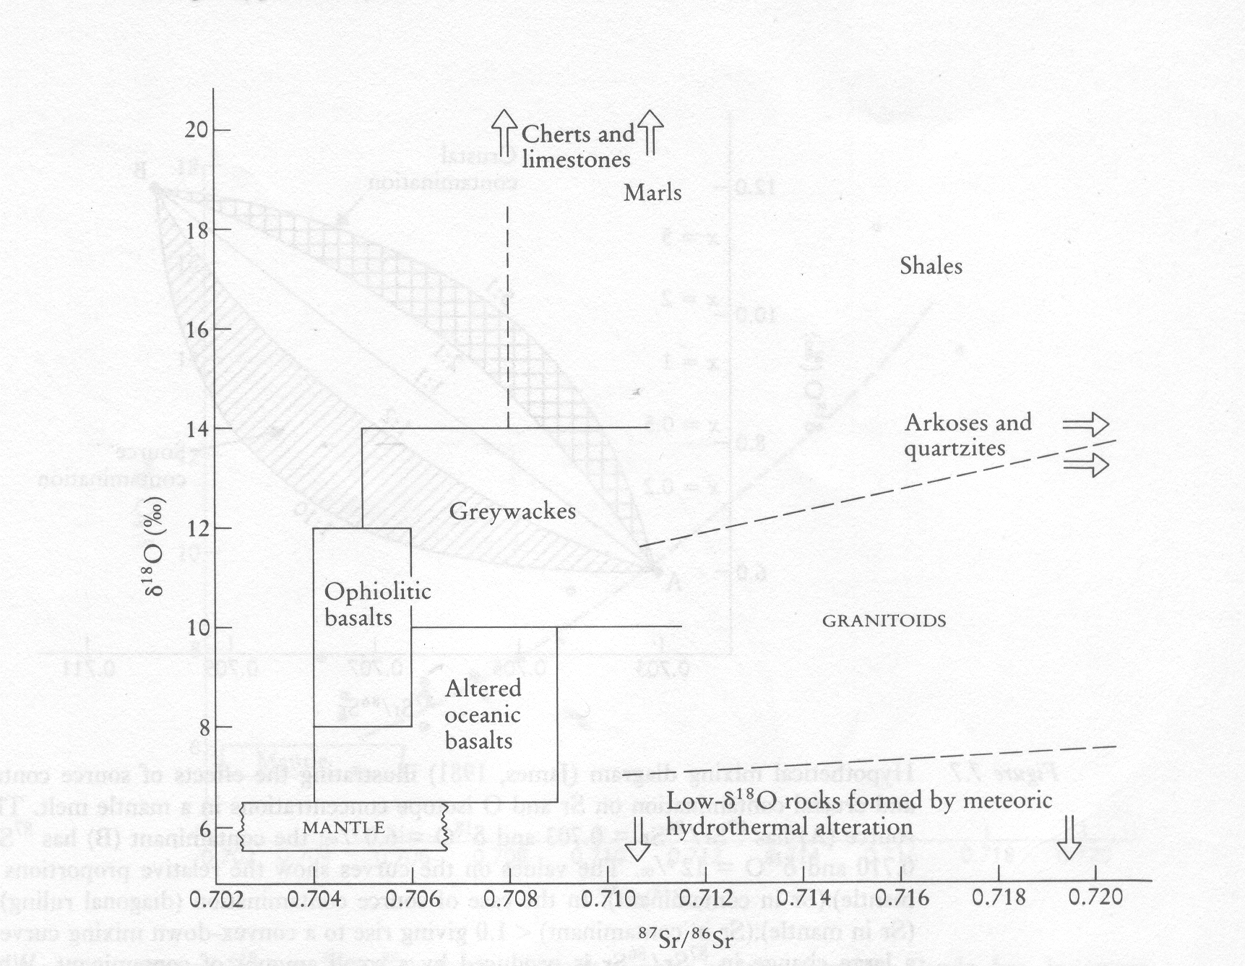

(Figure shows approximate ranges of δ¹⁸O and ⁸⁷Sr/⁸⁶Sr in common igneous and sedimentary rocks)

Radiogenic isotope, on the other hand, show differences between crust and mantle reservoirs which are a function of long-lived differences in parent/daughter element ratios and indicate the isolation of the reservoirs from one another for long periods of Earth history. This give rise to crustal reservoirs which generally are enriched in ⁸⁷Sr/⁸⁶Sr and in radiogenic lead isotopes but depleted in ¹⁴³Nd/¹⁴⁴Nd relative to mantle.

Recognizing crustal contamination in igneous rocks

Crustal rocks are enriched in both strontium and oxygen isotopes relative to the mantle; thus a bivariate Sr-O isotope correlation diagram is a powerful means of recognizing crustal contamination in mantle-derived rocks. There are two contamination mechanism – the contamination of the source region and contamination of a magma during its ascent through the continental crust. These two types of contamination may be distinguished from one another from the shape of mixing curve on a Sr-O isotope plot. In the case when the contaminant in a source region is enriched in Sr relative to the mantle and form a relatively small proportion of whole , then contamination on an ⁸⁷Sr/⁸⁶Sr vs δ¹⁸O mixing diagram is characterized by the convex-downward curvature of the mixing line (see Figure below). This arises because crustal materials are not only enriched in Sr relative to the mantle but also their ⁸⁷Sr/⁸⁶Sr ratio is greater than that of the mantle and thus dominates any mixure of the two. Oxygen concentrations, however, are broadly similar in all rocks so that there is no massive increase in the oxygen isotope ratio of the derivative melt. The small increase in δ¹⁸O is a simple linear function of the bulk proportion of crustal to mantle materials.
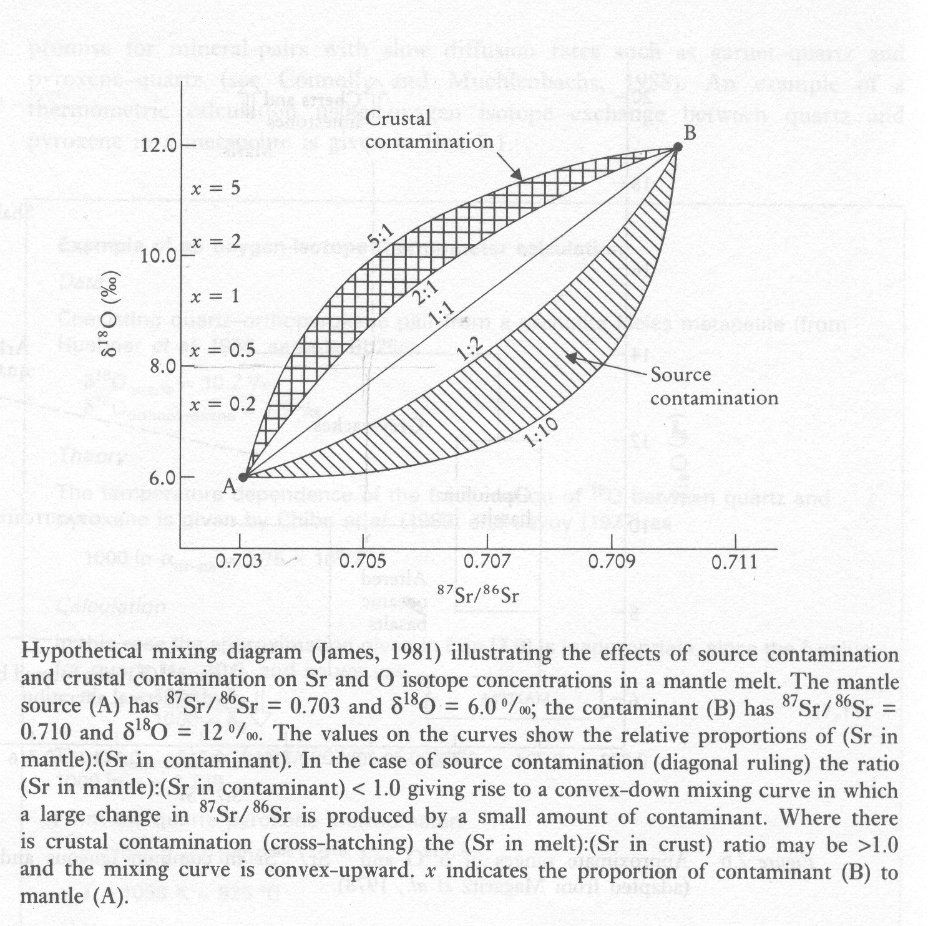

Recognizing simple crystal fractionation in igneous rocks

An igneous system which has not suffered crustal contamination will exhibit the radiogenic isotope characteristics of the source, for radiogenic isotope ratios are not altered by crystal-liquid equilibria such as crystal fractionation. Oxygen isotopes, on the other hand, do show small changes in isotope ratio with crystal fractionation, although extreme fractionation is required to produce small changes in δ¹⁸O.

