**MORALE**

* Morale is an overall attitude of an individual and group towards all aspects of their work
* It is an attitude of an employee towards his **job**, his **superior**, his **organisation**, etc.
* Morale is purely emotional.
* Morale may range from very high to very low.
* It is not a static thing.
* **DEFINITION**
* **Edwin B. Flippo** defines it as:

“a mental condition or attitude of individuals and groups, which determines their willingness to co-operate.

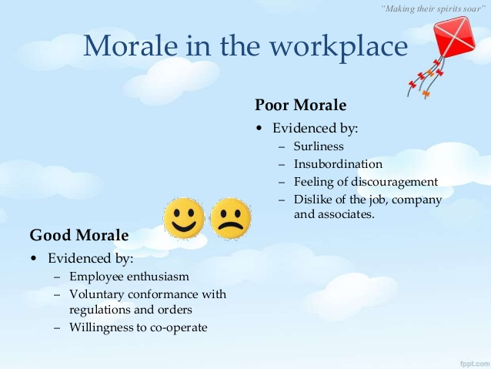

* **Indicators/Sign of Low Morale**
* The High rate of absenteeism
* Tardiness
* High labour turnover
* Strikes
* Lack of pride in work
* Wastage and spoilage
* **Indicators/Sign of High Morale**
* Internal cohesiveness
* Absence of sub groups within a group
* Ability to cope with changing environment
* Feeling of belongingness
* Commonness of goals
* **Morale Results In:**

1. High level commitment, sincerity, employee loyalty
2. Reduction in absenteeism, labour turnover, grievances
3. Increase in discipline
4. Reduction in industrial conflicts
5. Sound superior-subordinate relations
6. Increase in employee pride
7. Team building
8. Employee empowerment
9. Easy implementation of enterprise resource planning

**Morale and Productivity**

* There is positive relation among both morale and productivity ….high the morale ……high will be productivity.

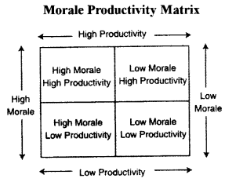

**(1) High Morale-High Productivity**

* When group goals are satisfied and individual goals including freedom of work, salary, etc. are satisfied, it will lead to motivation of the employees, so standard of performance will be high, which in turn leads to **high productivity** and vice versa.

**(2) Low Productivity-High Morale**

* Though the individual goals rather than causing high productivity like pleasant fellow workers, good working conditions, etc.. are satisfied.
* Where supervisors lack technical & administrative skills, it leads to **low productivity of high morale group**
* Where workers lack adequate skills or training it leads to low productivity by high morale.

**(3) High Productivity-Low Morale**

* Supervisor is only able to increase high productivity through his skills or planning ability rather than through motivation
* He practices penalty method to give rise to high productivity.

**(4) Low Productivity-low Morale**

* Where group goals and individual goals did not get satisfied.
* It will thus be observed that there is a complexity of relationship between morale and productivity.
* High morale is conventionally considered as a contributor to high productivity, but such correlation may not always be true.
* This is because high productivity may be the outcome of many other organizational initiatives, which may be independent of employee morale.
* Hence, even with low employee morale, high productivity is achievable.
* This can be illustrated using the model of Keith Davis, as shown in Figure:

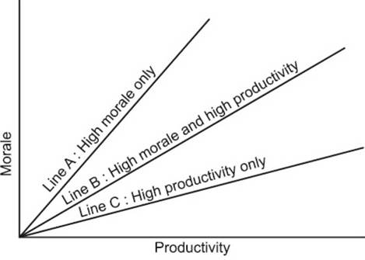

* Factors which affect morale are, primarily, attitude and job satisfaction levels of individual employees.
* From an organizational point of view, such factors can be delineated into:
  + organizational goals
  + leadership styles
  + co-workers’ attitude
  + nature of work
  + work environment
  + the employee himself.

**Satisfaction, Motivation & Productivity**

* These three are closely related in most workplaces.
* While productivity depends on a number of factors, including organizational structure and access to physical resources, it is also a direct result of employee motivation.
* Employees who are more satisfied have more reasons to work hard and contribute to a shared work ethic, that encourages others to do the same.
* Likewise, drops in productivity may stem from low levels of worker satisfaction.
* A business with high satisfaction and motivation levels can:
  + - better serve its customers
    - enjoy a competitive advantage over competitors
    - Managers use a variety of tools/techniques to encourage employee satisfaction, promote motivation and improve productivity.
* Some of these tools involve finding ways to make employees more comfortable in their jobs.
  + Employee benefits
  + flexible work hours
  + recognition for achievement

……. all help improve job satisfaction.

* “Happy Workers are Productive Workers”
  + Developed in 1930’s & 1940’s
  + Result from Hawthorne studies at Western Electricals
  + In 1980’s- relationship between satisfaction and performance was not particularly high.
  + Recently as per review found the correlation between job satisfaction and performance is moderately strong
  + Satisfaction was a likely cause of better performance, but higher performance was not a cause of higher job satisfaction.
* Satisfaction-Performance relationship is present in both:
  + Individual and
  + Organizations level.
* Organizations with more satisfied employees tend to be more effective than organizations with fewer

**MEASUREMENT OF MORALE**

1. **Observation**

A keen observation of employees behaviour, talk, gestures should help the manager to identify any change in the level of morale.

On identifying this, the manager should immediately think of a remedial action in order to restore the morale at its previous level.

1. **Attitude Surveys**
2. Interview Method
3. Questionnaire Method

**(3) Company Records And Reports**

* Certain reports from the personnel department provides the information about labour turnover, rate of absenteeism, no of workers grievances, strikes, etc..