**Attitude**

Attitude represents ones belief, feeling and ideas ,action, tendency towards object and ideas.

When a person feels about something, about a place, commodity and a situation or an idea is called attitude.

An attitude is a **predisposition** to act or feel a certain way towards a person or thing.

It represents an individual's degree of like or dislike for an item.

Attitudes are generally positive or negative views of a person, place, thing, or event this is often referred to as the **attitude object**.

**Nature of Attitude**

1. Attitude are learned
2. It is not permanent it can be changed
3. Are organized and are core to an individual.
4. Have an emotional charge + or –
5. Occur within a situation
6. Can not be measured direct
7. Not similar to values but interrelated

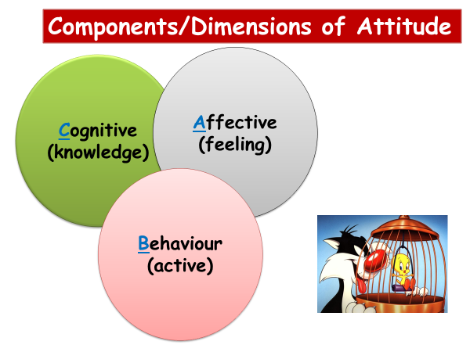

**Three components of Attitude (ABC model)**

* **Affect** (How I feel about it) moods and emotions about some idea, person, event or object.
  + **Behavioural** tendency (active), favourable or unfavourable evaluation of something.
  + **Cognitions** (what I think or know) beliefs, opinion, knowledge or information held by individual.

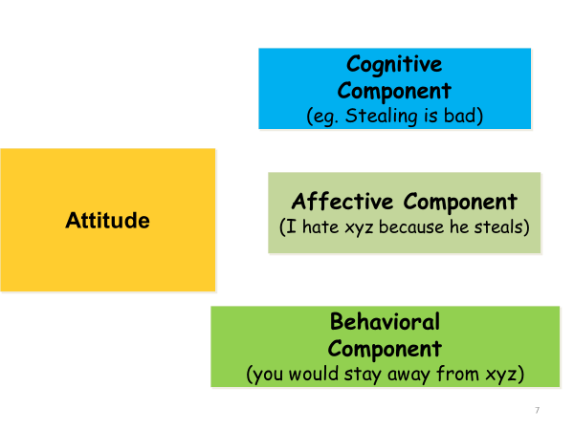

**ABC Model**

* The importance of the model is that to thoroughly understand an attitude, one must assess all three components.
* Example – one wants to evaluate one’s employees attitude toward ‘flexitime’.
  + One would determine how they feel about flexitime(affective)
  + Whether they would use flexitime (behaviour)
  + What they think about policy (cognition)

Attitudes have a stronger affect on behavior if they are :

* + important
  + specific
  + accessible
  + social pressure reinforces the attitude
  + you have experience with the attitude.

**Formation of Attitudes**

* Essentially attitudes are the outward manifestation of your inner values and beliefs.
* These develop over time.
* As we grow, we watch the people around us behaving in a particular way; and are told to cherish certain things over others.
* We learn from our teachers and peers and come to value certain things over other, thus forming your value system.
* These in turn give rise to development of your attitudes.

**Attitude can be developed through:**

* Self image and self reformation
* Education and hard work
* Discipline and organization
* Belief in goodness's and truth and many more**.**

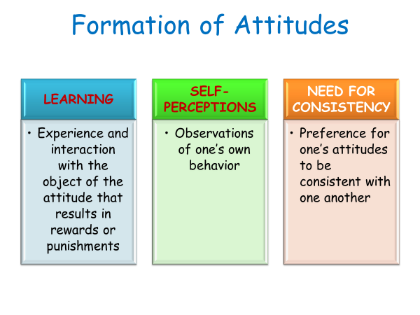

**Why Attitudes Matter at Work?**

**Because attitudes to work might affect:**

* Whether a person seeks a new job
* How co-operative they are with others at work?
* Whether they present a positive image of the organisation to clients or customers?
* How they react to change?
* How hard they work (motivation)?

**Positive Attitude in Organization will:**

1. Increases productivity
2. Fosters teamwork
3. Solves problems
4. Improves quality
5. Breeds loyalty
6. Increase profits
7. Reduces stress
8. Makes for pleasing personality