**The Johari Window**

* It is a communication model that can be used to improve understanding between individuals.
* Developed by **Joseph Luft** and **Harry Ingham.**

(the word “Johari” comes from:

**Jo**seph Luft and **Har**ry **I**ngham).

* Two key ideas behind the tool:

1. Individuals can build trust between themselves by disclosing information about themselves.
2. They can learn about themselves and come to terms with personal issues with the help of feedback from others.

Using this model, each person is represented by their own four-quadrant/pane, window.

Each of these contains and represents:

* personal information – feelings
* motivation - about the person

Shows whether the information is known or not known by themselves or other people.

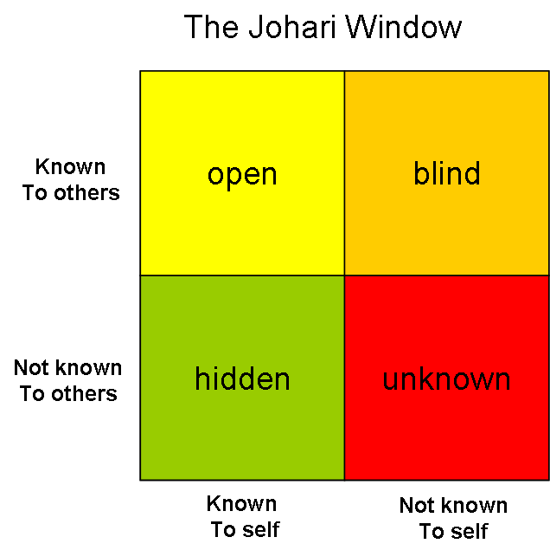

* **Quadrant 1: Open Area(**open self, free area, free self, or 'the arena**)**
  + What is known by the person about him/herself and is also known by others.
  + This is the information about the person - behavior, attitude, feelings, emotion, knowledge, experience, skills, views, etc - **known** by the person ('the self') and **known** by the group ('others').
* Person socializes about himself with others and constantly receives feedback from others.
* As a result, group becomes more effective and the relationship in group is very dynamic.
* Process of feedback solicitation is very common. Occurs in the group that has an understanding and the feedbacks of the other person are heard.
* Open area through this group can be increased horizontally such that the blindspot area is reduced
* Vertically it is increased so that the hidden and unknown areas of a person are reduced when that person reveals about his feeling to the other person.
* **Quadrant 2: Blind Area, or "Blind Spot“**
  + What is unknown by the person about him/herself but which others know.
  + This can be simple information, or can involve deep issues (for example, feelings of inadequacy, incompetence, unworthiness, rejection) which are difficult for individuals to face directly, and yet can be seen by others.
  + Other people may interpret your personality different than you might have expected. For efficient communication, this area must be reduced.
  + One way to do it is through feedback that you get from other members in the group
* **Quadrant 3: Hidden or Avoided Area (** hidden self, avoided self or 'façade’)
  + What the person knows about him/herself that others do not.
  + The reason may be the information might be personal to you so that you are reluctant to share it with others.
  + Includes secrets, past experiences, feelings, etc. Many people keep their information private and do not share it with others.
* **Quadrant 4: Unknown Area** (unknown self**)**
  + What is unknown by the person about him/herself and is also unknown by others.
  + Might be some traumatic experience in the past about a particular event or experiences which might be unknown for your ever.
  + The person & group, is unaware about this till he or she discovers it. One way to reduce this area is through open communication.

When we work in Open area we are at our most effective and productive, and the group is at its most productive too.

* Established team members tend to have larger open areas than new team members.
* New team members start with small open areas because relatively little knowledge about the new team member is shared
* Reduce the Blind Area by Using Solicit Feedback from others, this will expand the open area
* Relevant hidden information and feelings, etc, should be moved into the open area through the process of 'disclosure‘ thereby increasing the open area
* Reducing hidden areas also reduces the potential for confusion, misunderstanding, poor communication, etc, which all distract from and undermine team effectiveness
* Managers and leaders can help by creating an environment that encourages self-discovery, constructive observation and feedback among team members.

**Increasing the Open Area:**

Feedback develops the open area by reducing the blind area.

The open area can also be developed through the process of disclosure, which reduces the hidden area.

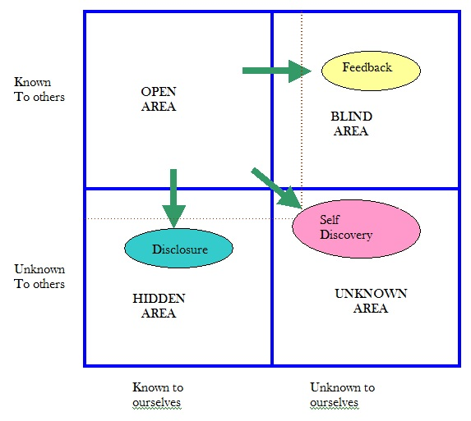

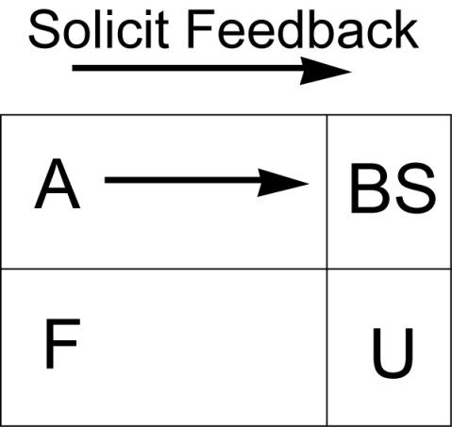

**The size of open area can be expanded horizontally into Blind space by seeking and actively listening to feedback from other group members.**

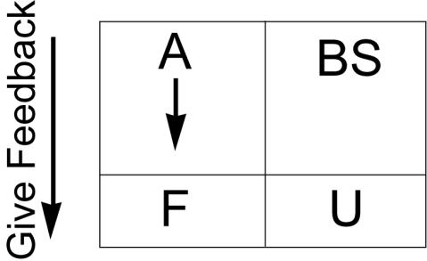

**The size of open area can also be expanded vertically downward into the hidden or unavoided space by sender’s disclosure of information, feelings etc. about himself/herself to the group and group members.**

**The unknown area –**

**…..**can be reduced by

1. Observation
2. Self Discovery
3. Mutual Enlightenment
4. Group Discussion

**Team**

* Team with Large open area has strong mutual understanding compared to the ones having large Hidden, Blind , and/or Unknown Areas
* Team Leaders should always strive to increase the open Area
* The individual should disclose more information about his/her feelings , experiences , views, etc. to reduce the size of Hidden area.
* Seeking feedbacks will reduce the Blind area and will overall increase the team performance
* Sensitive communications, active listening and experience will transfer the unknown area blind or hidden or open areas.

**Tips for using Johari Window**

* Don’t be rash in your self-disclosure.
* Be careful in the way you give feedback.
* Improve understanding & group’s relationship.
* Based on two assumption.
* Used to improve personal & professional relationship.
* Develop interpersonal relationship.