**Group Behaviour And Group Dynamics**

Founded by Kurt Lewin to study:

group decision

group productivity

group interaction

group cohesiveness

group communication

The underlying assumption was that the laws of the group behavior can be established independently of the goals of group irrespective of the structure of the group.

**CONCEPT OF GROUP DYNAMICS**

* Group dynamics contains two terms:
  1. **Group** is basically a collectivity of two or more persons. Dynamics comes from
  2. Greek word meaning **Force**

Thus,

“Group dynamics is concerned with the interactions of forces among group members in a social situation.”

**What is Group???**

In order to be called a group, an aggregation of people must satisfy the following conditions:

1. People must interact with one another
2. People must be physically aware of one another
3. People must perceive themselves to be a group

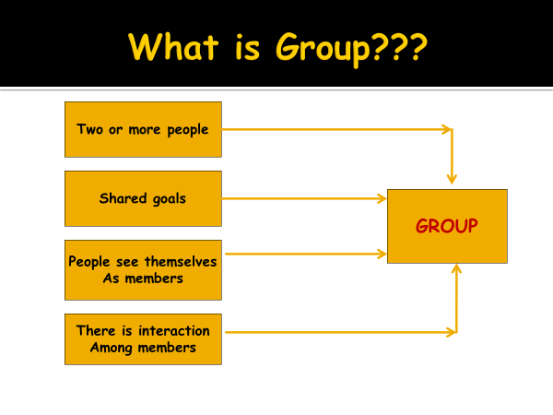

**Why People Join Groups?**

1. To satisfy mutual interests
2. To achieve status and security
3. To fill social needs of interaction
4. To fill need for self esteem.
5. Add up to skills
6. Need for power and strength
7. Goal achievement becomes easier

**Types of Group**

**A. Formal Group:** A group defined by organisation’s structure with designated work assignments, establishing tasks directed towards organisational goals.

**i) Command group:**

* + A group composed of the individuals who report directly to a given manager. Are determined by the organisational charts.
  + They are long term in nature and remain un-effected by the changes in the people at that particular level.

**ii) Task group:**

* + represents those who work together to complete a job task.

“ All command groups are task groups but all task groups need not be command groups as task groups can cut across the organization.”

**B. Informal Group:**

* + A group that is neither formally structured nor organizationally determined; appears in response to the need for social contact.
  + Membership in such groups is voluntary.

**i) Interest group :**

* + A group of employees who come together to satisfy a common interest like:
    - improving working conditions
    - protesting company’s environmental policies
    - adjusting vacation schedules.

**ii) Friendship group :**

* + Groups that develop because the individual members have one or more common characteristics.
  + The social alliances extend beyond work situation.

**iii) Reference group :**

* + Base of Interest & Friendship.
  + Have in common race, gender, religion, social class, educational level, profession.

**Importance of Groups to Organization**

1. Filling in gaps in manager’s ability
2. Solving work problems
3. Better coordination
4. Channel of communication
5. Restraint on managers
6. Better relations
7. Norms of behaviour
8. Satisfied workforce
9. Developing future executives

**Group Development/Formation**

Groups have life cycles similar to people.

They are born, grow, develop and often die

Group’s effectiveness is influenced by its stage of development and how well its members have learnt to work together.

Groups passes through 5 stages:

* 1. Forming
  2. Storming
  3. Norming
  4. Performing
  5. Adjourning
* **Five stage Model of Group Formation**

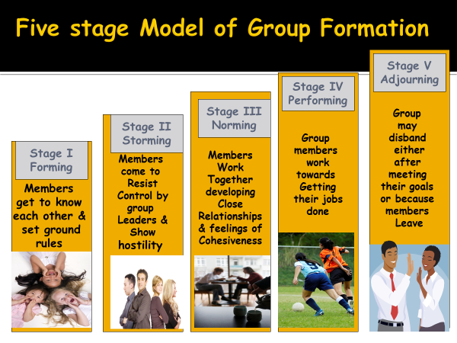

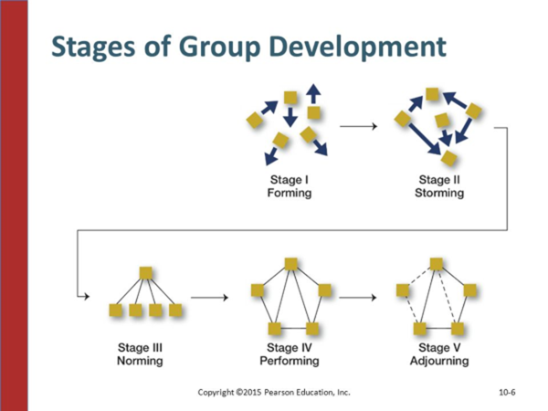

**1. FORMING**

* Group members look to the leader for direction.
* Members have a desire for acceptance by the group and fitting in.
* Members are sizing each other up – checking out personalities and talents of other members.
* Members focus their discussion on the task at hand, not worrying about relationships.
* Feelings going through members include insecurity, nervousness. they are asking themselves :

“do i belong?”

“will i be accepted by the group?”

**2. STORMING**

* Characterized by tension, competition, and conflict among group members.
* Questions arise about who is responsible for what and what the rules are.
* Some members may remain silent while others attempt to dominate.
* Some members question authority and competency of the group leader
* The group leader has to raise the conflict issue and deal with it.

**3. NORMING**

* Leadership is shared and cliques dissolved.
* Conflicts are resolved and there is a stronger sense of belonging to the group.
* Creativity is high.
* People know where they fit in and what is expected of them.

**4. PERFORMING**

* Now the group is in high gear and highly productive. the need for group approval is past.
* Group members can now focus on the task and care for other members of the group.
* Group identity is complete, group morale is high, and group loyalty is intense.

**5. ADJOURNING/RE-FORMING**

* This stage occurs when the tasks are completed and there no longer is a need for the group to exist.
* This stage includes recognition for participation (awards) and an opportunity for group members to say good bye. (closure)
* With the dissolving of the group, new leaders are needed to take on the new tasks, so a new group forms.

**Group Structure**

Four different aspects of group structure are:

* + 1. Norms
    2. Roles
    3. Status
    4. Cohesiveness

**A. Group Norms:**

* Set of beleifs, feelings, and attitudes commonly shared by group members.
* These are also referred to as rules or standards of behaviour that apply to group members.
* Norms serve three functions namely:
  1. Predictive- basis for understanding the behaviour of others
  2. Control- regulate the behaviour of others
  3. Relational- some norms define relationships

**B. Role:**

-various parts played by group members.

There are two elements that define this role identity-

* Role Perception -An individual is expected to behave according to his own perception in the group.
* Role Expectation- It is defined as how others believe one should behave in a given situation.

**C. Status:**

Status is “ a socially defined position or rank given to groups or group members by others”.

Group members get high status or low status in the group based on their authority and performance:

* **High** status members of the group have more freedom to deviate from the norms.
* **Low** status members of the group should not have freedom to deviate from the norms as it leads to status inequality.

**D. Group Cohesiveness:**

**The degree to which members are-**

* + Attracted to each other
  + Motivated to stay in the group
  + Share group goals
  + Have common values

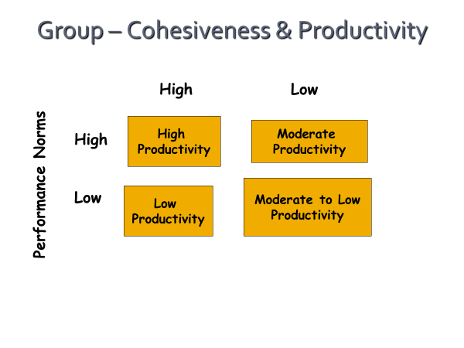

**Importance of High/Low Cohesiveness**

**High Cohesiveness**- Unity  
- Interactive  
- Positive Feelings  
- Ability to Cope with Problems  
- More Productive

**Low Cohesiveness**  
- Negative Feelings  
- More Problems  
- Less Productive

**Social loafing -** the tendency of people to work less hard in a group than they would individually.

Reasons for social loafing:

* + Individual contributions are less noticeable in the group context.
  + -Some individuals prefer to see others carry the workload

**Theories of Group Formation**

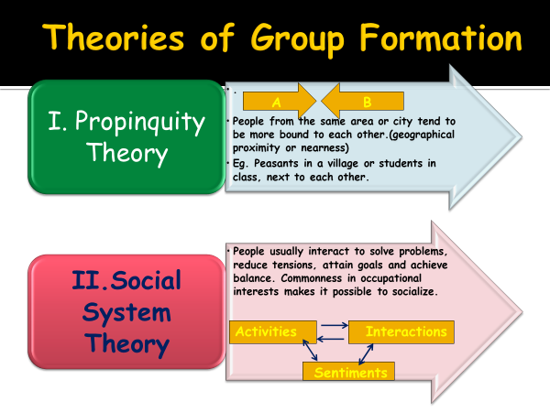

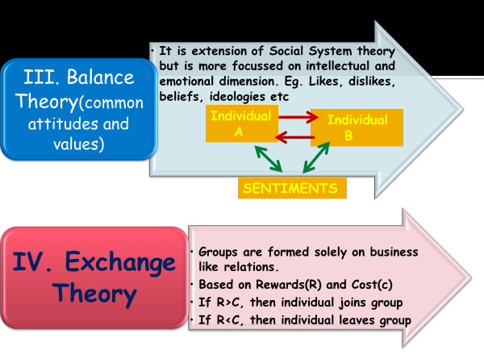

**CONCLUSION:**

* The groups operate on a common task and common attitudes.
* GD is concerned with the interaction between the group members in a social situation.
* This is concerned with the gaining in the knowledge of the group, how they develop and their effect on the individual members and the organization in which they function.

It is essential to study since it helps to find how the relationships are made within a group and how the forces act within the group members in a social setting.

* This helps to recognize the formation of group and how a group should be organized, lead and promoted.