**TRANSACTIONAL ANALYSIS**

**(A piece of business between two people)**

* TA was developed by Eric Berne(1961)
* It is theory of personality and organised system of interactional therapy.
* A model for explaining why and how:
  + - People think like they do
    - People act like they do
    - People interact/communicate with others
* Humans are :
  + - Social beings
    - Influenced by social forces
    - Influenced by the expectations and demands of significant others
    - Known to make a habit patterns

Purpose of TA is to provide better understanding of how people relate to each other, so as to develop improved communication.

TA consists of identifying the ego states that the initiator and the respondent exhibit in an interaction

* + People have three ego states : -
    1. **Parent:** when a person thinks, feels & behaves in ways copied from his/her parents.

 These people tend to talk to people and treat others like children.

Features are:

* + - * Judgemental
      * Rule maker
      * Moralising
      * Over protective
      * Indispensable
    1. **Child:** thinking, feeling, behaving as one did as a child

It is characterized by very immature behaviour.

Features are:

creativity

Anxiety

Depression

dependence

fear

joy

emotional sentimental etc.

* + 1. **Adult:** thoughts, feelings, or behaviors that are a direct result of current happenings.

 They assume that human beings as equal, worthy and responsible. Goes through one’s own experiences and continuously updates attitudes. Adult ego state is data processing center. Can evaluate parental and child programming and decide on what is all right and what needs to be changed.

* **Adult**, the final ego state, is the period in which a child develops the capacity to perceive and understand situations that are different from what is observed (Parent) or felt (Child).
* The Adult serves as a data processing center that utilizes information from all three ego states in order to arrive at a decision.

**Key point: People shift in & out of these states**

* Ego states are important facets of a personality
* Each ego state has particular verbal and non-verbal characteristics, which can be observed, if you are watching people.
* Each ego state has a positive and negative aspect

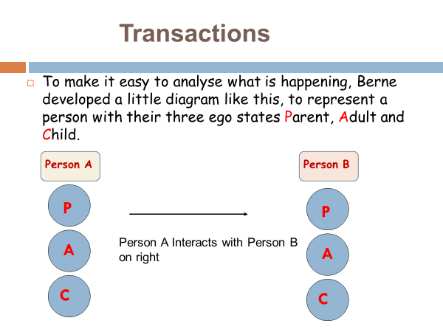

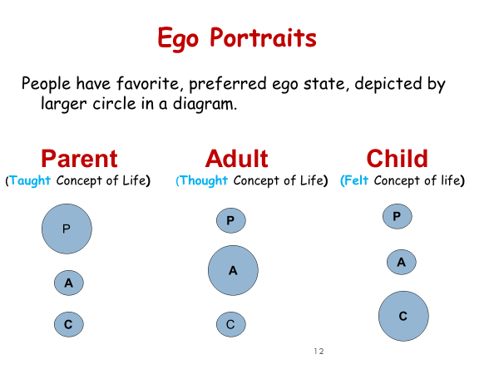

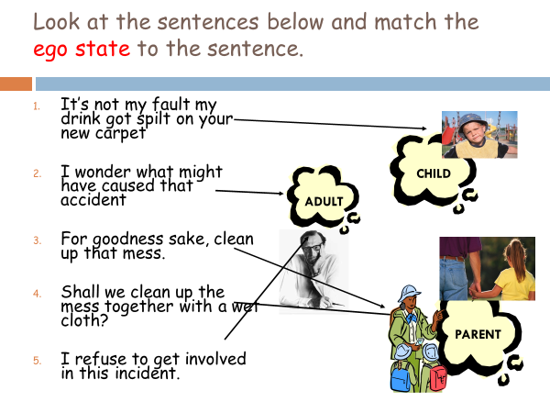

* People’s interactions are made up of t**ransactions**
* These involvea **stimulus** and **response**
* Berne said that when people are in their different ego states and they interact with other people, three main types of transaction (or interaction) can happen.

**I. Complementary Transactions (**both people are operating from the **same ego state**)**:**

* Appropriate and Expected Transactions indicating healthy human relationships.
* Communication takes place when transactions are complementary.
* A stimulus invites a response; this response becomes a stimulus inviting further response and so on.
* 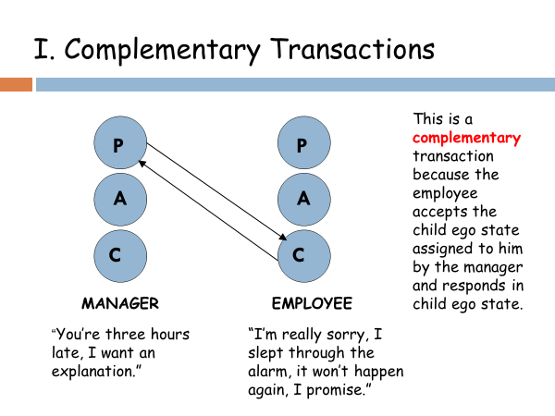

**II. Crossed Transaction** ( the other person reacts from an unexpected ego state)

A leader in the adult ego state deals with a subordinate who responds from their free child ego state with somewhat negative, rejecting input from the leader.

The one in which the transactional vectors are not parallel.

The ego-state being adressed is not the ego-states that responds.

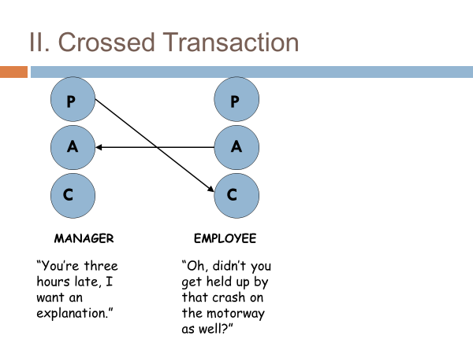

* Although the manager (**parent** ego state) attempted to address the employee as a **child**, the employee **refuses** this ego state and responds in **adult** ego state.
* In such transaction the person being spoken to refuses the ego state they are assigned by the first speaker.

III. **Ulterior Transaction(**two ego states within the same person but one disguises the other)

One of these is an overt or, the other a covert or psychological-level message.

They are very damaging to IP relation because it always involve at least two ego state on the part of 1 person.

Individual may say one thing but mean quite another.

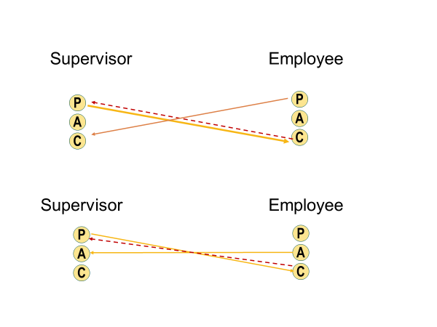

**Employee**: “Sorry, I won’t have the drawing ready for tomorrow’s deadline.” (ulterior message: “kick me, I’m a bad boy.”)

**Manager:** “It’s O.K. I’ve been thinking of assigning the job to someone else anyway.” (hidden meaning: “yes, you are a bad boy. here’s your kick

**Summary on Ego states:**

* We all have three different ego states programmed with different behaviour
* Become aware of when you are coming from your parent, ego and child.
* Awareness gives you more choice in your communication pattern
* By analysing transactions and knowing your own ego states, people gain a conscious control over how they interact or **‘Transact”** with each other.
* They can determine if transactions are complimentary, crossed or ulterior.

**T.A. - Importance**

1. TA helps to identify communication better and improves Interpersonal Skills
2. It is a powerful tool in organizational training
3. An understanding of TA helps people to modify their own behaviour in order to obtain the required behaviour from others
4. It helps people to develop leadership qualities
5. With the aid of TA you can identify ego state from which people operate and consequently adapt suitable leadership style.

**STROKES**

* Transactions can be viewed as a series of strokes and counter strokes.
* A stroke is the recognition of presence of another person(nod, smile, gesture)
* They can be physical or psychological.
* Essential to a person's life

* Positive Strokes- “I love you”, “ you did a good job”
* Negative Strokes- “I hate you”
* When positive strokes are not given, we look for negative strokes rather than be without strokes at all!!

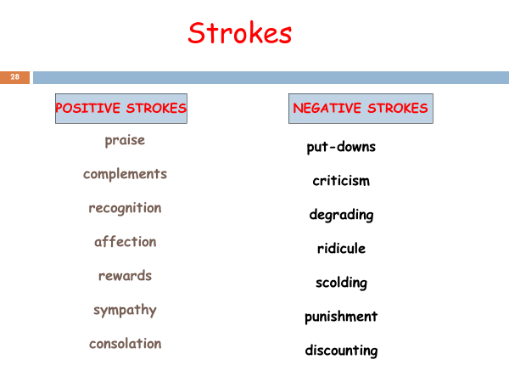

**Games**

* An ongoing series of complementary ulterior transactions progressing to a well defined predictable outcome. – manipulation
* Are played compulsively over and over
* Basically dishonest, involves the avoidance of intimacy
* Usually supports one’s life position regarding self and others.
* Ulteriorly motivated transactions that appear complementary on the surface but end in bad feelings.
* People play games to:
  + Structure time.
  + Achieve recognition.
  + Make others predictable.
  + Prevent intimacy.
  + Because intimacy involves risks, games keep people safe from exposing thoughts and feelings.
* Various types of games are given particular name:
  + Kick me
  + See what you made me do
  + I’m only trying to help you.
  + If it weren’t for you.

**Life Positions**

* In the process of growing up, people make basic assumptions about themselves and others.
* Very early in childhood a person develops from experience a dominant philosophy. Such philosophy is tied into his identity, sense of worth, and perception of other people.
* This tends to remain with the person for lifetime unless major experience occur to change it. Such positions are called life positions.

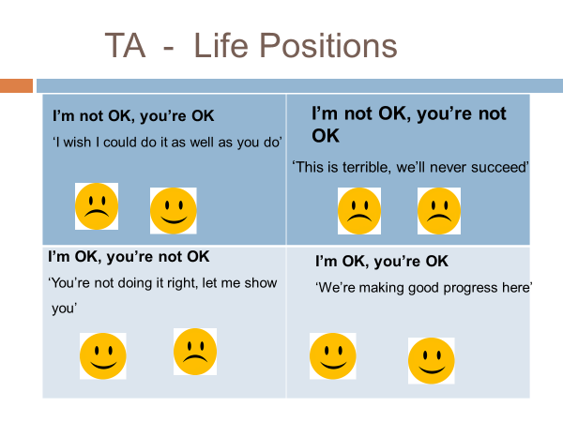

Four possible relationship resulted from this life position:

1. I am not OK, You are not OK (neither person have value)
2. I am not OK, You are OK (you have value but I do not have)
3. I am OK, You are not OK (I have value but you don't have)
4. I am OK, You are OK (we both have value)

**I AM NOT OK, YOU'RE NOT OK:**

* People tend to feel bad about themselves and see that the whole world as miserable.
* Give up, do not trust other people and have no confidence in themselves.
* **I AM NOT OK, YOU'RE OK:**
* People with this life position often come from their child ego state.
* They feel that others are more capable and generally have fewer problems than they themselves do.
* **I AM OK, YOU'RE NOT OK:**
* This type of people often come their Critical Parent ego state. They tend to be down on other people for at least two reasons-

1. They regard other people as source of criticism, and feel that if they are not exactly perfect or right, people will be excessively critical of them.
2. They want to break away or rebel from some authority figure and become more independent.

**I AM OK, YOU'RE OK:**

* This life position is considered as healthy position.
* People with these feelings express confidence in themselves as well as trust and confidence in other people in their environment.

**USES OF TA**

1. To learn or improve communication skills
2. A technique in resolving interpersonal conflicts
3. Studying supervisory control
4. Important tool for executive development
5. Leads to self development
6. Supervisors adopt parental ego state for control

**LIMITATIONS OF TA**

1. Not a Practical Approach
2. Difficult To Understand
3. Not Been Proved Empirically
4. Very Difficult To Define Human Behaviour And Communication