IATA Global Indicators

Global Indicators are two-letter codes used in fare construction to determine the routing to which the fare applies. This is one of the first steps in the construction of fares if you are unable to identify the correct global indicator for a routing then most probably you would end up choosing the wrong fare for the itinerary hence learning Global indicators is Vital.

1. **WH**– Western Hemisphere – Any Travel itinerary which originates and ends in Western Hemisphere or TC1 will have WH as Global indicator.

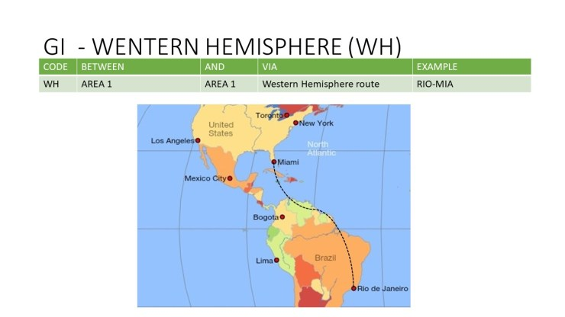

1. **EH**-Eastern Hemisphere – When Travel is conducted solely within the Eastern hemisphere the itinerary will have Global Indicator as EH.

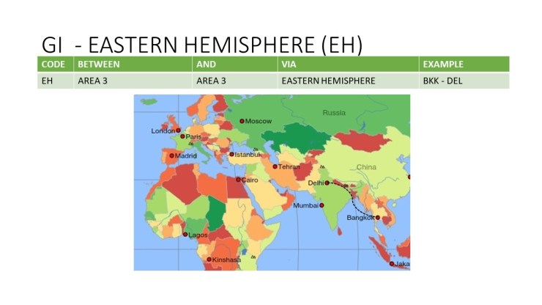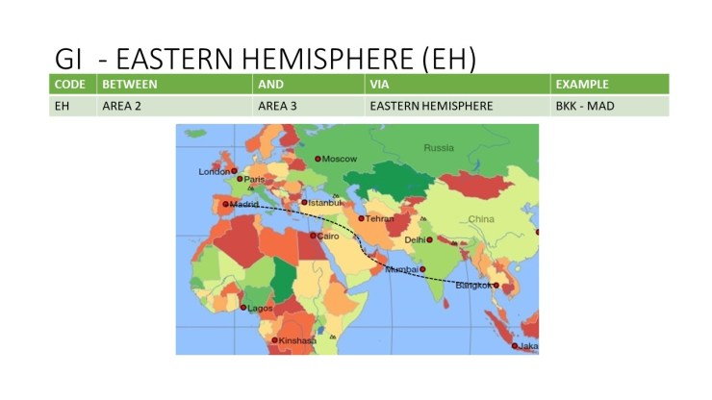

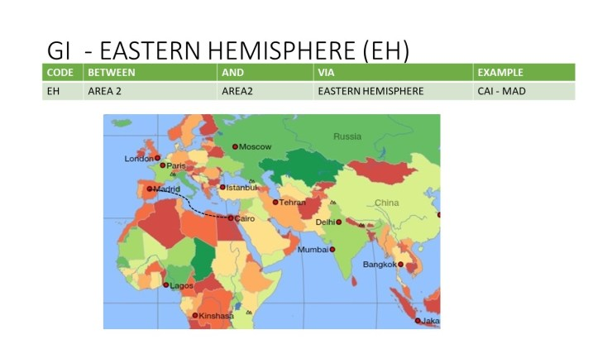

1. 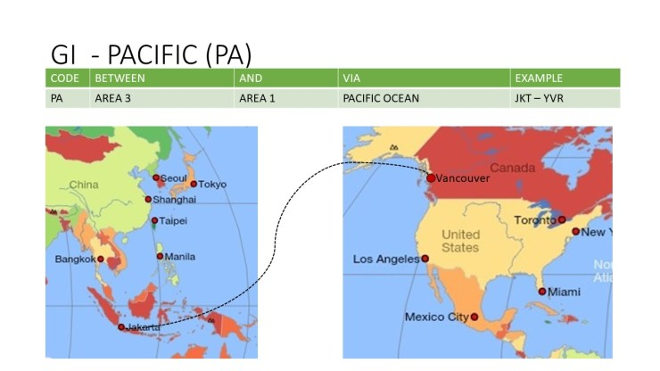**PA** or Pacific – When travel is conducted across the Pacific ocean only then Global indicator “PA” applies for the itinerary.

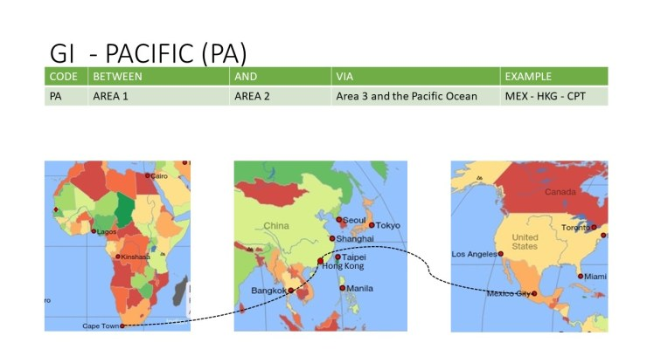

1. **PN**– Pacific North – This Global indicator is similar to PA with one major distinction. When travel is conducted between Area 1 and Area 3 via North America across the pacific ocean then the itinerary will have a Global indicator as PN.

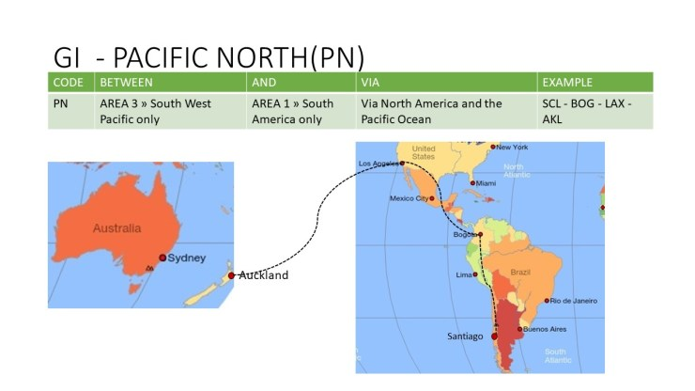

1. **AP** – Atlantic/Pacific – When travel is conducted across the Atlantic and Pacific oceans both then AP global indicator will be applied for the itinerary.

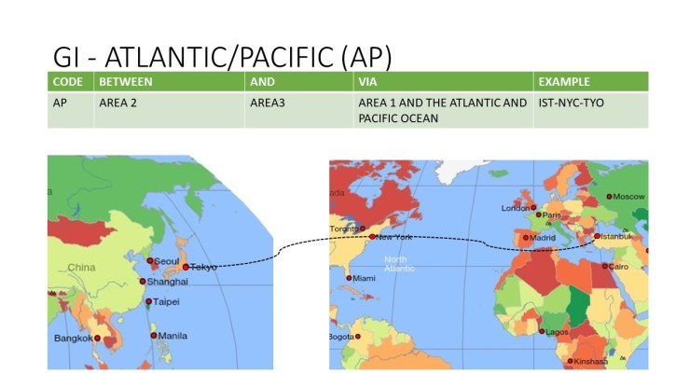

1. 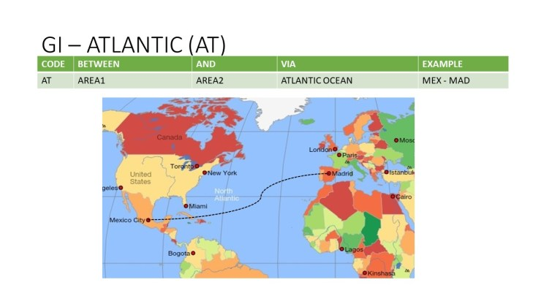**AT** – Atlantic – When travel is conducted across the Atlantic Ocean the itinerary will have “AT” as a global indicator. (TC1 and TC2 or TC3).

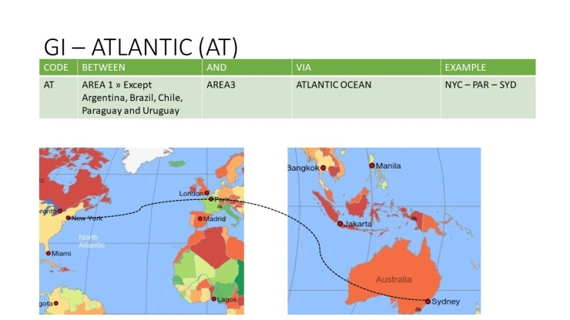



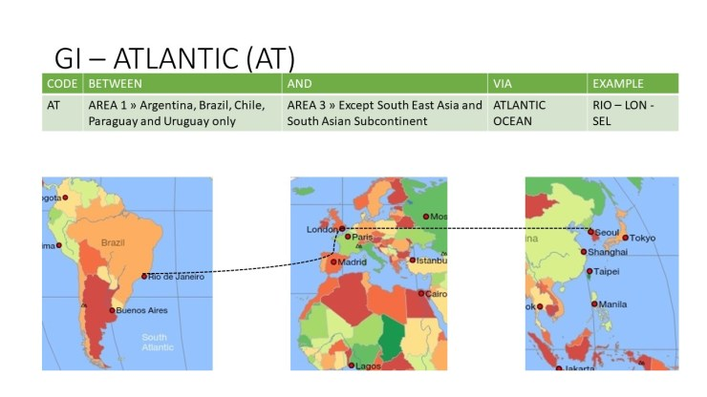

1. **SA**-South East Asia or South Atlantic – When Travel is conducted from South Atlantic Countries which are ABCUP – Argentina, Brazil, Chile, Uruguay, and Paraguay to Southeast Asia to South Asian Subcontinent via Southern Africa or Indian ocean island or direct transatlantic flights than for such itinerary Global indicator “SA” will be applied.

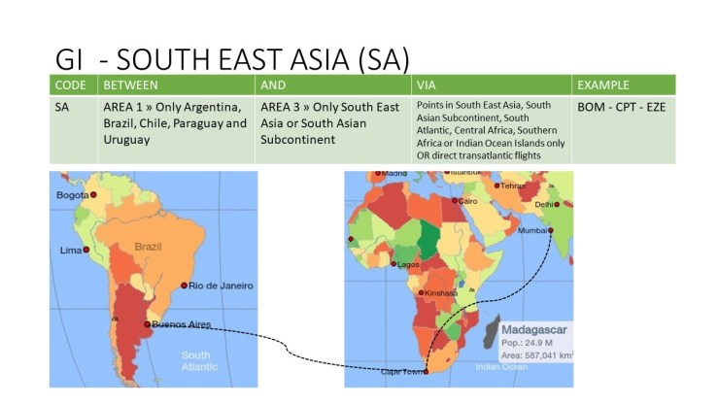

1. **FE** – Far East -When travel is conducted between European Russia or Russia west of Urals (primarily Moscow and St.Petersburg) and Ukraine to **TC3 non-stop**(exception of travel to Japan and Korea) then the itinerary will have Global Indicator as FE.

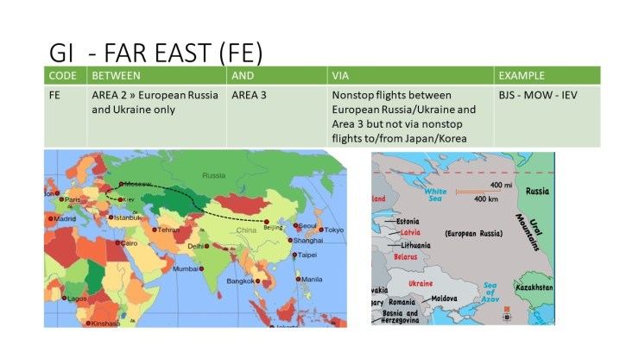

1. **RU** -Russian – When travel is conducted from Russia west of Urals to Area 3 except for travel to Central Asian countries via non-stop travel from Japan and Korea then the itinerary will be RU.

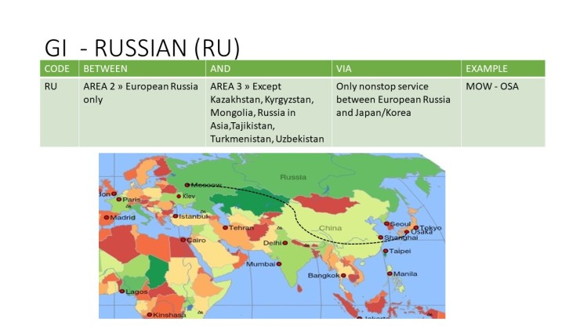

1. **TS** – Trans Siberian – When travel is conducted from TC2 (except Russia west of Urals) to TC3 via a non-stop service from japan and Korea then the itinerary will have a Global indicator as TS.

